Developed by Daniel Adenew – Lead Software Engineer - Malaria Diagnosis and Treatment Activity Project-USAID/PMI

Columbia UNIVERSITY, ICAP | Addis ABABA, Ethiopia 2020 ©

Software User Manual

Malaria SLide bank management Software– V.1.0.0

Ethiopian Public Health INSTITUE – EPHI

**1 INTRODUCTION**

The software described in this manual is intended to be used in the Ethiopian Public Health Institute ( EPHI) Malaria slide bank database automation project by EPHI.

While every requirement has been taken in the development of the software and in the preparation of this documentation, MDTA/ICAP assumes no responsibility for errors or omissions, or for damage resulting from the use of the software or of the information contained herein.

1.1 Overview

This document is the User Manual of the Malaria Slide Bank Management Software (MSBMS).

It is intended to provide all the necessary information to use this software to manage the slide bank archive, slide, donor, check-in/checkout, replacement, exchange and other slide related information on standalone workstation PC/s.

In addition to this***Introduction*** section, this manual contains four major sections:

* ***User's Guide***, included in this document describing the functionality provided by the software, including examples of utilization.
* ***Reference***, describing all the functions, commands and tools available to the applications and the application developers.
* ***Installation Guide***, describing how to install and make the software ready to be used. This section has been moved into a dedicated manual covering the full Malaria Slide Bank Database Software installation.
* ***Error Messages and Recovery***, provides a list of errors and diagnostic messages and possible recovery actions.

1.2 SCOPE

This manual describes the release of the Malaria Slide Bank Database Software v1.0.0.

1.3 REFERENCE DOCUMENTS

The following documents are referenced in this document and provide additional information:

**1.1 Overview of Software**

This manual describes the MSBMS software functionalities implemented as per the requirements collected and finalized since *Dec 1/2020* with frequent review of EPHI’s team.

The software has the following Major Modules/Components:

* + 1. Starting Application from Start Menu

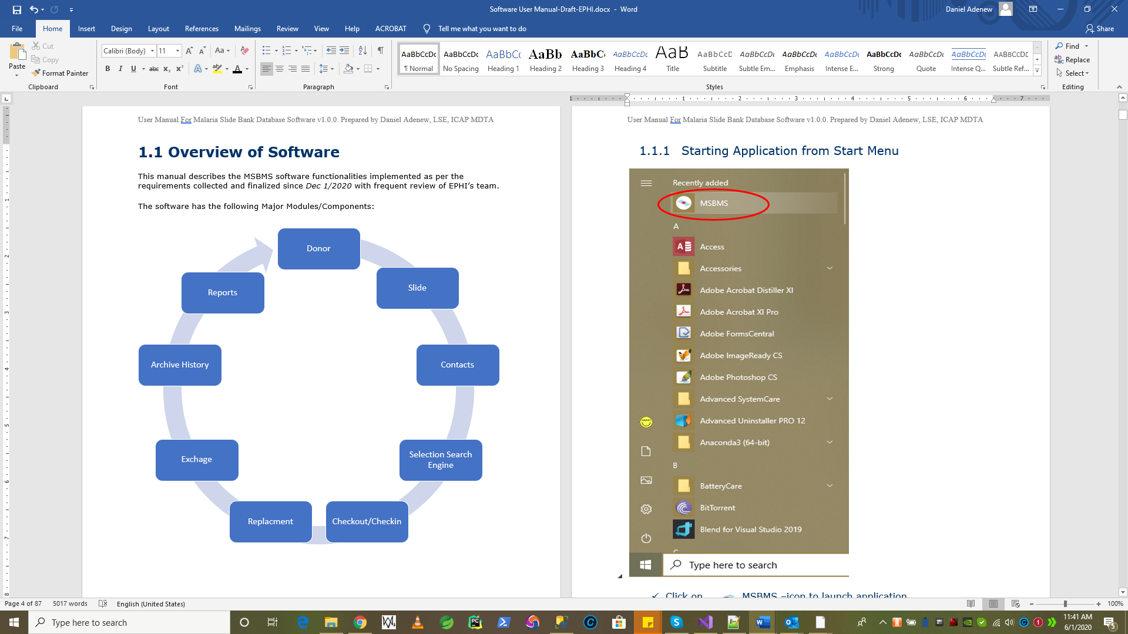

* Click on MSBMS –icon to launch application
* Or Type “**MSBMS**” on search bar
* Application Shows a starting window

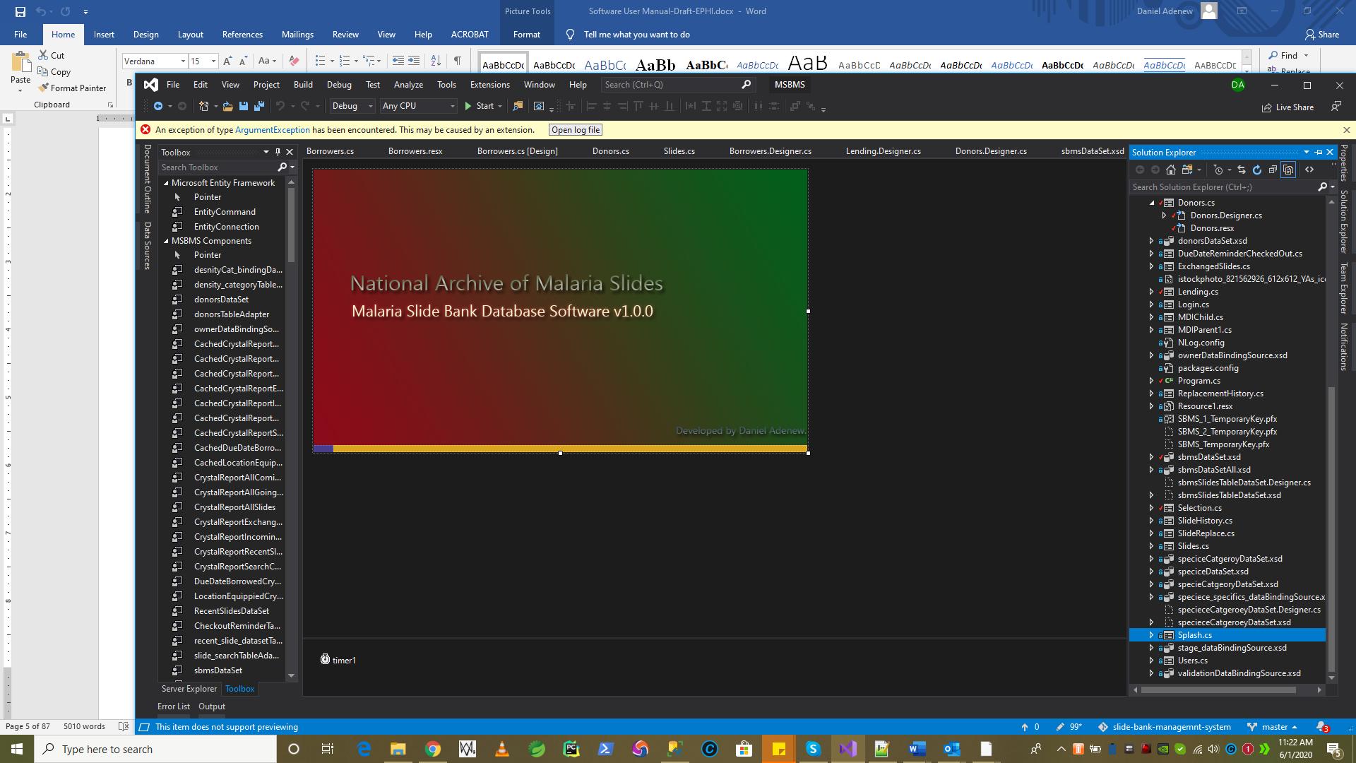

System initializes, checks for the necessary environment setup and show login screen.

* Check SQL server installation
* Connect to SQL for local data storage
* .NET Framework 4.7.X
* Windows 10 latest SP
* Initializes default country of origin data to EPHI as new contact
* Loads login forms
  + 1. Login to application

To operate the functionality of SBMS software login is required. Login or authentication is using Username and Password. The authentication details must be created by a super admin of the Database Administrator prior using the software.

**N.B No authentication is needed to run the software; to perform action is.**

The following screen will appear under a normal opening of the SBMS software: enter correct login details to authenticate.

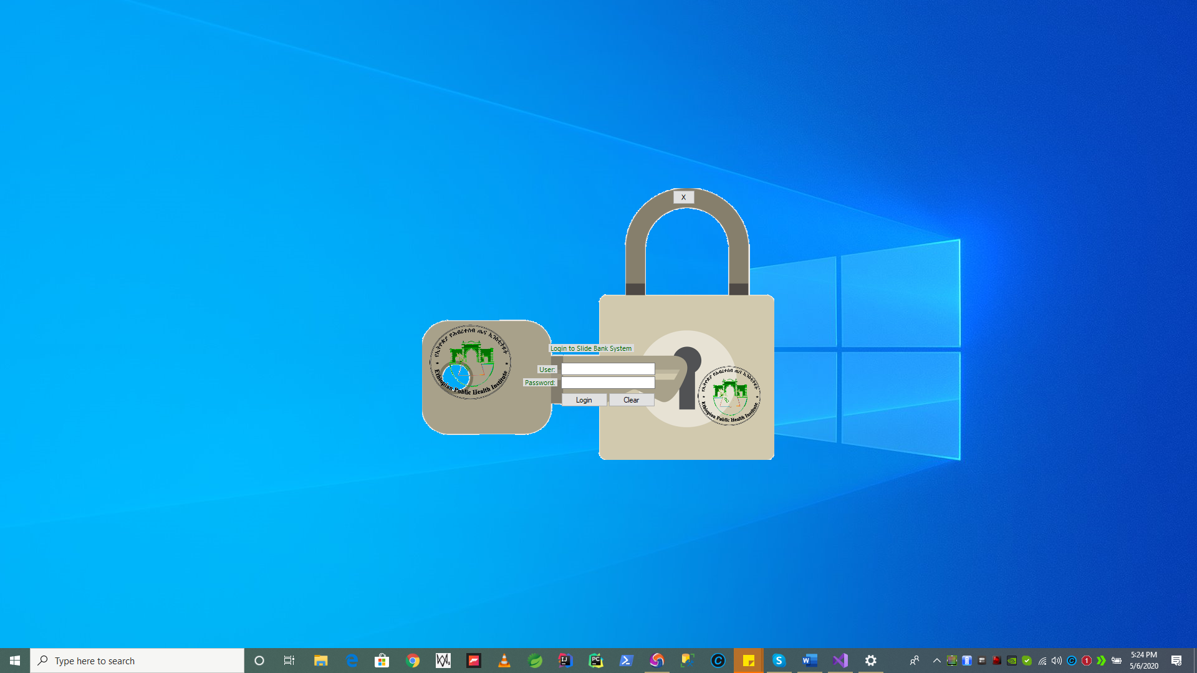

Figure 1: login screen

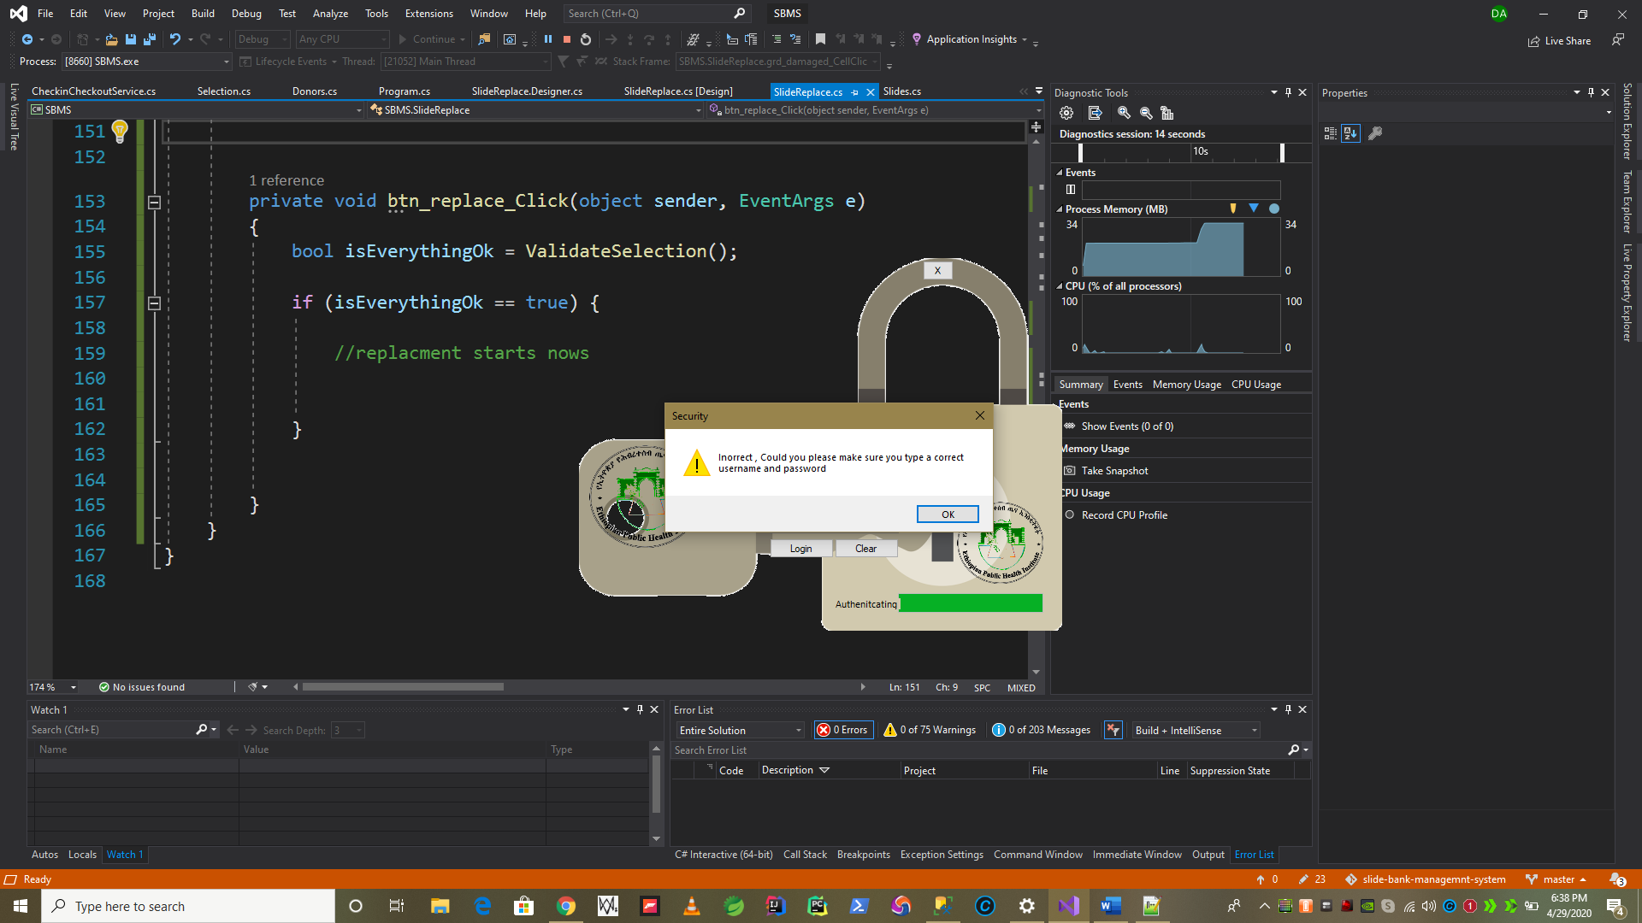

Figure 2: Login authentication wrong details entered

* + 1. Applications Start Menu

After a successful Login. The **MSBMS** software show the following start menu.

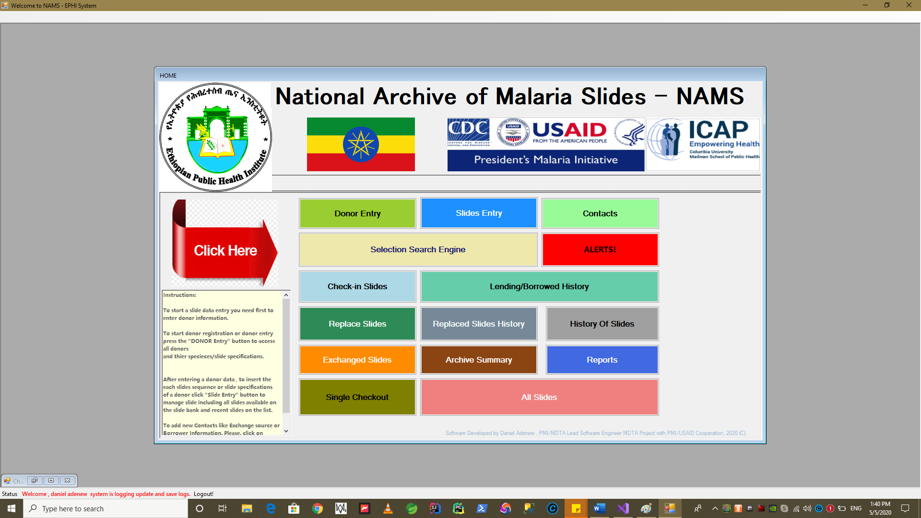

You can logout the system and close the application safely here, by clicking **Logout**! button

* + 1. Donor Information

To start donor information management module. Press “***Donor Entry*** “as indicated below.

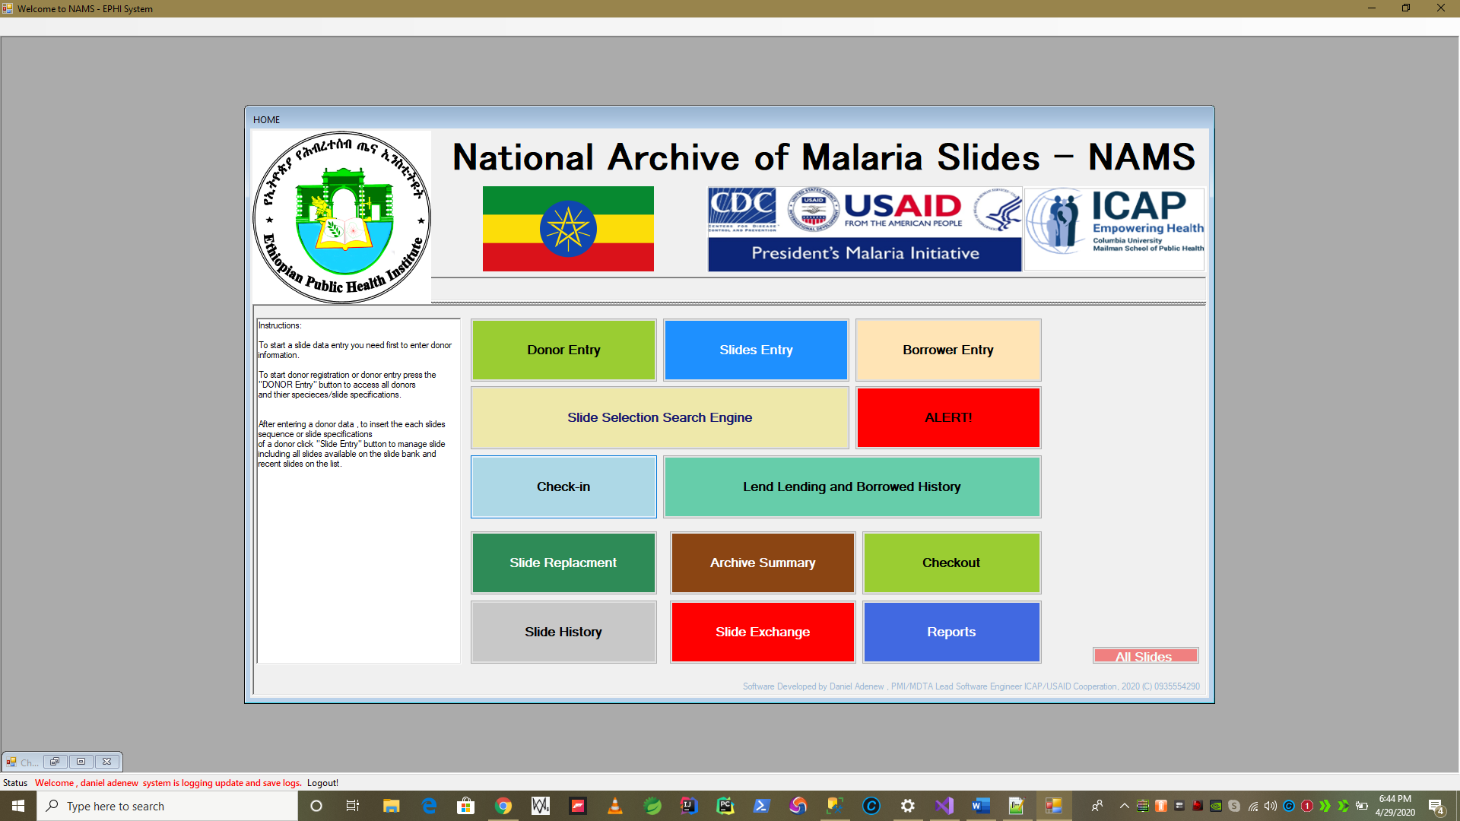

* **Donor Information module has the following major logical actions in addition to other minor/supportive features:**

1. Donor Information Registration
2. Validation for duplicate donor code within a same country code
3. Input Validation
4. Edit Donor Information after save
5. Search Donor – using donor code

* 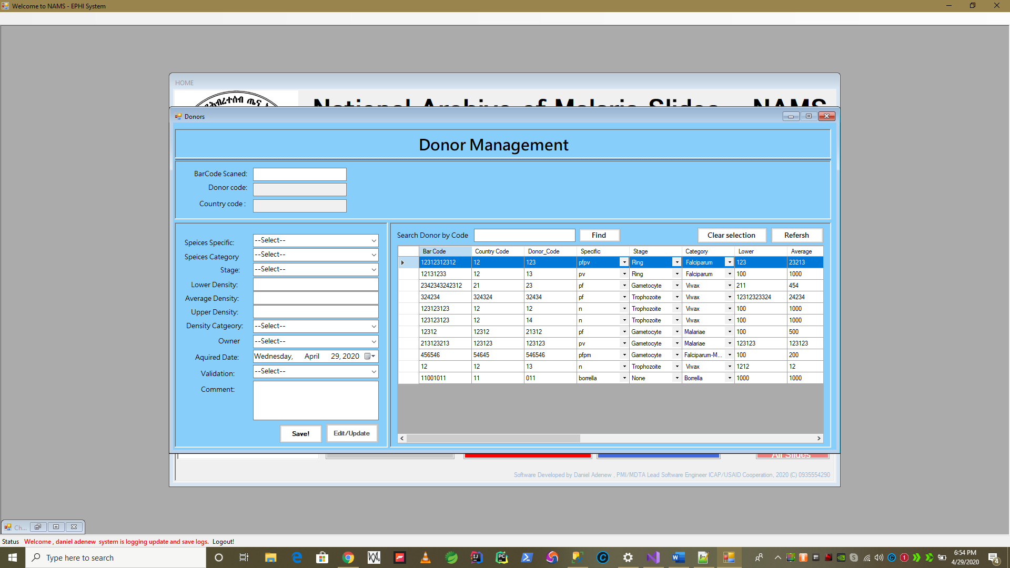To start donor registration please enter the barcode here => **Barcode Scanned**: and **press “Enter” on your keyboard!**
* **Next: Start filling the initial Donor Identification.**

**Requirements :**

1. Must scan or enter barcode in the following format ***Country Code-DSDSDS***
2. *Enter the other species related details and press “Save”*
3. *If duplicate system will report – “Duplicate Donor ID” if not system will show donor saved message box.*

***If you Enter less than 8-Digit for barcode system will show you Error Message as shown below.***

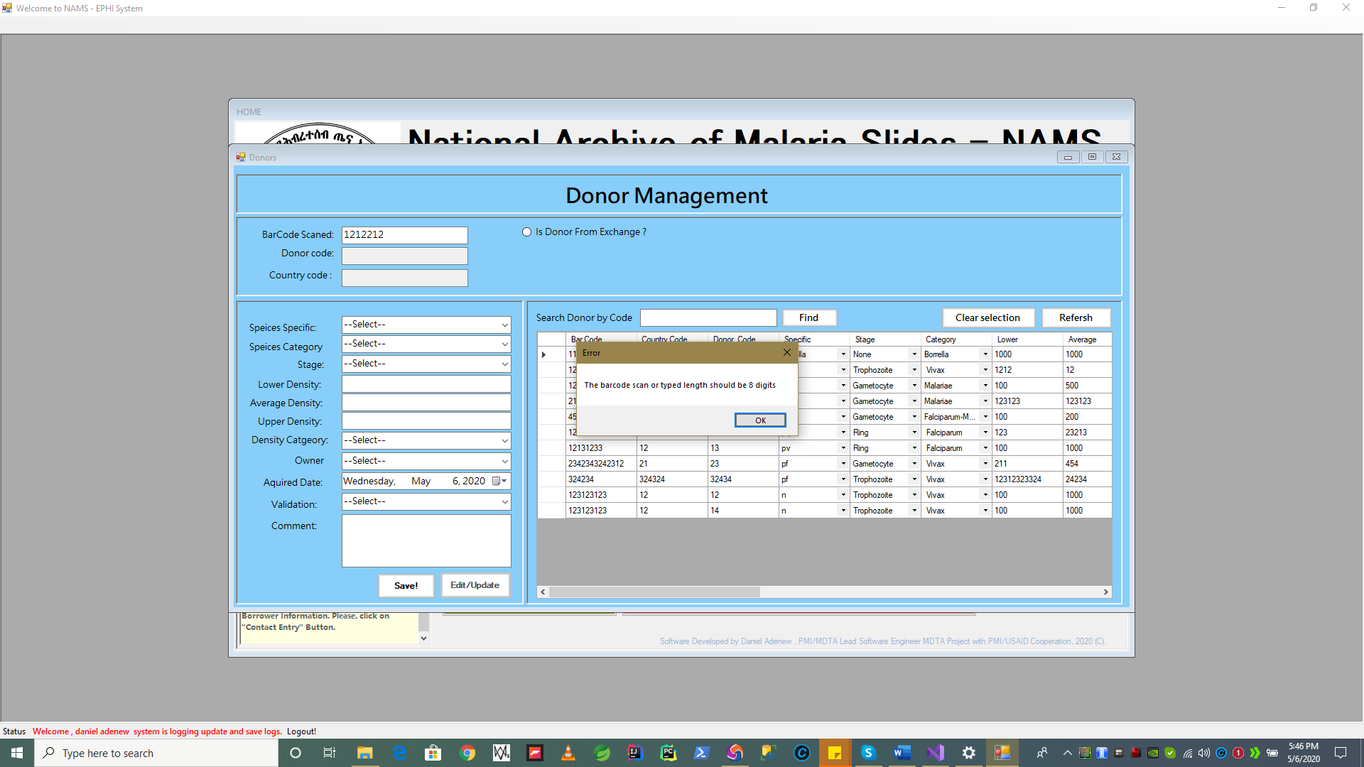

*After a successfully registering a donor Information the following message will be displayed and new donor is added to the list on the right of the edit/update screen.*

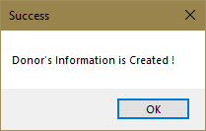

**Donor Barcode i= 12121233 after saved it is shown on the right screen highlihted in blue as shown below.**

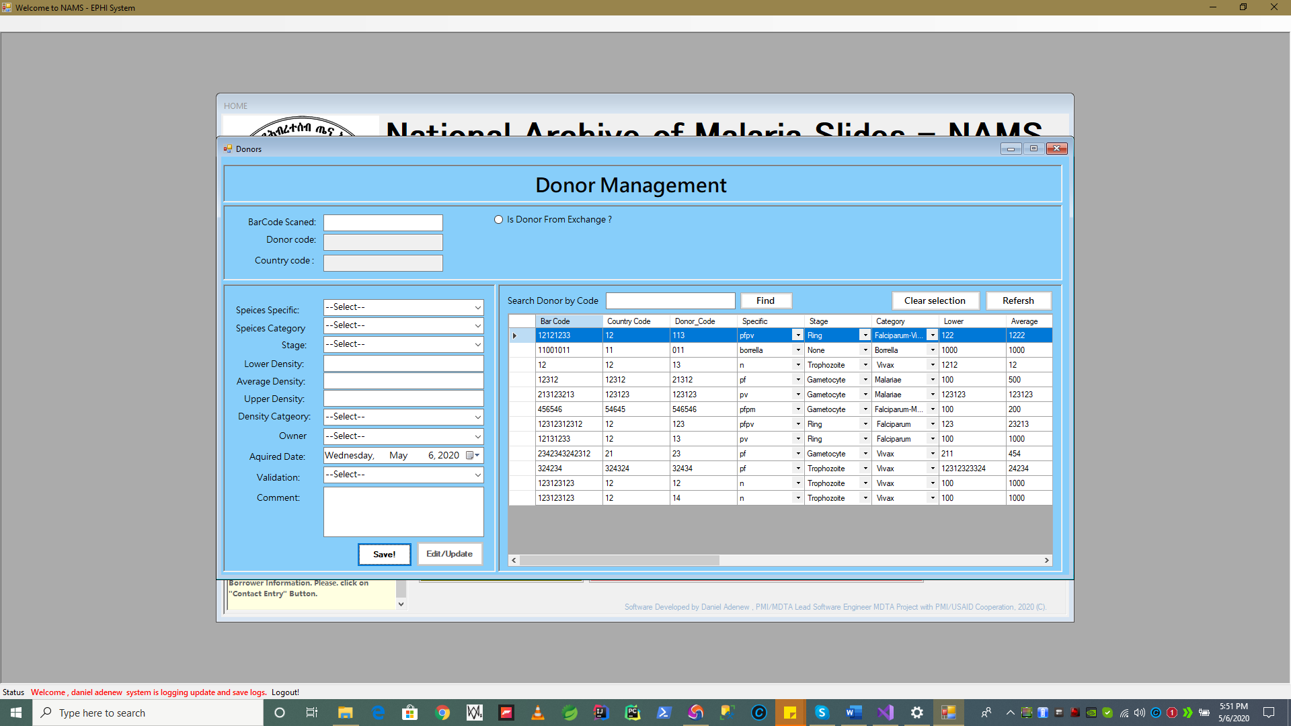

**Scrolling the left data grid view revels more columns and data element fields as shown below.**

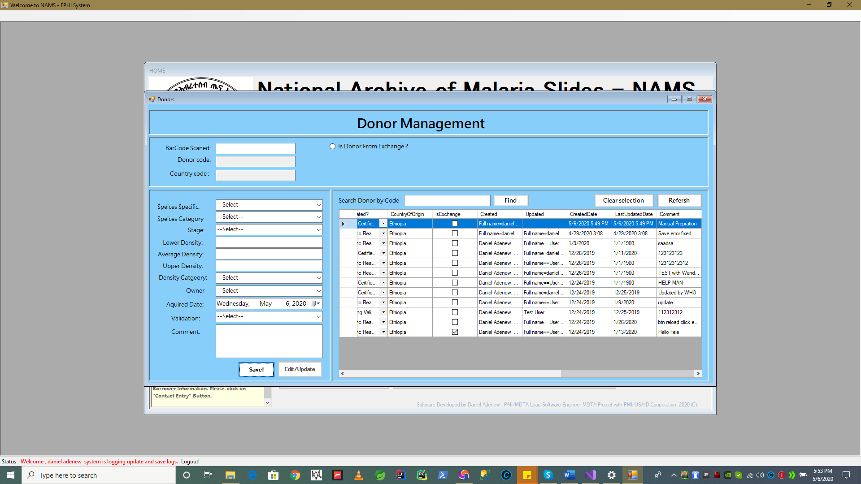

***Scroll button to show record details e.g. created date, created by.etc.***

Select any record on data grid view to edit/update it. The below section discusses how edit/update a donor information.

* **Preventing Duplicate Donor Record Saving**

e.g. **11030270** is a donor with code **007**

If there is an exising donor with the same code registred before. The system will show donor is duplciate warning message and will not save any record if entered.

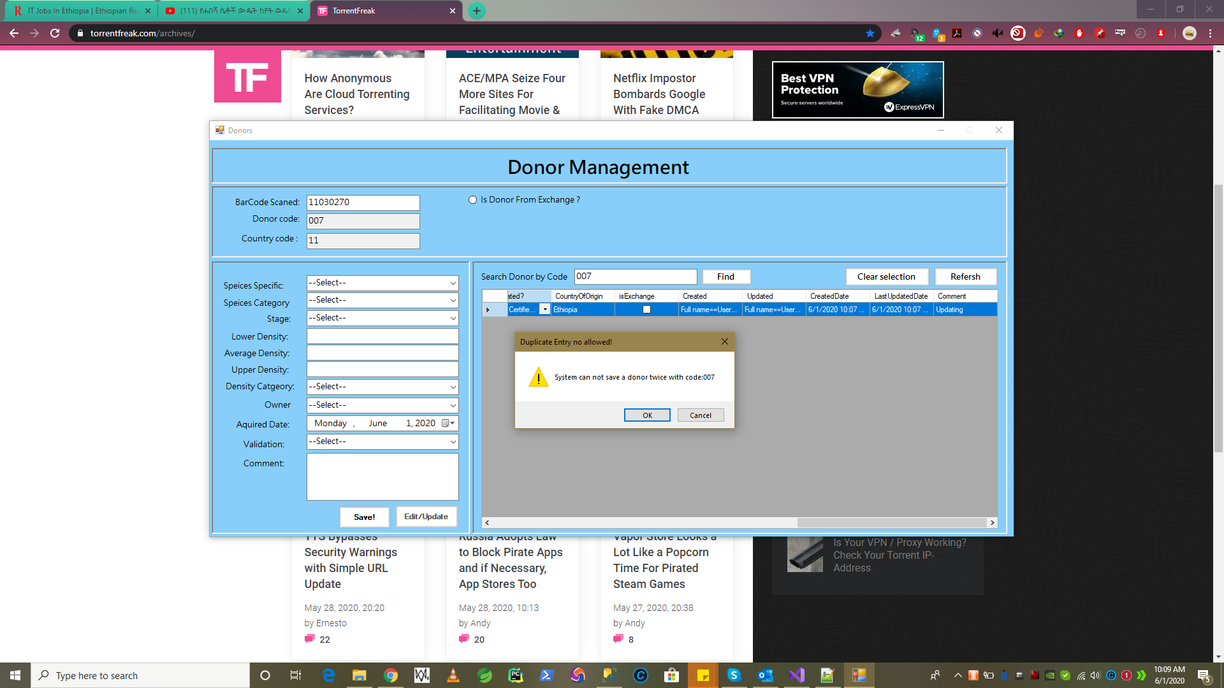

**Press “Ok” system clears the input for Barcode Scanned for NEXT entry.**

* **Donor Information Update has the following major logical actions in addition to other minor/supportive features:**

1. First you have to select a donor data from the data grid list of records.
2. You have to change or edit/update some data values *e.g. may be species category ..etc.*
3. *Press* ***“Edit/Update****” Button when you are done, “Save” button will be offline this time because it is new record.*
4. *System validate the edit. Checks for discrepancies or unselected or empty values if any*
5. *When correct the system shows update is done successfully with message.*
6. *Record update is reflected spontaneously and displayed on the list data grid view.*

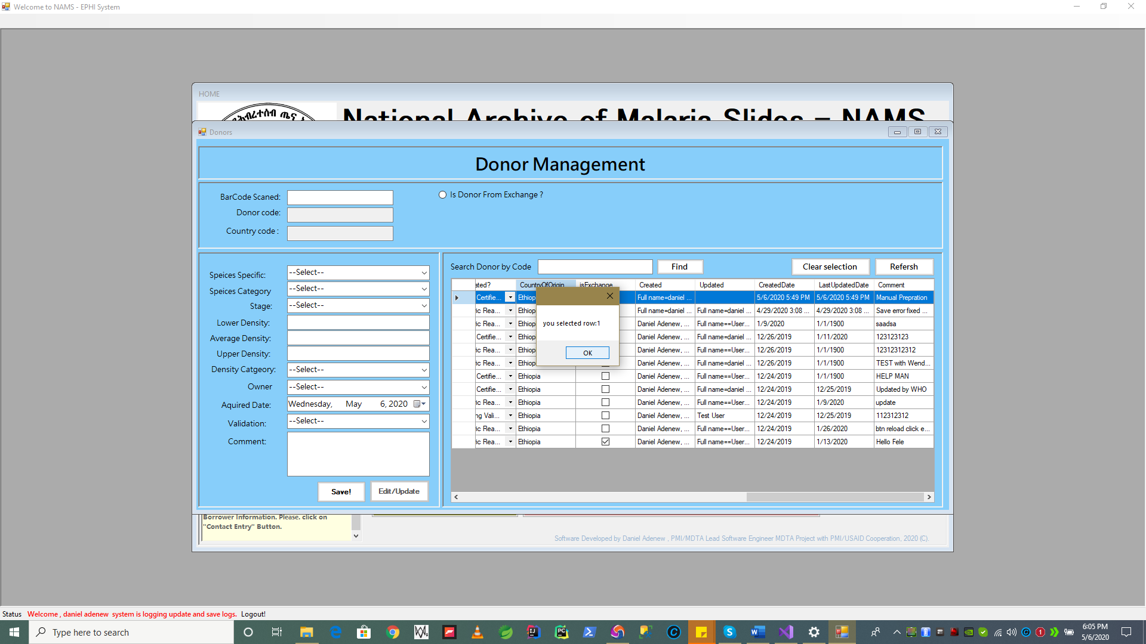

System showing selected row of a record during a record is selected for edit/update of donor info.

* **The selected data from row 1 as show in this example will be loaded in individual data elements for edit.**

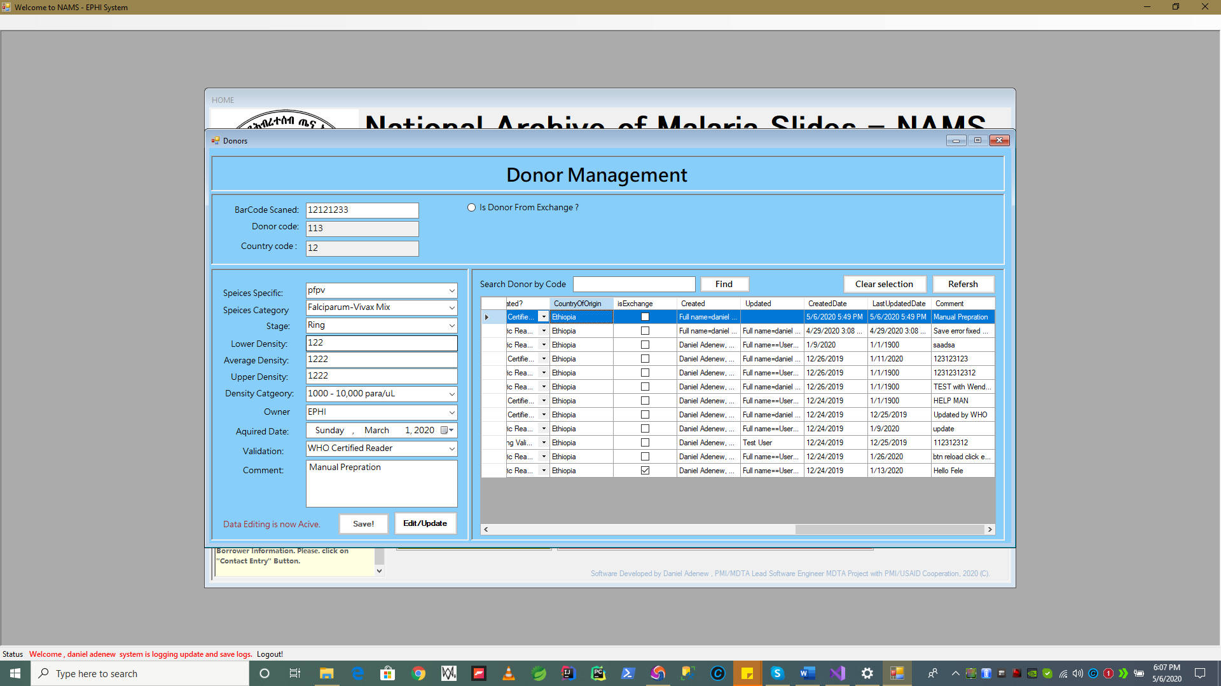

The text boxes data ,combo box , select box are now open for edit for the editing user.

Press “**EDIT/Update** ” button now when you done with editing.

When “Edit/Update” button pressed, and if information is edited correctly and no discrepancies found.

System show a **confirmation message** that the record has been updated successfully as follows.

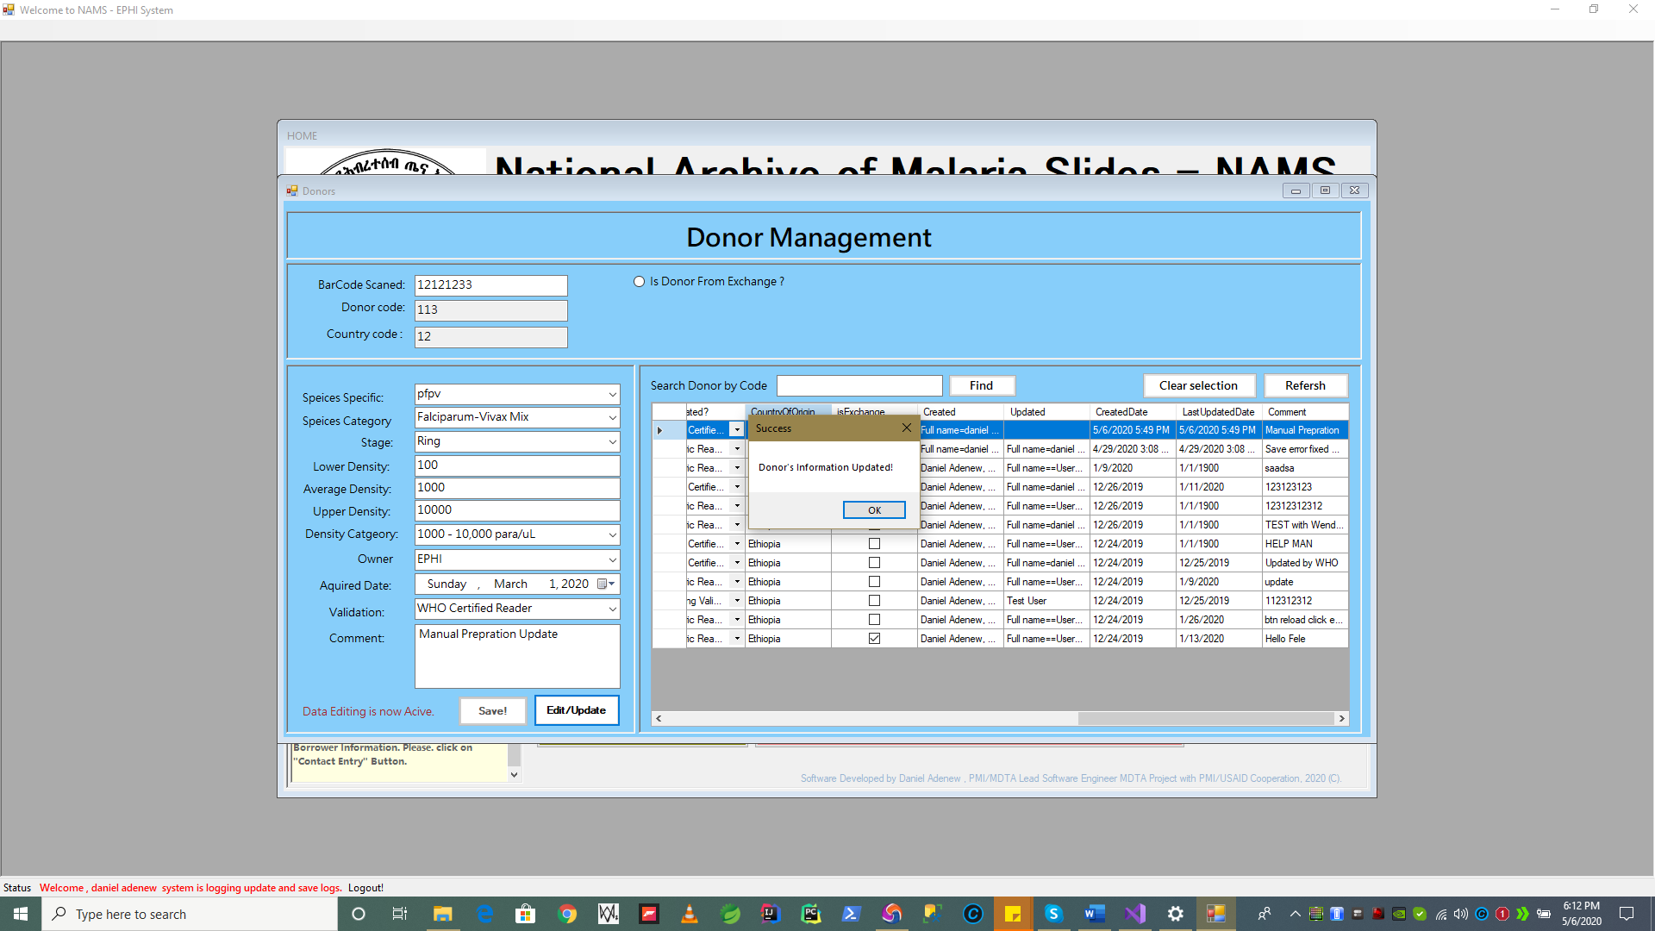

Updated record data in this example *are Lower , Average, Upper Density values.*

* **Searching a Donor by donor code** can be done by entering the **donor code** into the search by donor code text box and pressing find button. When system searches and found a donor as per the code in the database. It shows and highlights in blue as follow.

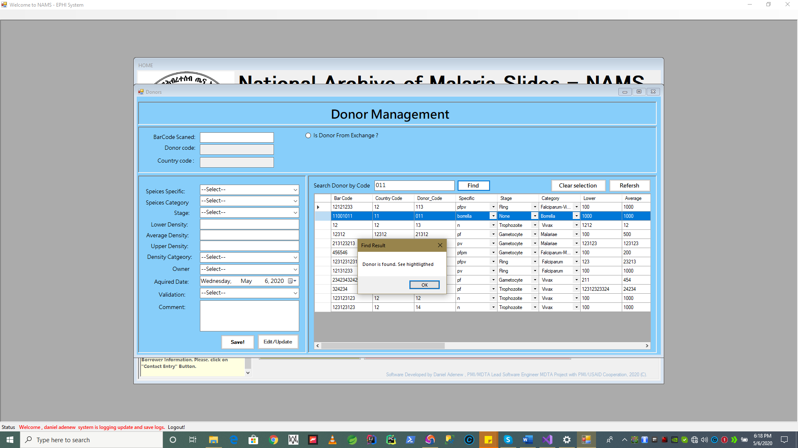

* + 1. Slides Information

After saving donor information, comes registering individual slide information for a particular donor code, simply a donor. To do launch the slide information/entry from application menu as follows.

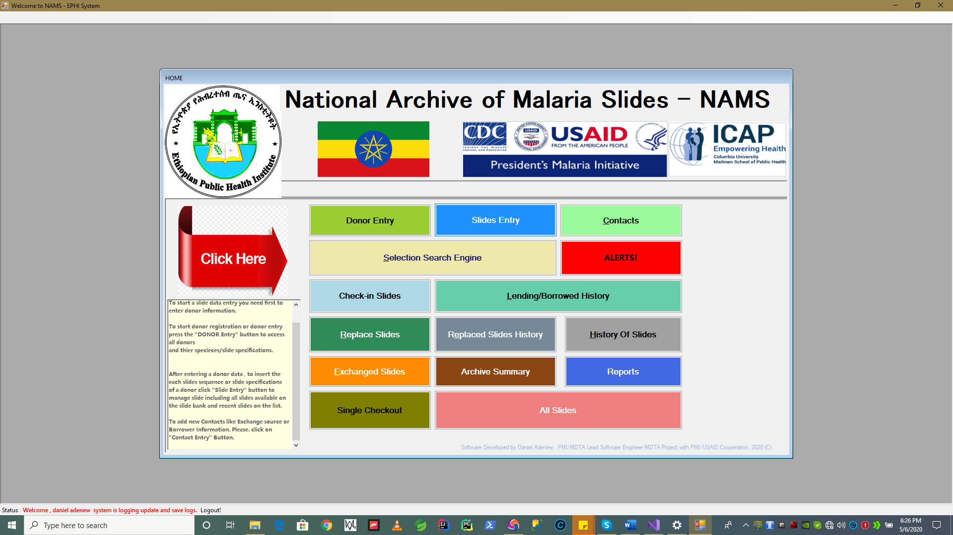

* **Add new Slide Information has the following major logical actions in addition to other minor/supportive features:**

1. First you have to enter the ***barcode of slide in Barcode input box or scan using barcode reader*** by placing the computer mouse on the input box.

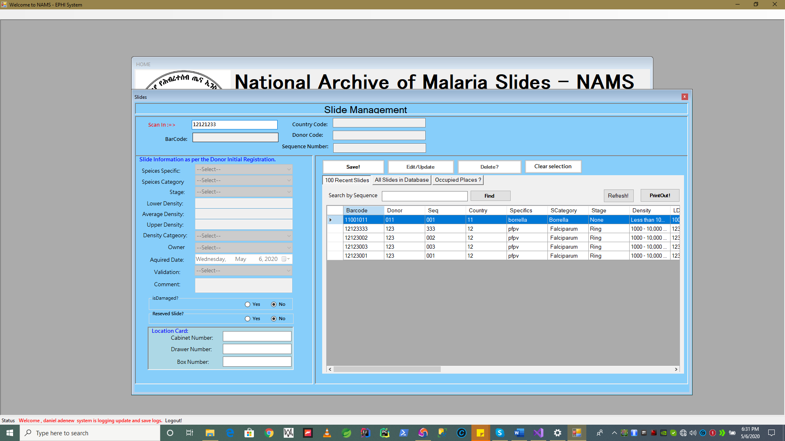

1. Press **Enter key on your keyboard** to fetch the slides specification that was formerly saved with a when registering a donor. Since, all slides under same donor always get information as per the **existing** donor.

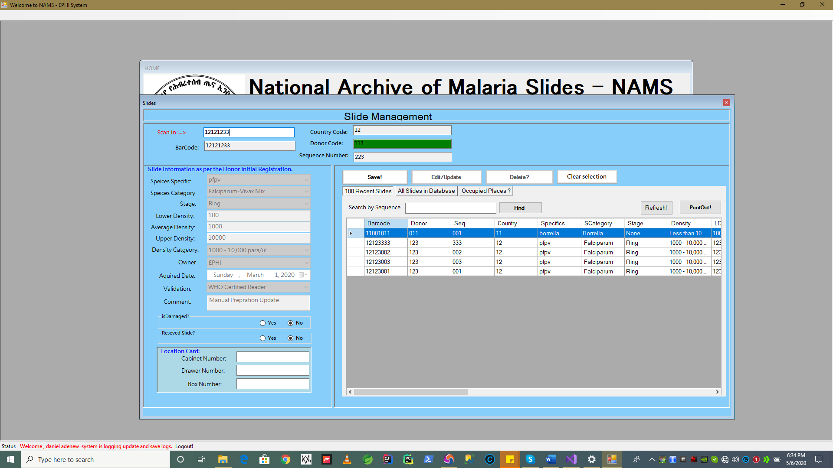

**This information is automatically fetched form existing donor information as per the donor code.**

* **N.B before registering slides a Donor has to be registered first.**

1. **If system could not find the donor** by the bar code’s donor id, it shows donor not found message, which will result any record not to be saved.

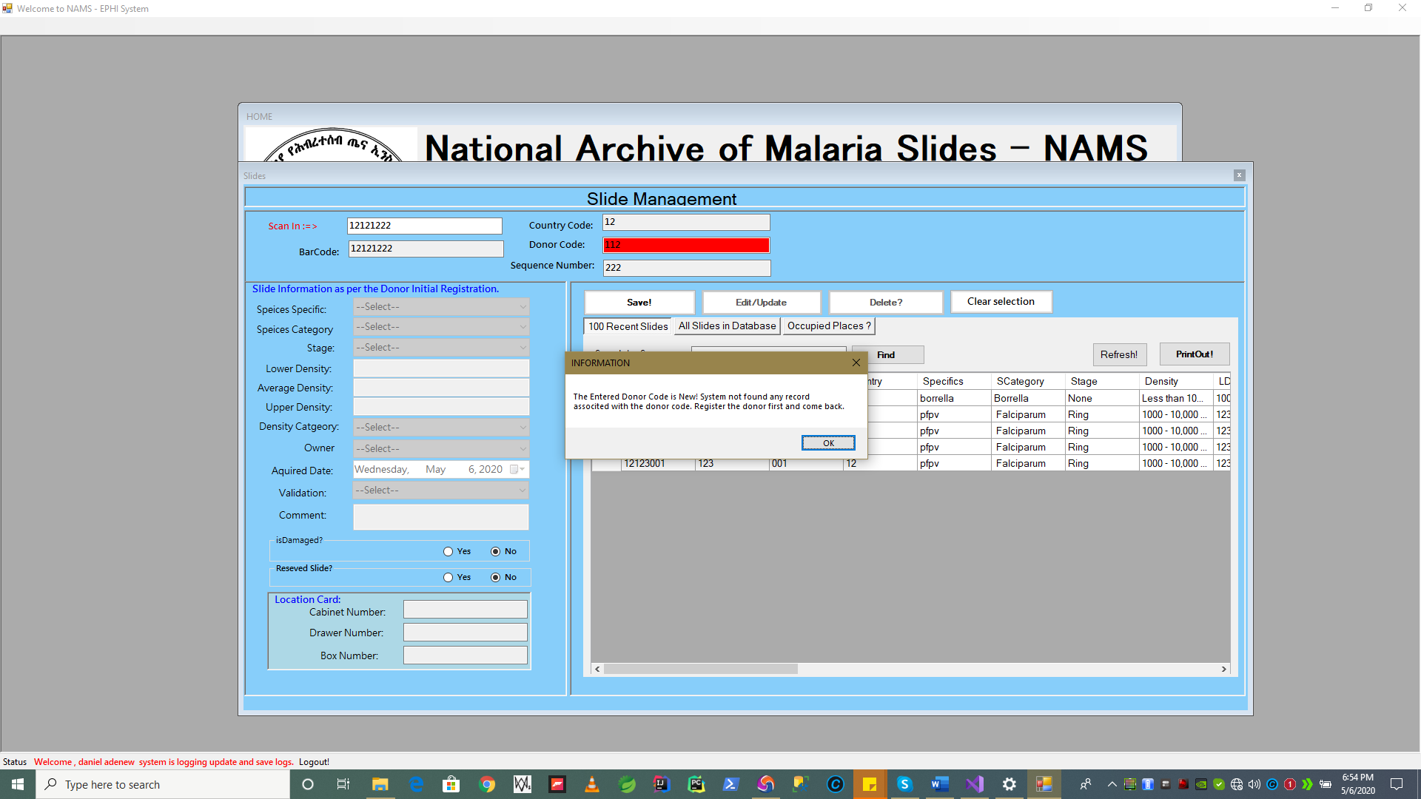



1. Pressing “Save” button while there is red flag on. The system automatically disables any input data filed to be entered/disable to prevent **invalid data.**  So, no record adding will happen at this time.

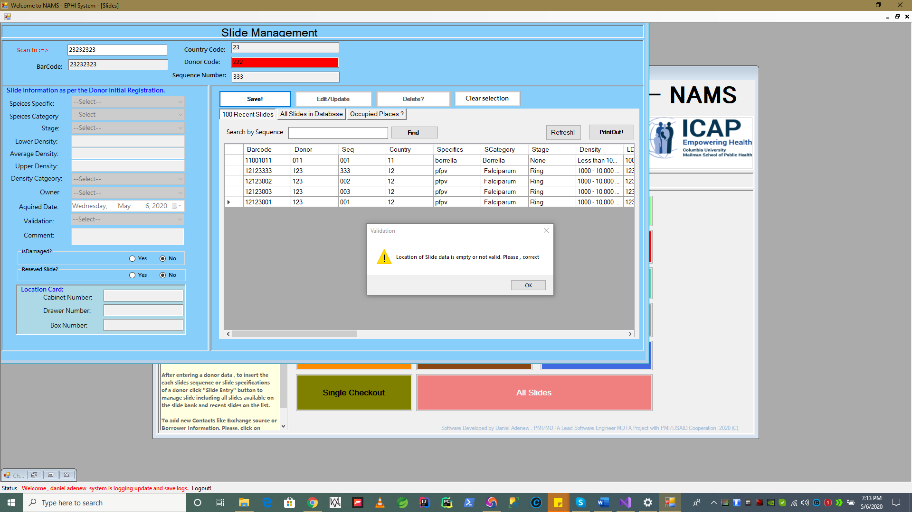

1. If donor code is valid , existing and slide specification is displayed with green color flag on as show in step #**3 above**. The system will accept data to be entered for file  **isDamaged, isReserved , Location (Cabinet,Drawer,Box) input fields as shown in figure below.**

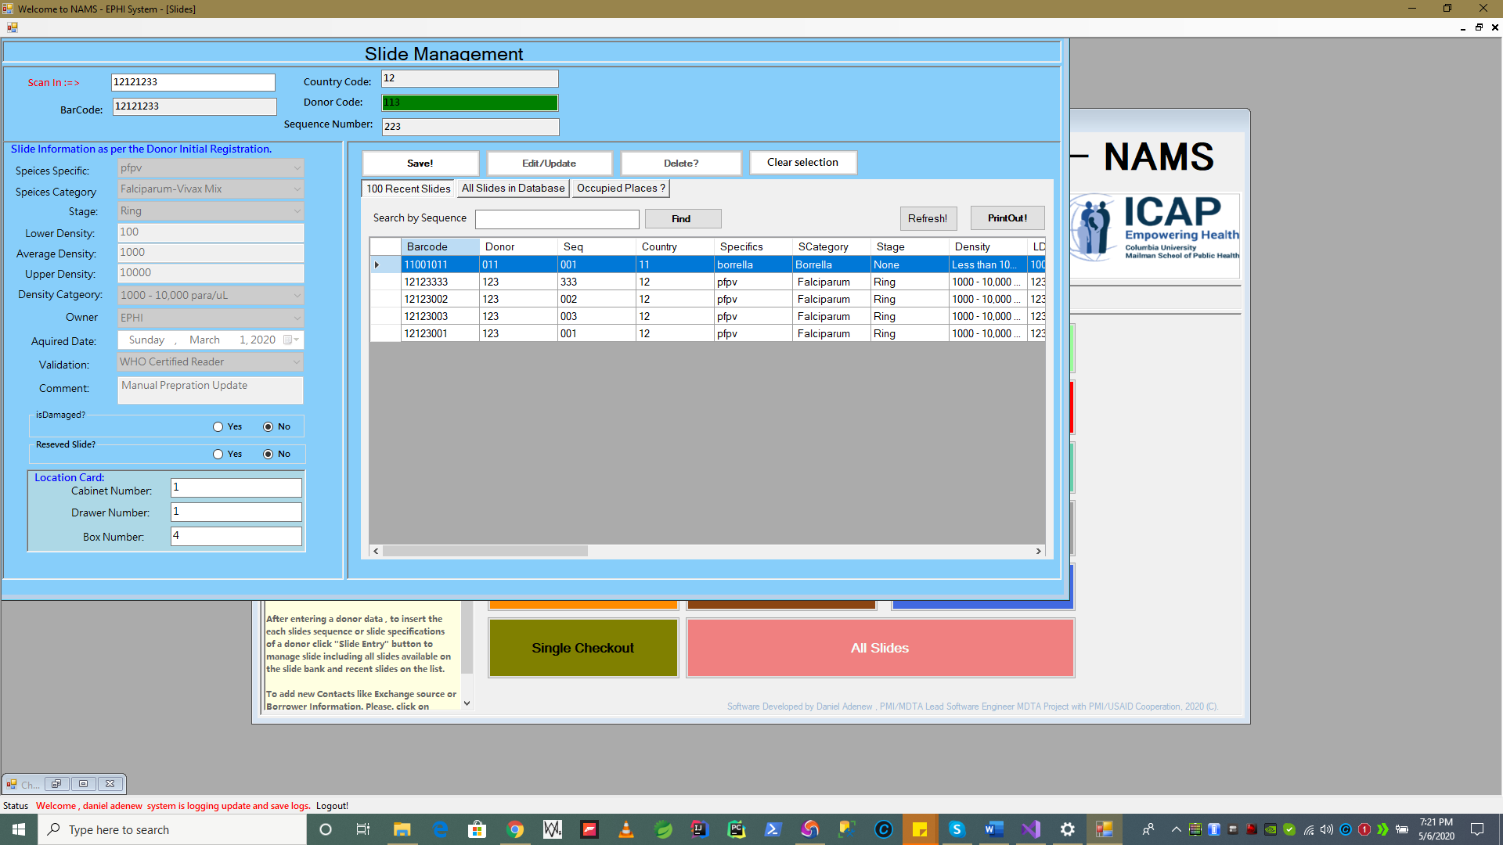

*Press* ***”Save”*** *now to save the slide in the unoccupied location.*

**N.B A this stage another validation awaits that if you enter Location data which is occupied system will report to you if it is already used and you need to change.**

1. User are required to check if the location for the slide is occupied or not by accessing the Occupied Location button on the slide page form as shown below.

* Other wise system will show **Validation Message** as follows to prevent duplicate slide location data saving or unwanted override of location which will make Slide Bank Unstable.

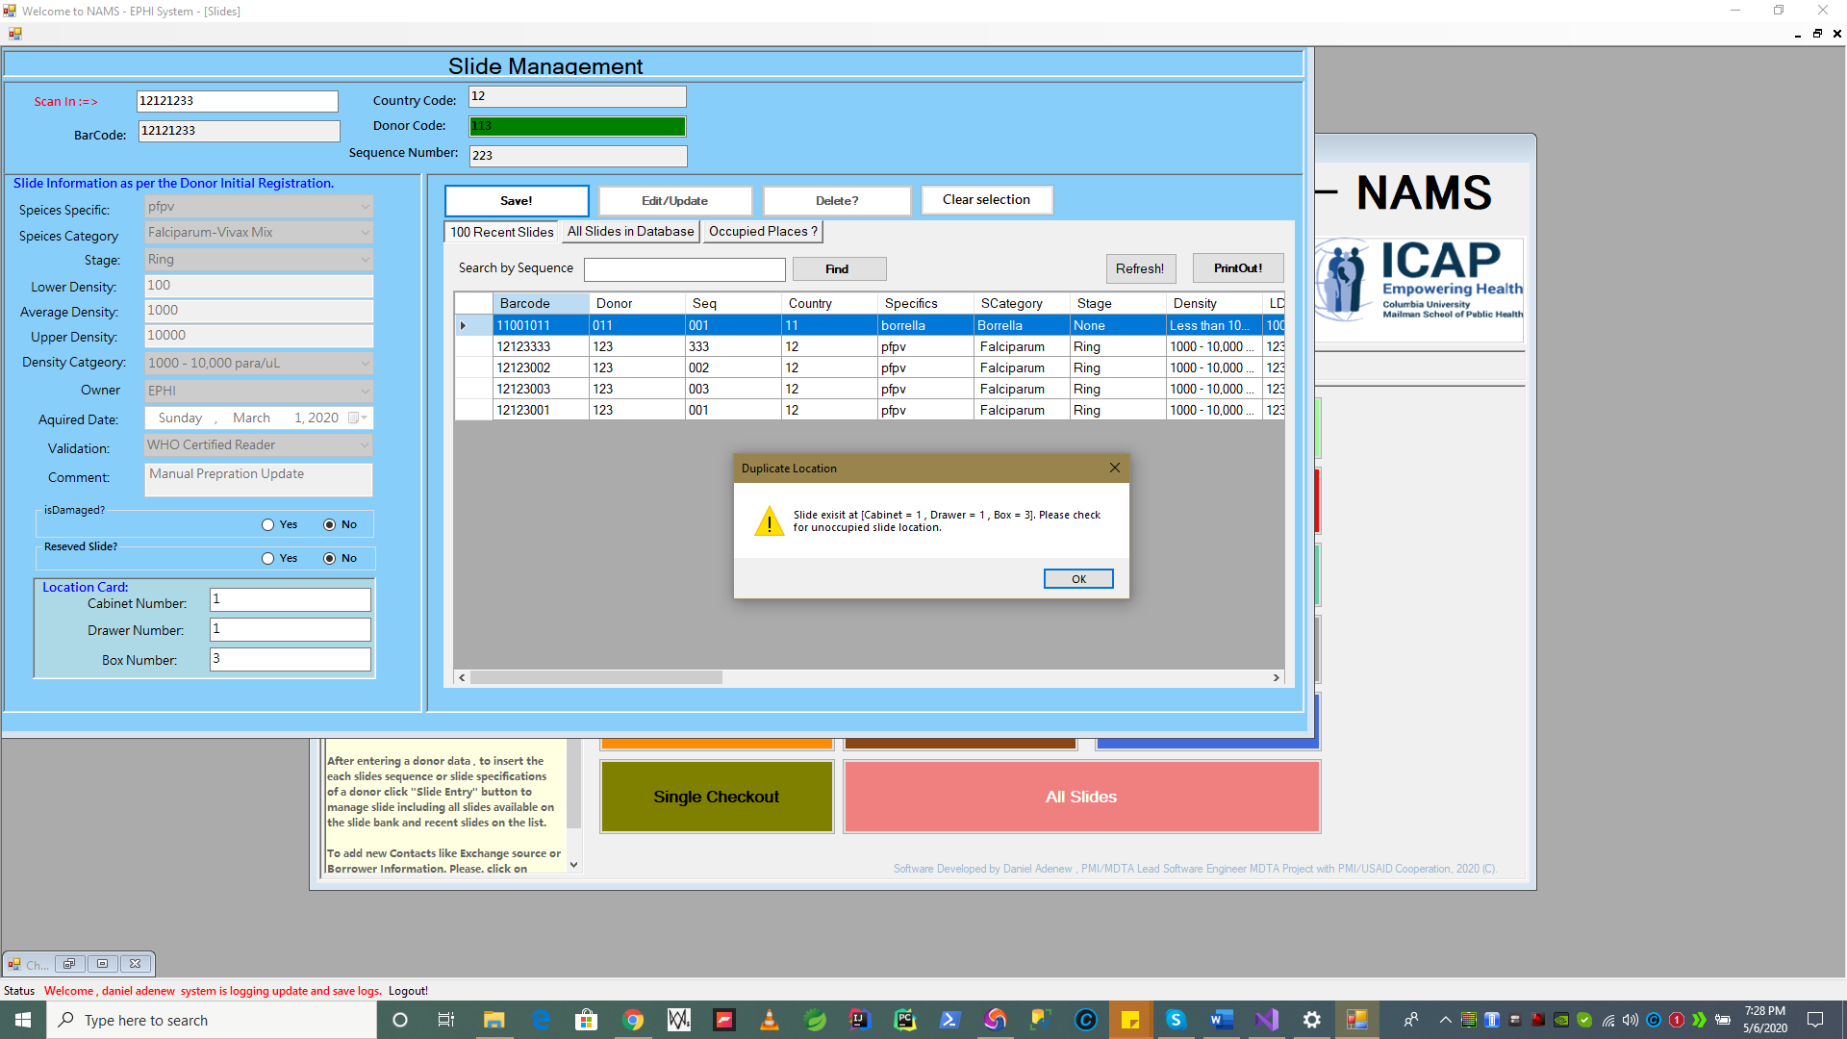

**See below for more…**

1. To check occupied and not occupied places press **‘ Occupied Places’** button as shown below.

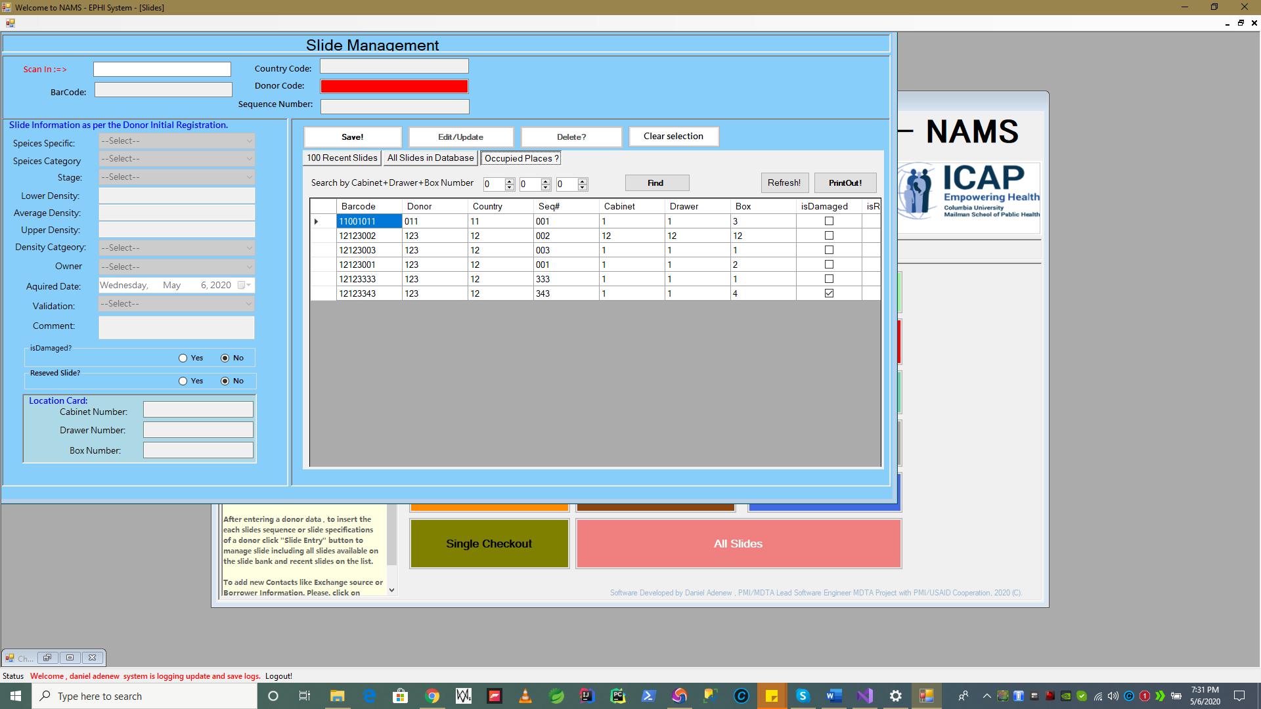

1. Change if Location is occupied for the slide you are saving if Duplicate Location Error message displayed and **press “Save” Button** again.

*You have now saved a slide information correctly. System will confirm success as show below and the new record will be seen on the left of data grid view as shown on the below figures.*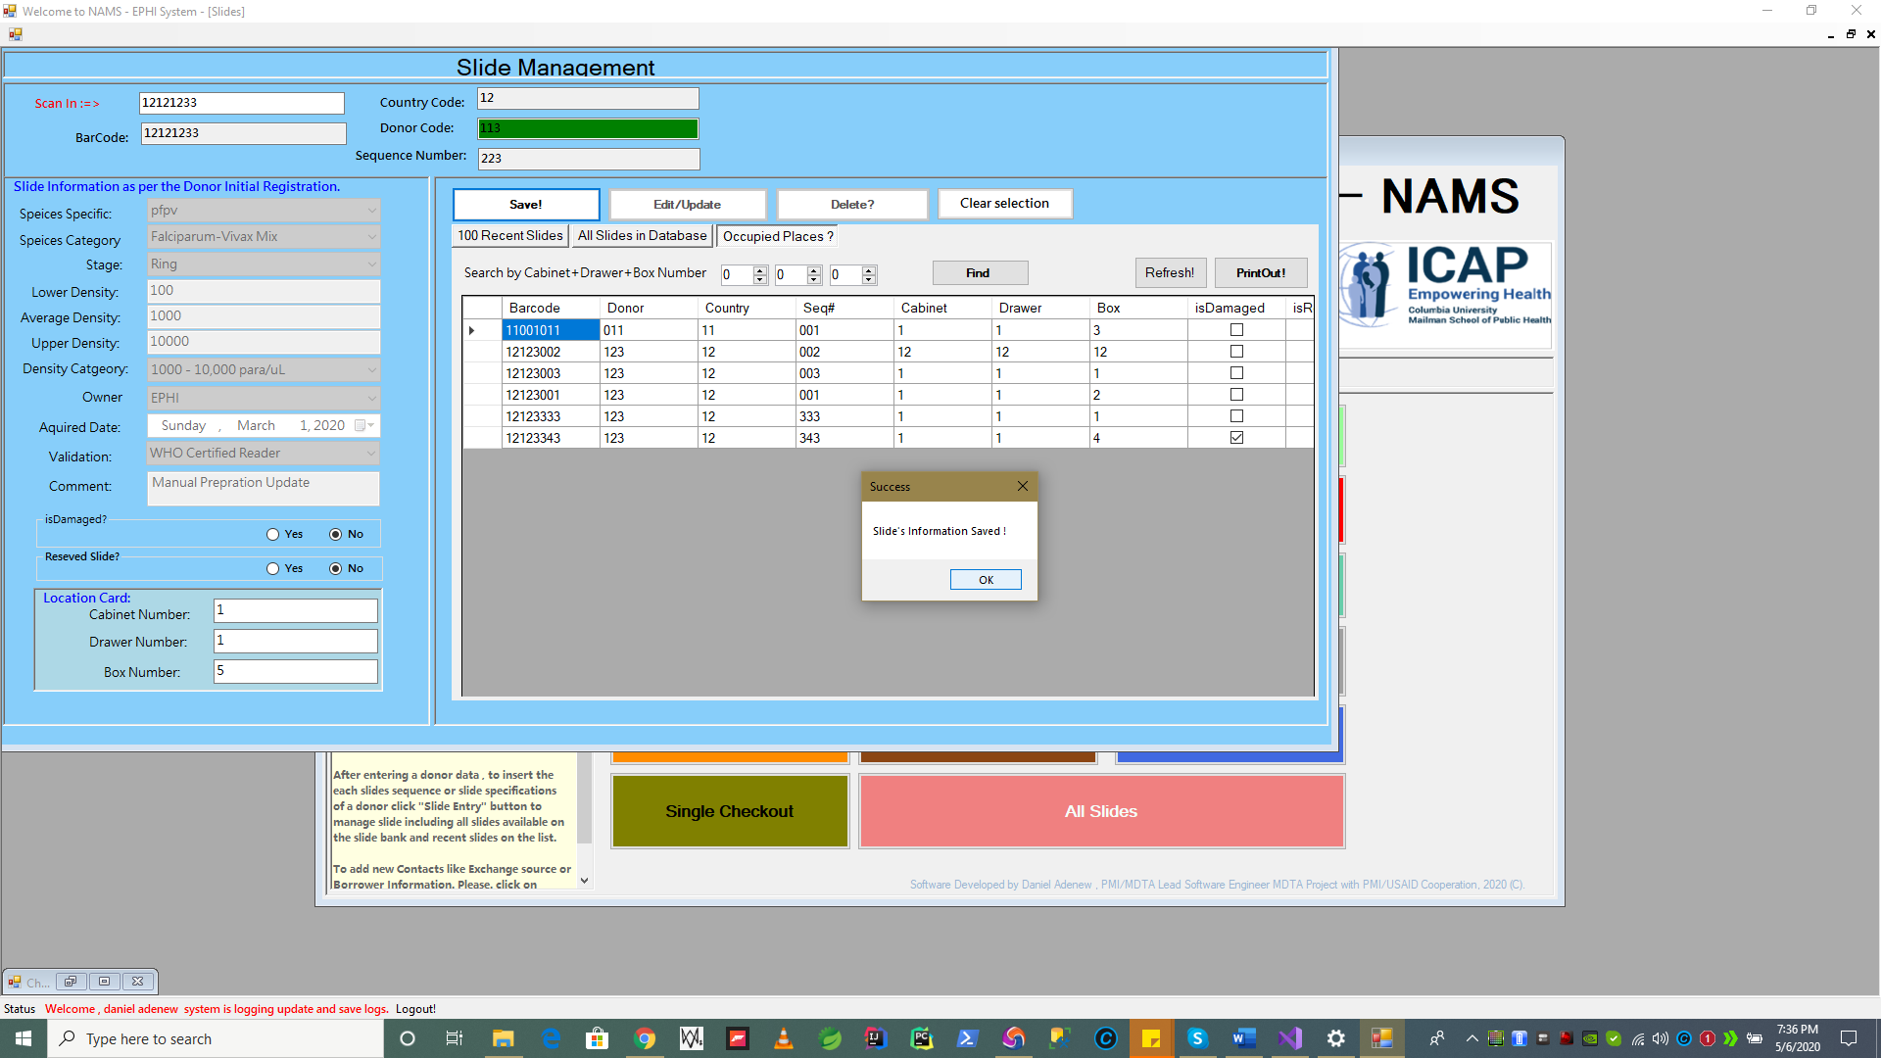

1. System displaying the new record. Press the tab button **“100 recent slides”.** Here is our new record we inserted as per our previous entered slide information under **donor code 113**/**sequence 223**.

**N.B** The slide now has 223 sequence id as per the scanned bar code. If you scan a slide for donor 113 with a sequence 001 , you have use a barcode with the following format. E.g CD-DSDSDS => 12101011 which result in sequence code 001.

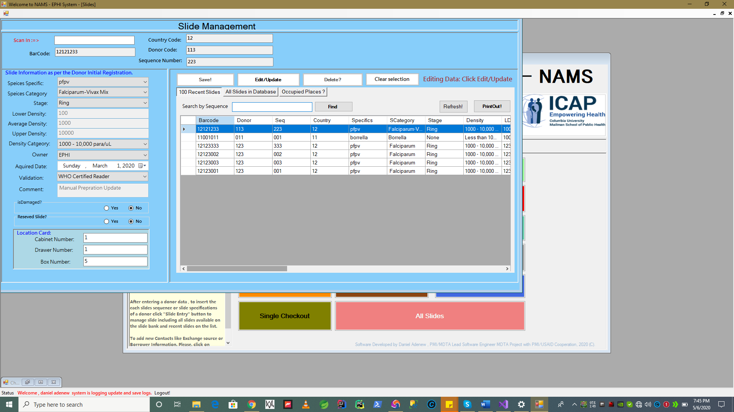

1. Scroll the data grid list view to see all records are entered correct? see below.

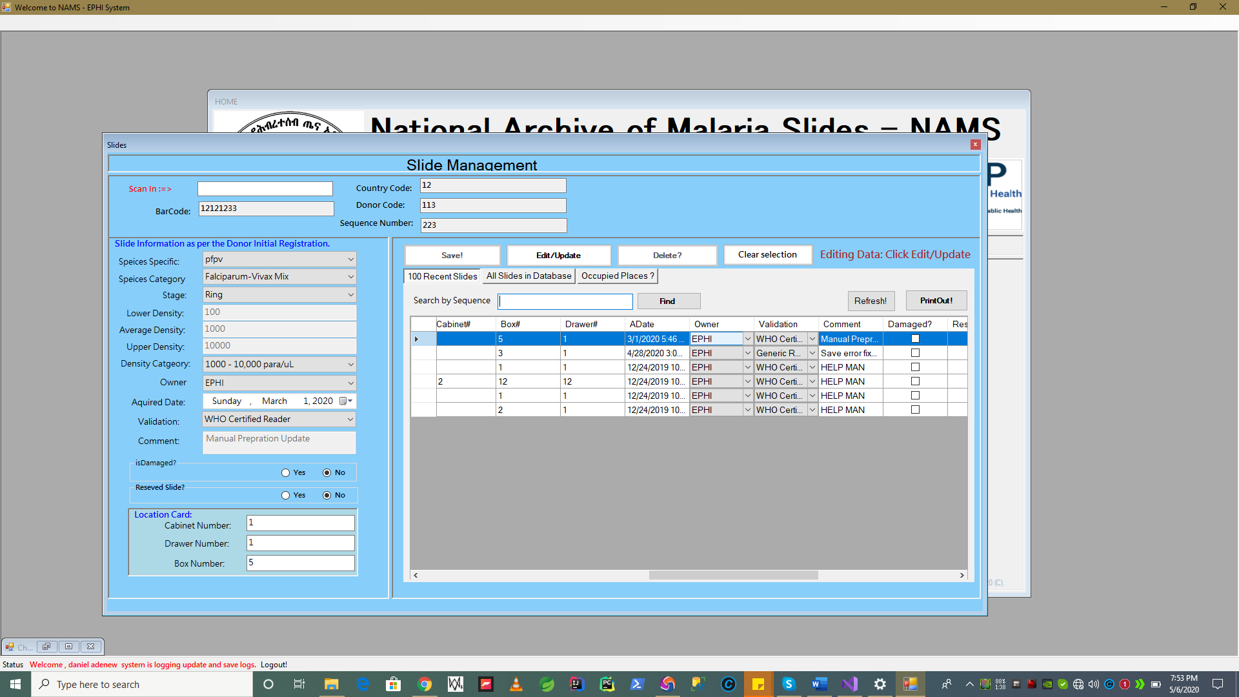

To this point we have seen that how we can save/edit particular Donor Information its child Slides Information under it.

* **Editing Slide Existing Slide Information**

Next Section describes editing a slide information after save. We select the record we have saved before on above step.

1. You have **to select the slide** you would like to edit the information.

**N.B The following are the only editable slide information after save. The rest data elements are only edited by using Donor Information. To sound a logic that initial specification for all slide is based Donor’s .**

* 1. Is Reserved Status
  2. Is Damaged Status
  3. Location Data - > **Drawer, Cabinet and Box**

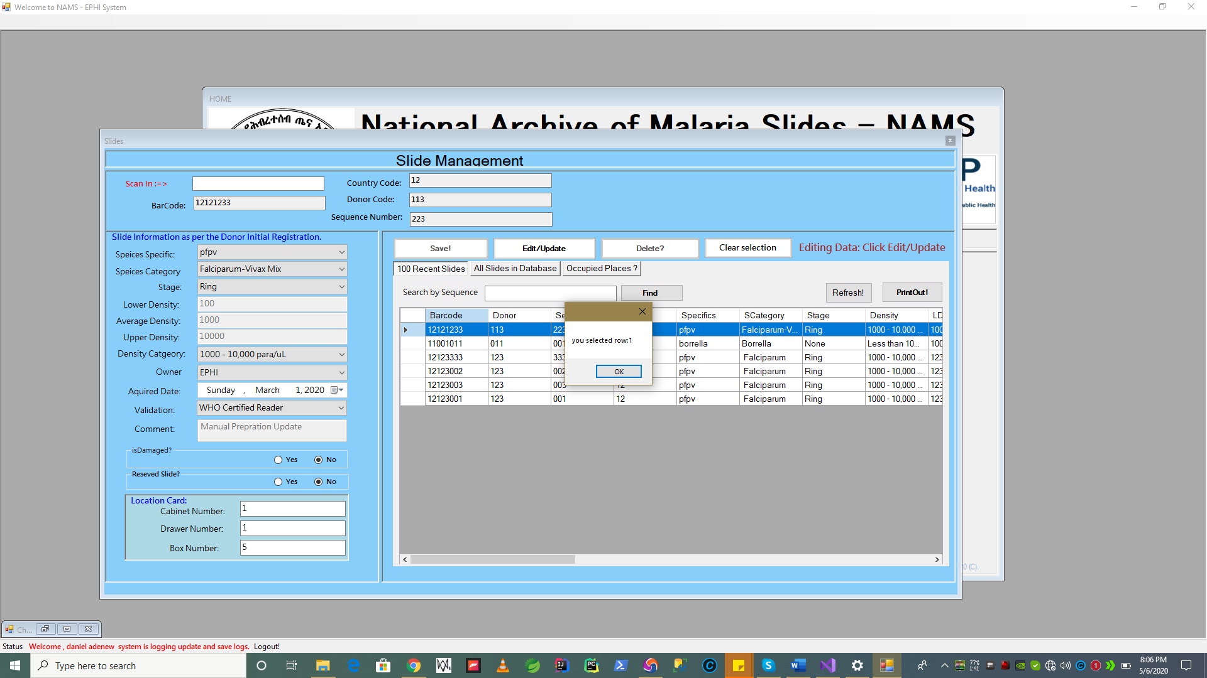

1. Now Edit some information after the selected slide is loaded on individual input data elements to the left.

In the following example Location Data (Box Number has been changed to **“6” from “5”**) and “**IsReserved”** data is selected to **“Yes”** by default all slides saved as not reserved.

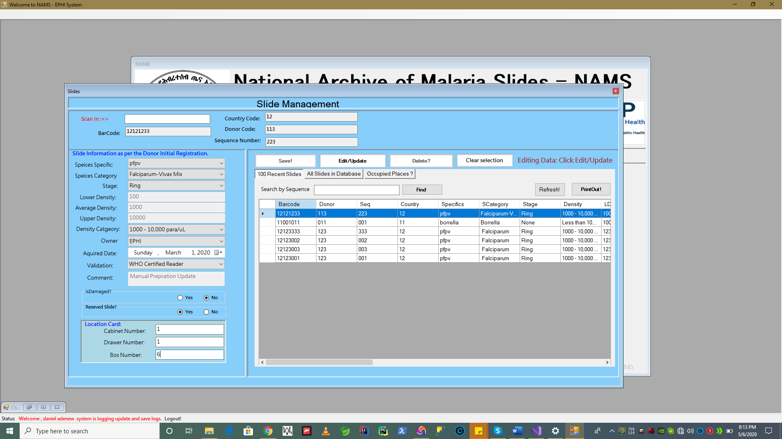

1. Press “**Edit/Update”** button, when you are done. Slide information is now **successfully** updated. System shows confirmation message.

**N.B if the location you choose during edit or save of slide information system will show “Error” message. In this case Drawer 6 is not occupied, slide location is changed.**

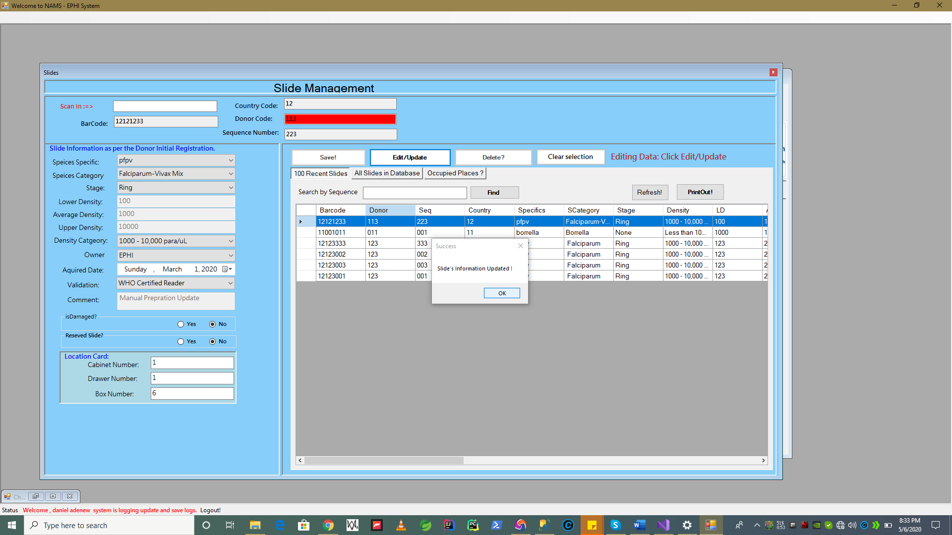

* **Recent slides information Views**

As show on screen below , by default slide form page show the recent 100 slides which are entered , order by their date as this one of the request by EPHI , during requirement gathering.

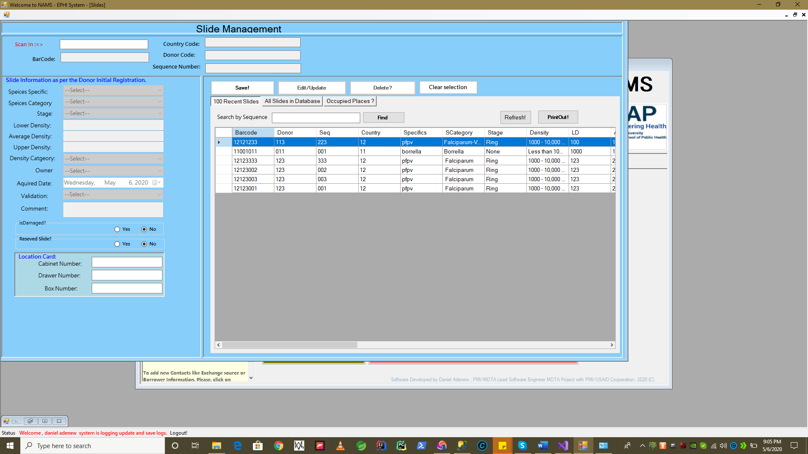

* **All Slides Information Views**

As show on screen below, to see all slides including the recent once and all in the slide database (**damaged, reserved, borrowed , exchange slides**….) we use the Tab button **“All slide in Database”** to list.

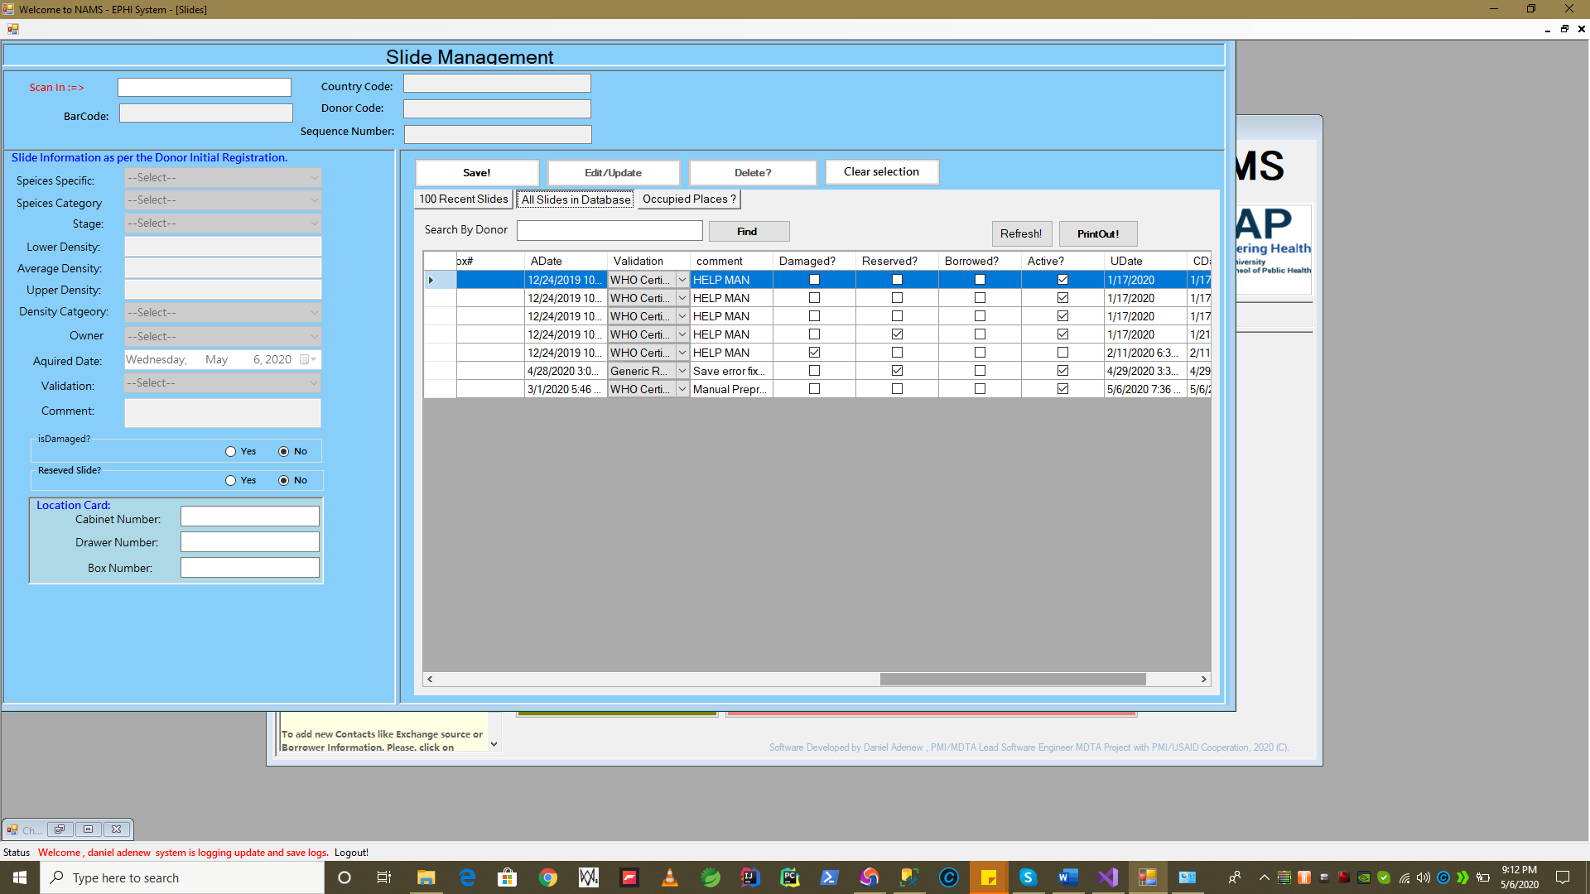

* + 1. Contacts Information

To work with contacts first, we need to start the contact management form application from the central menu as shown below.

* The purpose and use for contacts form is to capture personal and organizational details before borrowing slides, and during slide exchanges.

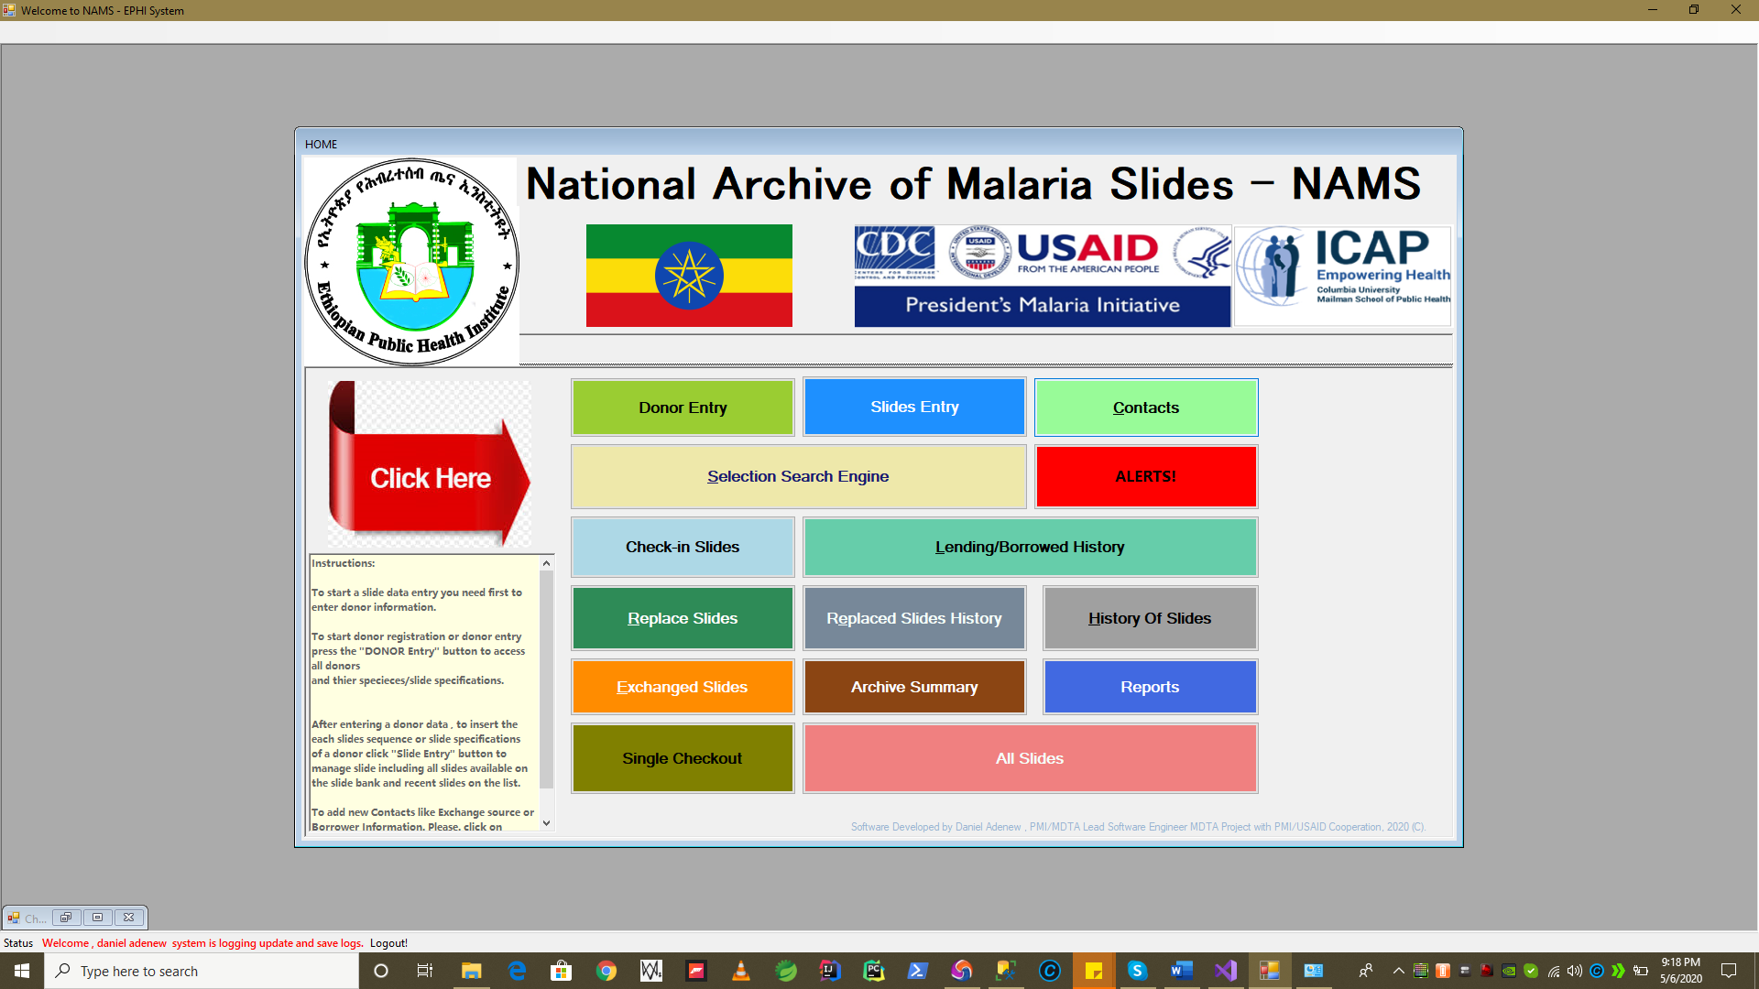

Click here

After click a - Contact Management form will open for data entry and management.

* **Adding /Editing and Deleting Contact**

To register a new contact

1. You have enter the personal and organization details on the left of the form , on the input data elements and boxes.

e.g Full Name , Organization , Phone Number …etc.

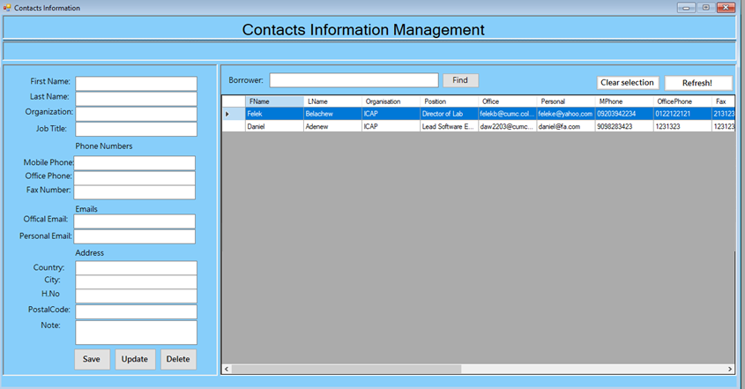

1. Press **“ Save”** button to save contact. While registering new contact, **“Edit/Update” and “Delete”** button/ operation are inactive to prevent invalid data operation.

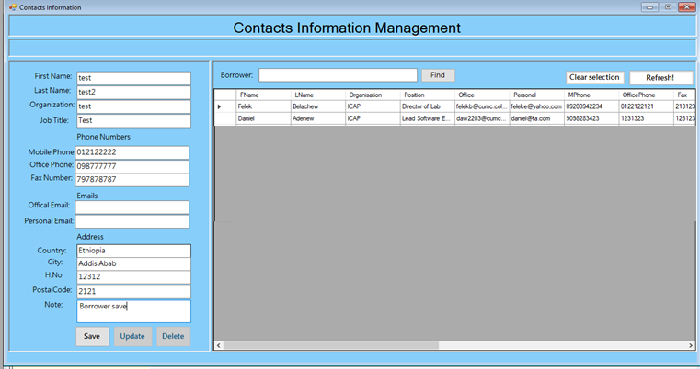

1. System issue **confirmation message** if save was correctly.

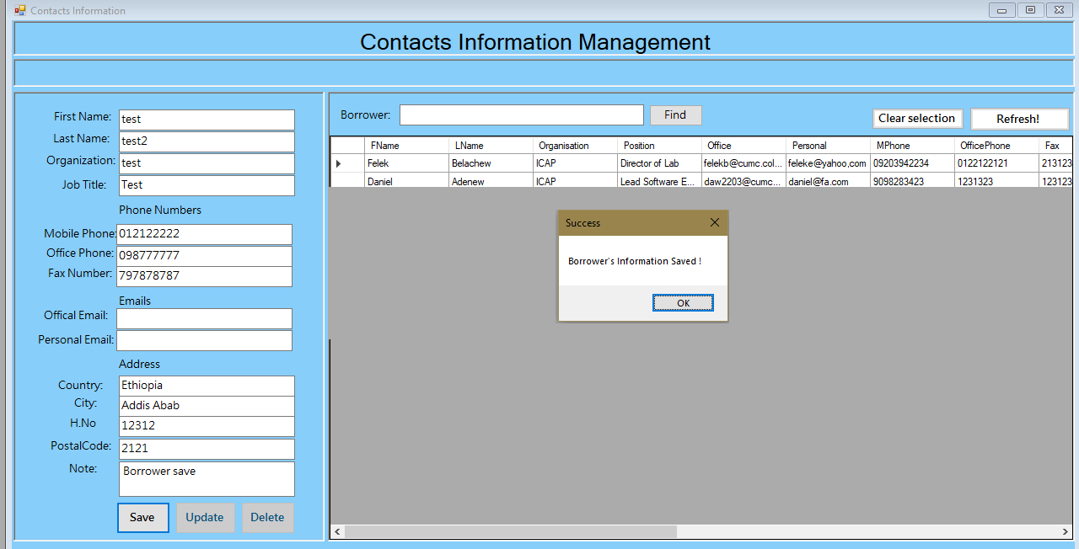

1. To **Edit /Update**/**Delete** Contacts Details if existing

First, select the record you would like to edit for the list

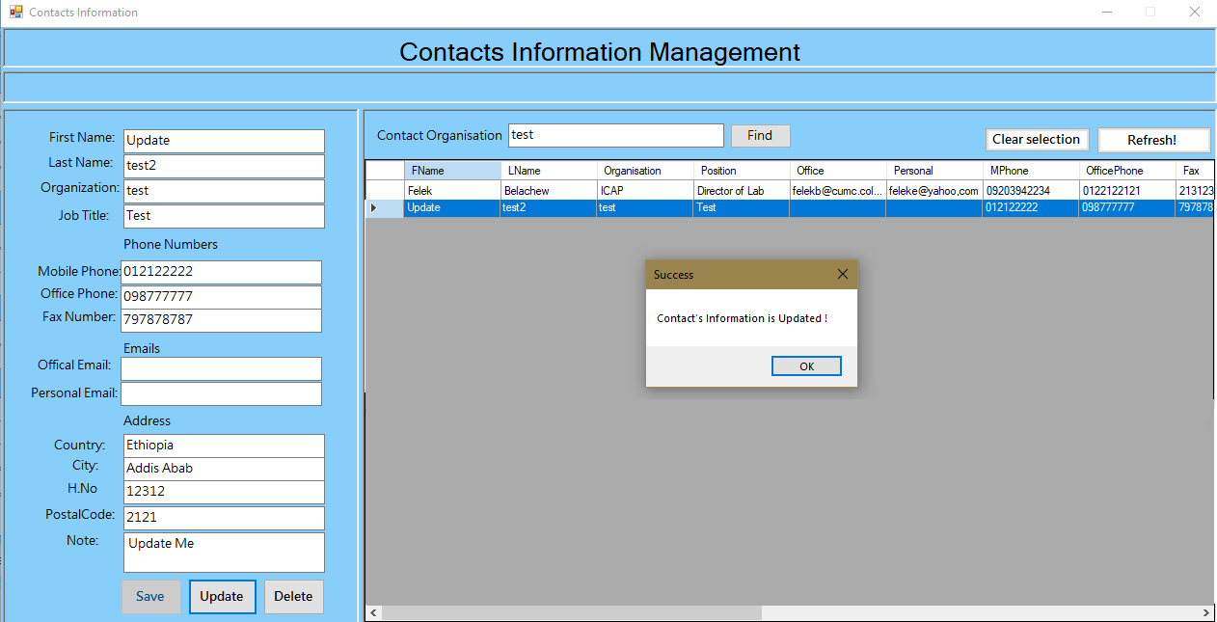

* To Delete a contact, first select a record from the data list on the right section of the Contact Management form as follows. And press **Delete** button

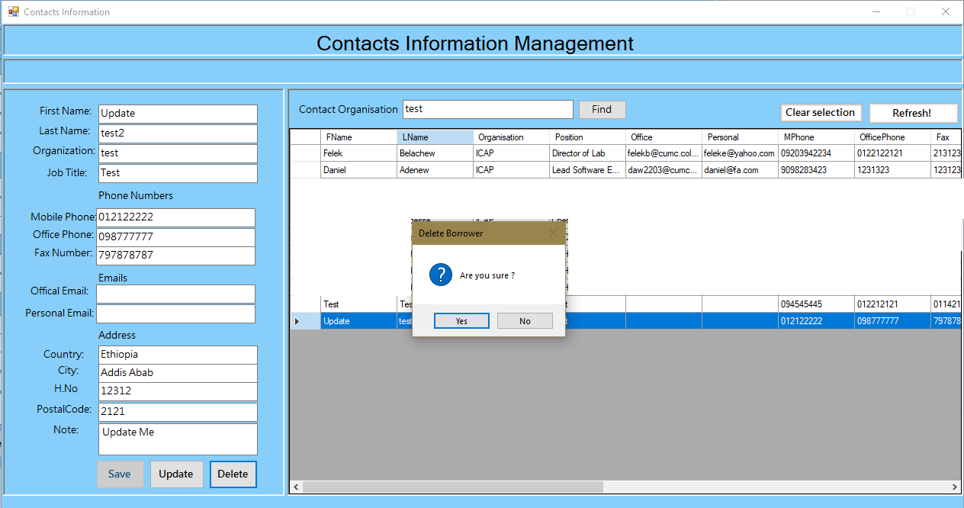

* System will show Yes/No Dialog to confirm deletion? If “Yes” Deletion of the record is confirmed. If “No” deletion will be canceled.
* After confirming deletion by pressing “Yes”. If there is not error found on the deletion process , system shows a deletion completed message box.

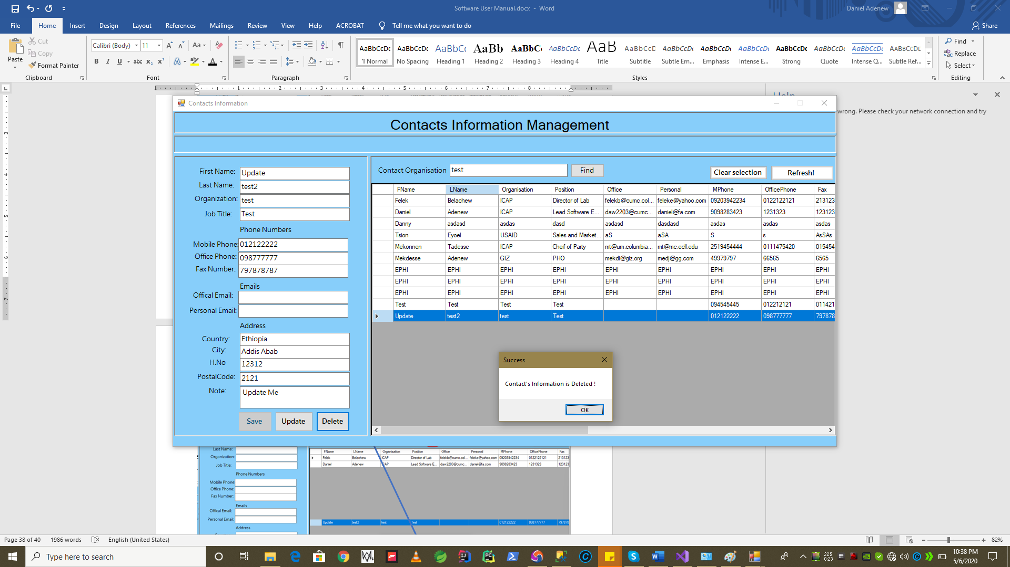

* **Now the Deleted record is vanished***– e.g test*record is vanished**.**

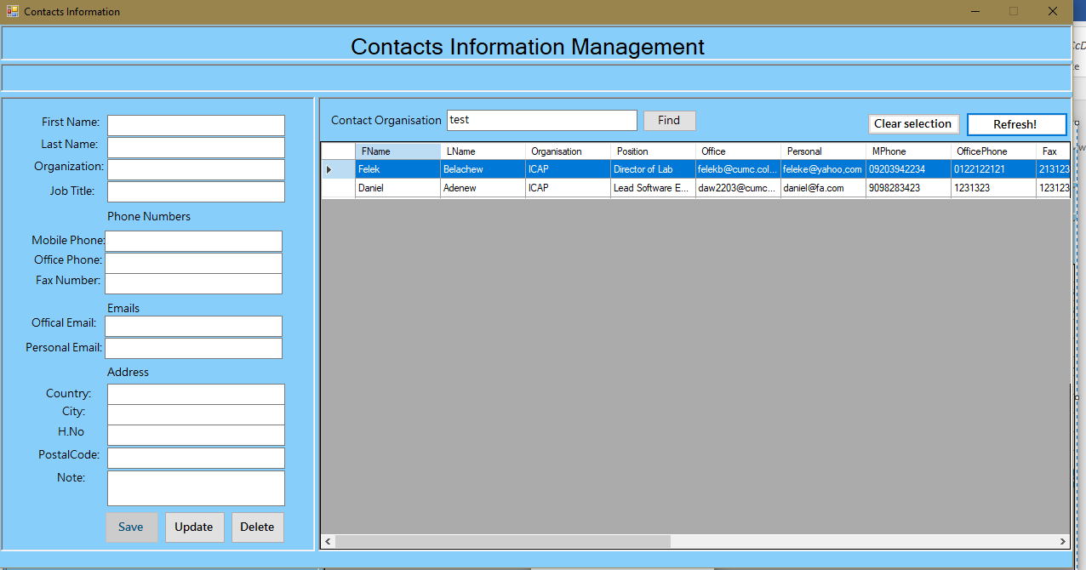

1. Searching contact by Organization name using search feature:

* Enter the name of the organisation on search box , and press “ Find” to start the search. System look the data and If match found it will **highlight** the **record** and show a **found message** or not found message.

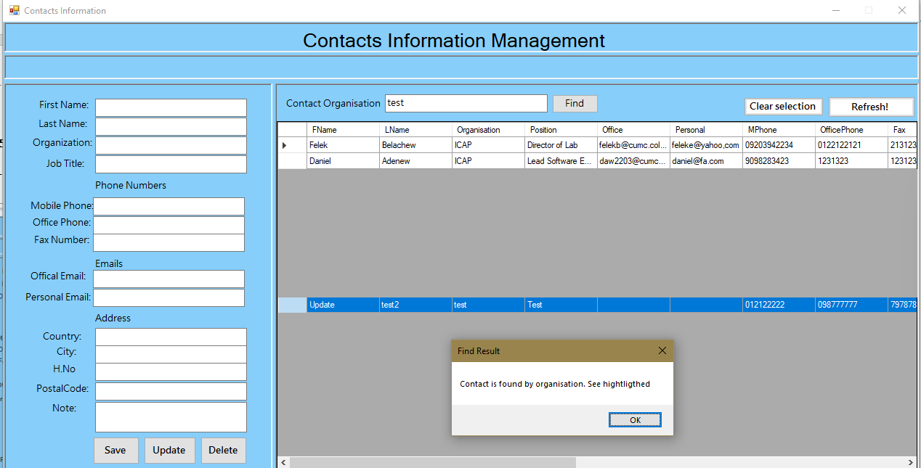

* + 1. Slide Selection Search Engine and Checkout/Lending Slides

**Requirements addressed Here:**

* + The ability to select slides per Specie Specifics *e.g pv ,pf , pvpf , po , bo …etc*
  + The ability to select sides in combination of many Specific Specifics together in one search
  + The ability to select slides in combination of Species Specifics, Density Category and Quantity required for each Specie Specifics
  + The ability to check out slides to Contacts/Borrowers/Exchange body once the search performed based on above abilities, and results found based on the given criteria’s

To start the Selection Search Engine operation, we need to select the “Selection Search Engine” button from the central menu as depicted in the diagram below.

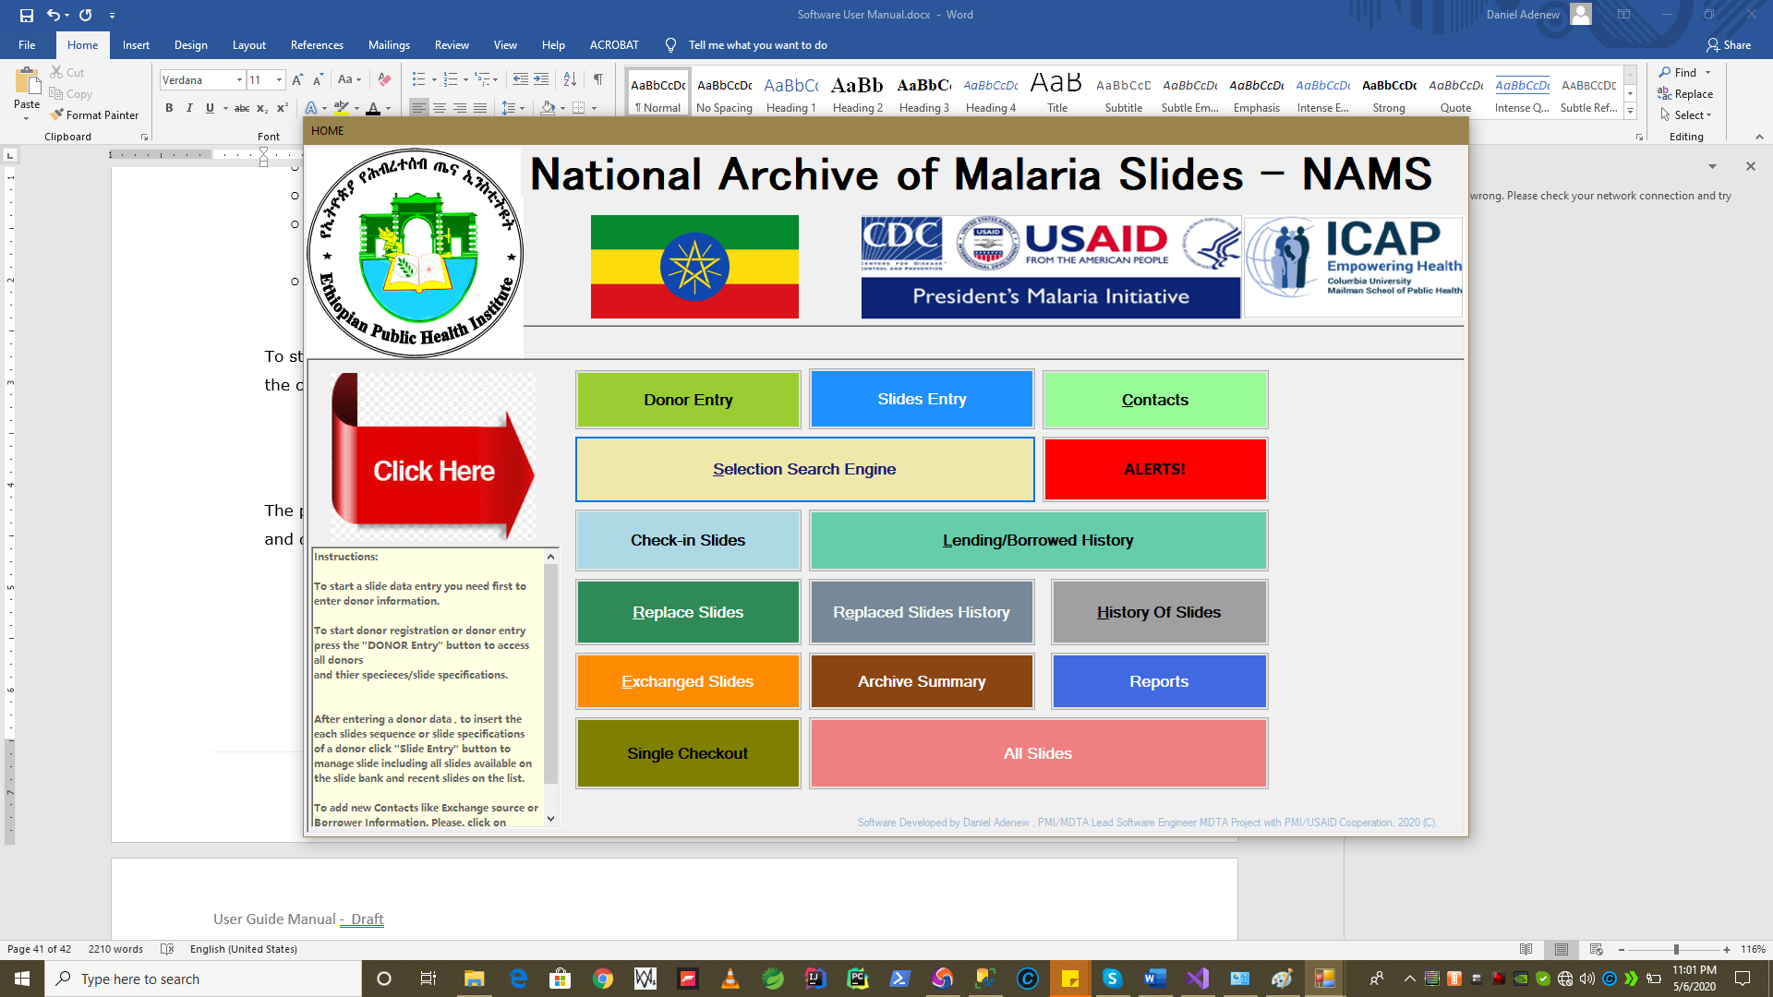

* After Opening the “**Selection Search Engine**” form you will be presented with the following window for mentiond operations above. Let see them one by one.
* Slide Selection Crieterias per Specice/Parasite Type: (***Pf,Pv,PfPv,Po,Pm,Others(popm,pmpo),Borrella,Negative***) Slides
* Density Catgeories repersent ***Low Density, Medium Density and High Density*** selections
* Qunaity represents – ***How much quantity for Pf with LD or MD or HD*** ? and for all other parasiste types. Each quanity of slide will be searched based on the *Parasite/Specice Type , Density Type and Quanity.*

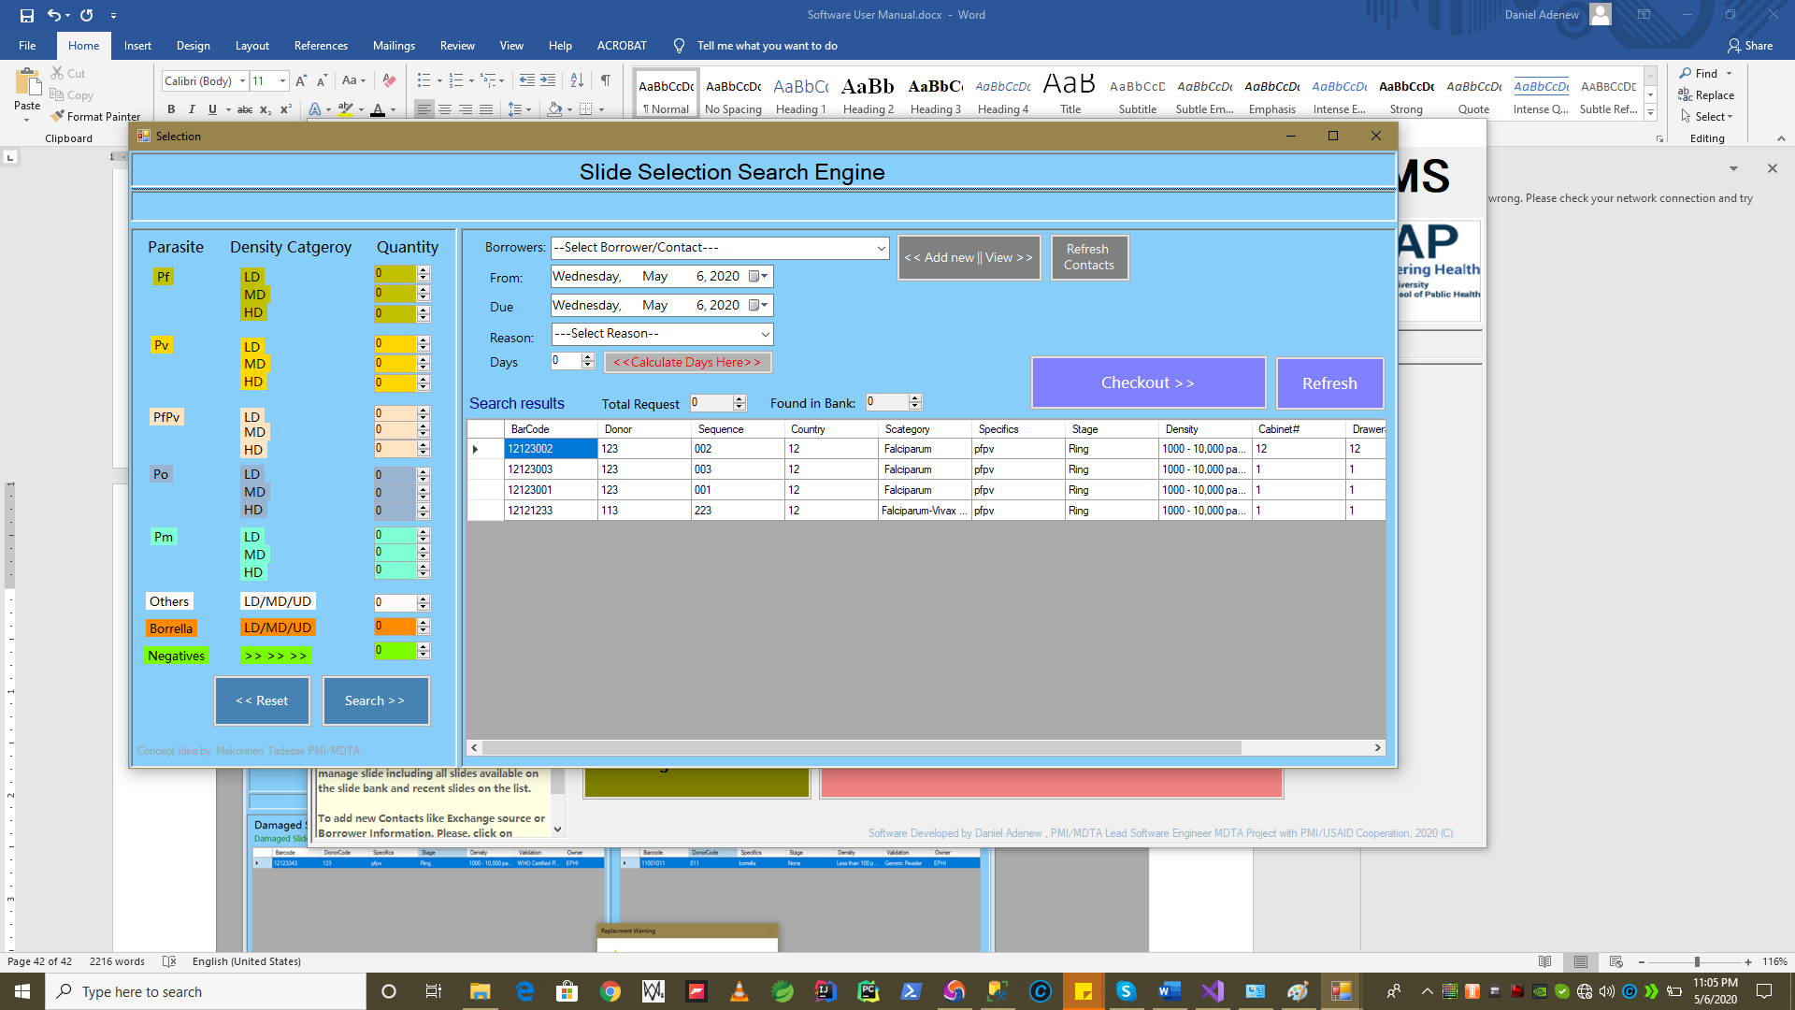

* **Searching for Slides based on Criteria**

**N.B** By Default on right side of the form, the list show only those that are available from the total slides. These records selected based on status with **No Damage**d , **Not Reserved** and **Not Borrowed** status currently active for borrow/exchange in the archive database.

* This is for demonstation purpose only. Actual EPHI Slide database could hold 40,000 or 100,000 of slides.



* **Searching for Slides based on Criteria Continued**

To perform search user has to enter , non zero (0) values on any of the quanitity input box and start search as follows.

**Example 1:**

*User might search* ***(1)******Hight Density (HD****) value* ***PfPv*** *Slide as shown below and press search.*

**Result***: System will look the entire database data for the search criteria and will display found result as follows if found.*

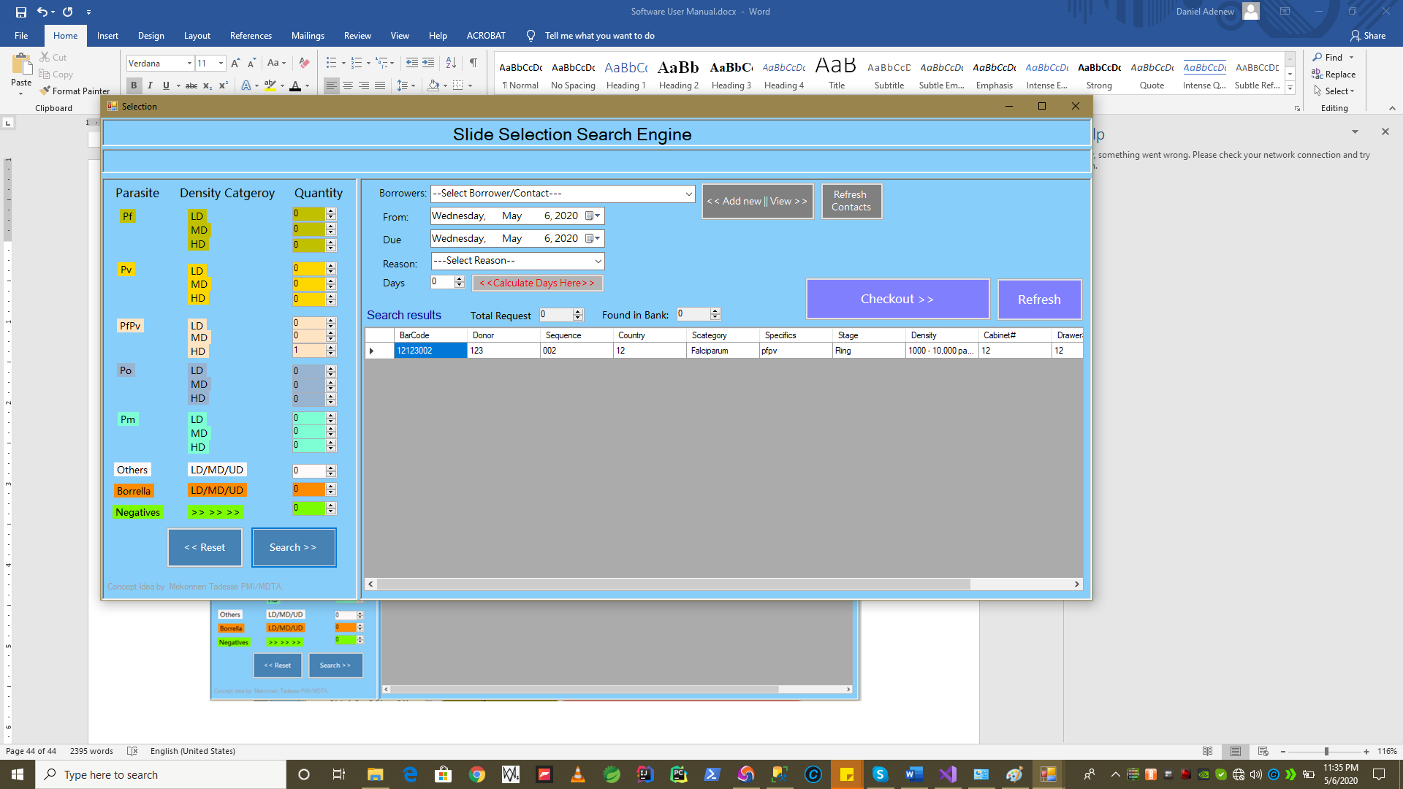

* **Searching for Slides based on Criteria Continued**

To perform search user has to enter , non zero (0) values on any of the quanitity input box and start search as follows.

**Example 2:**

*A combined result of* ***Quanity******(2)******Hight Density (HD****) value* ***PfPv*** *Slide as shown below and press search and Borrella Specicice with quanity 1 or more.*

*i.e the query looks:*

*PfPv , quanity =2 , Density=HD*

***Union***

*Borrela , Quanity=1+ ,Density=HD/MD/LD (any)*

**Result***: System will look the entire database data for the search criteria and should display the found result as follows.*

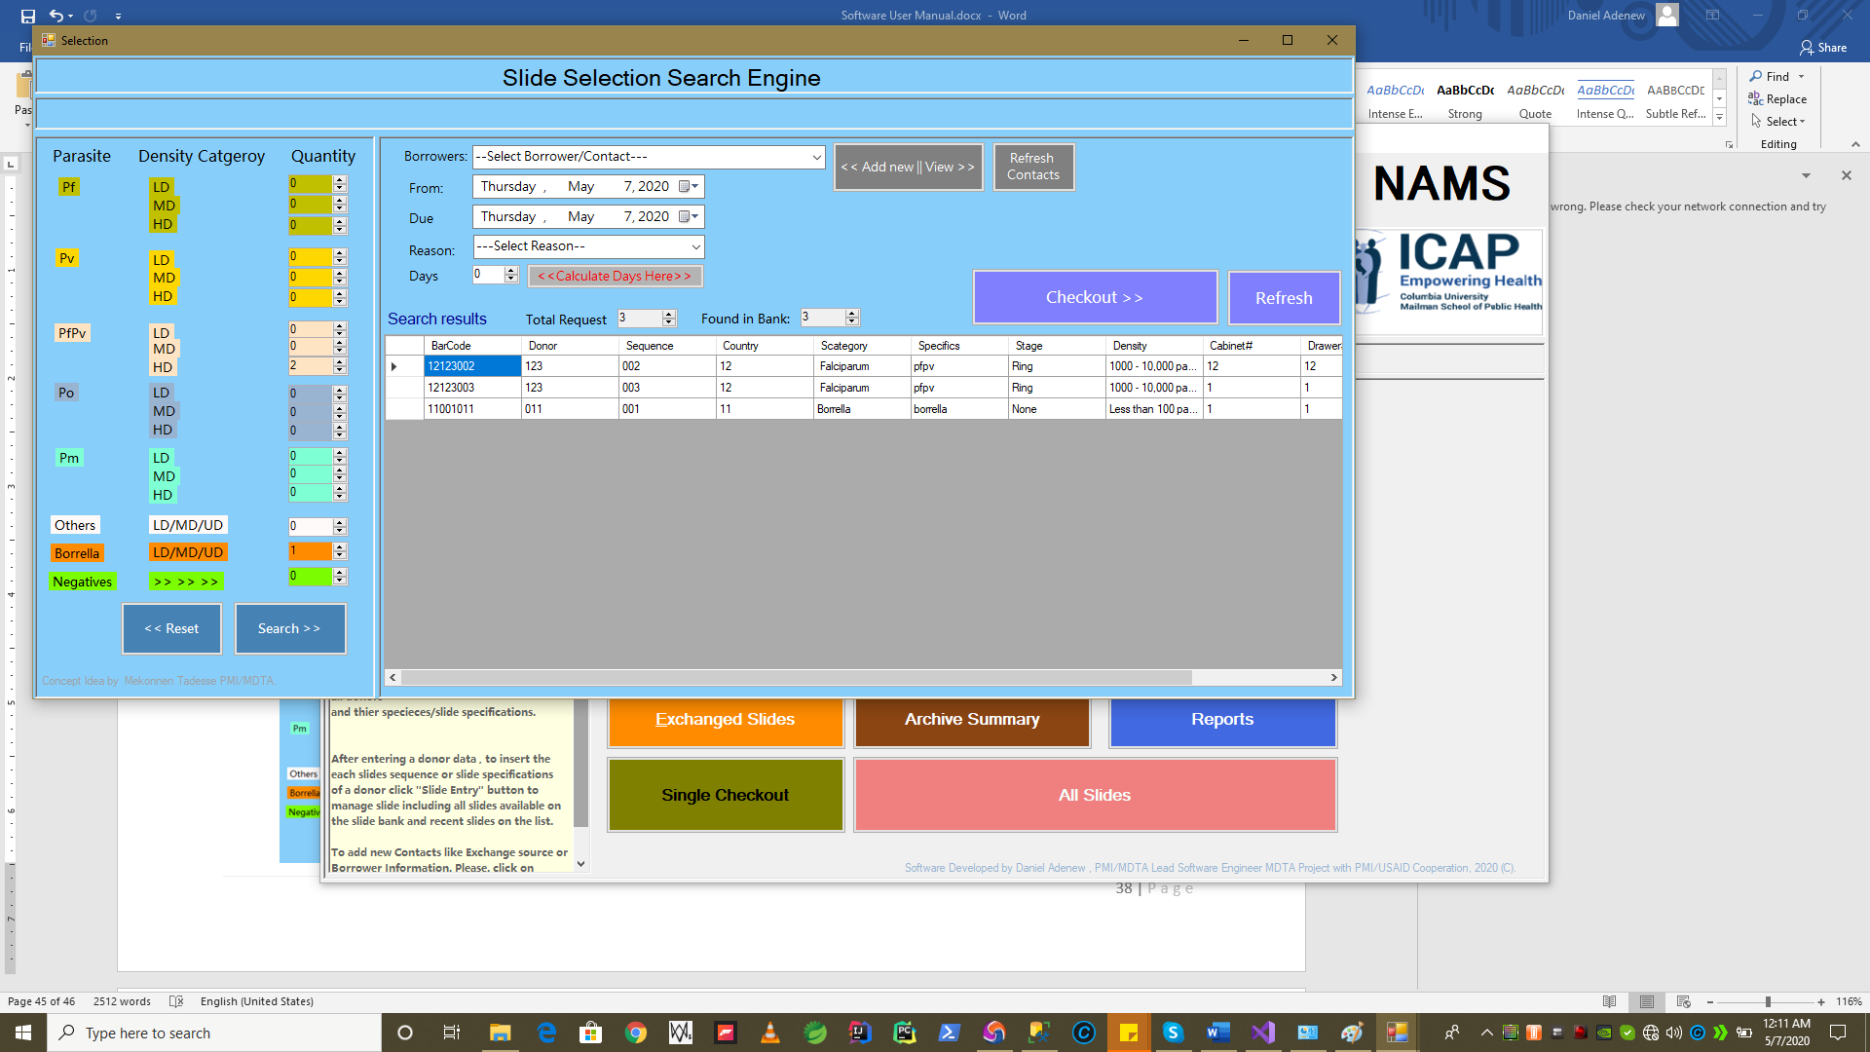

* **Searching for Slides based on Criteria Continued**

Searching all qunantities values as default(0) will return any record.

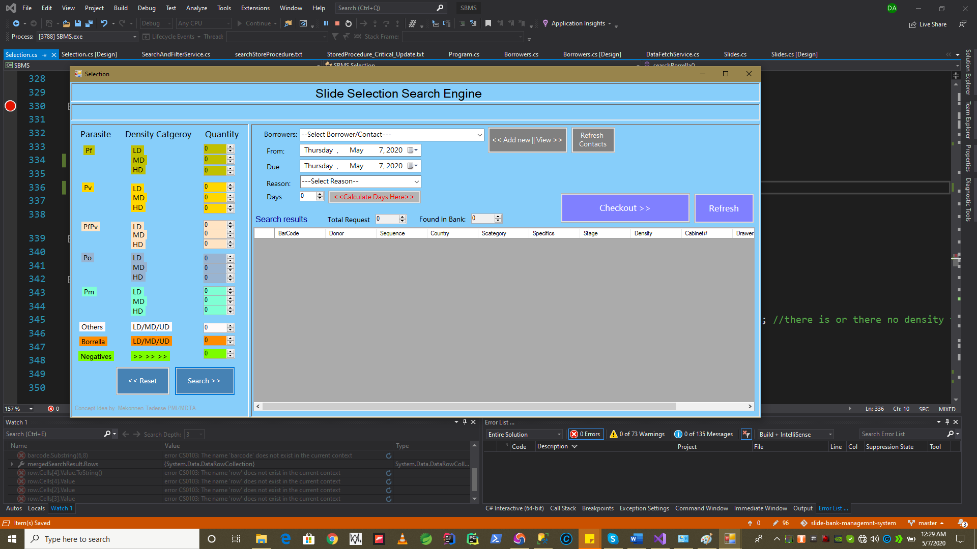

To perform a new search after one search by changing criteria. You need to clear the former search result by pressing **“Reset”** button. See below for samples. The search will return to its default initial values.

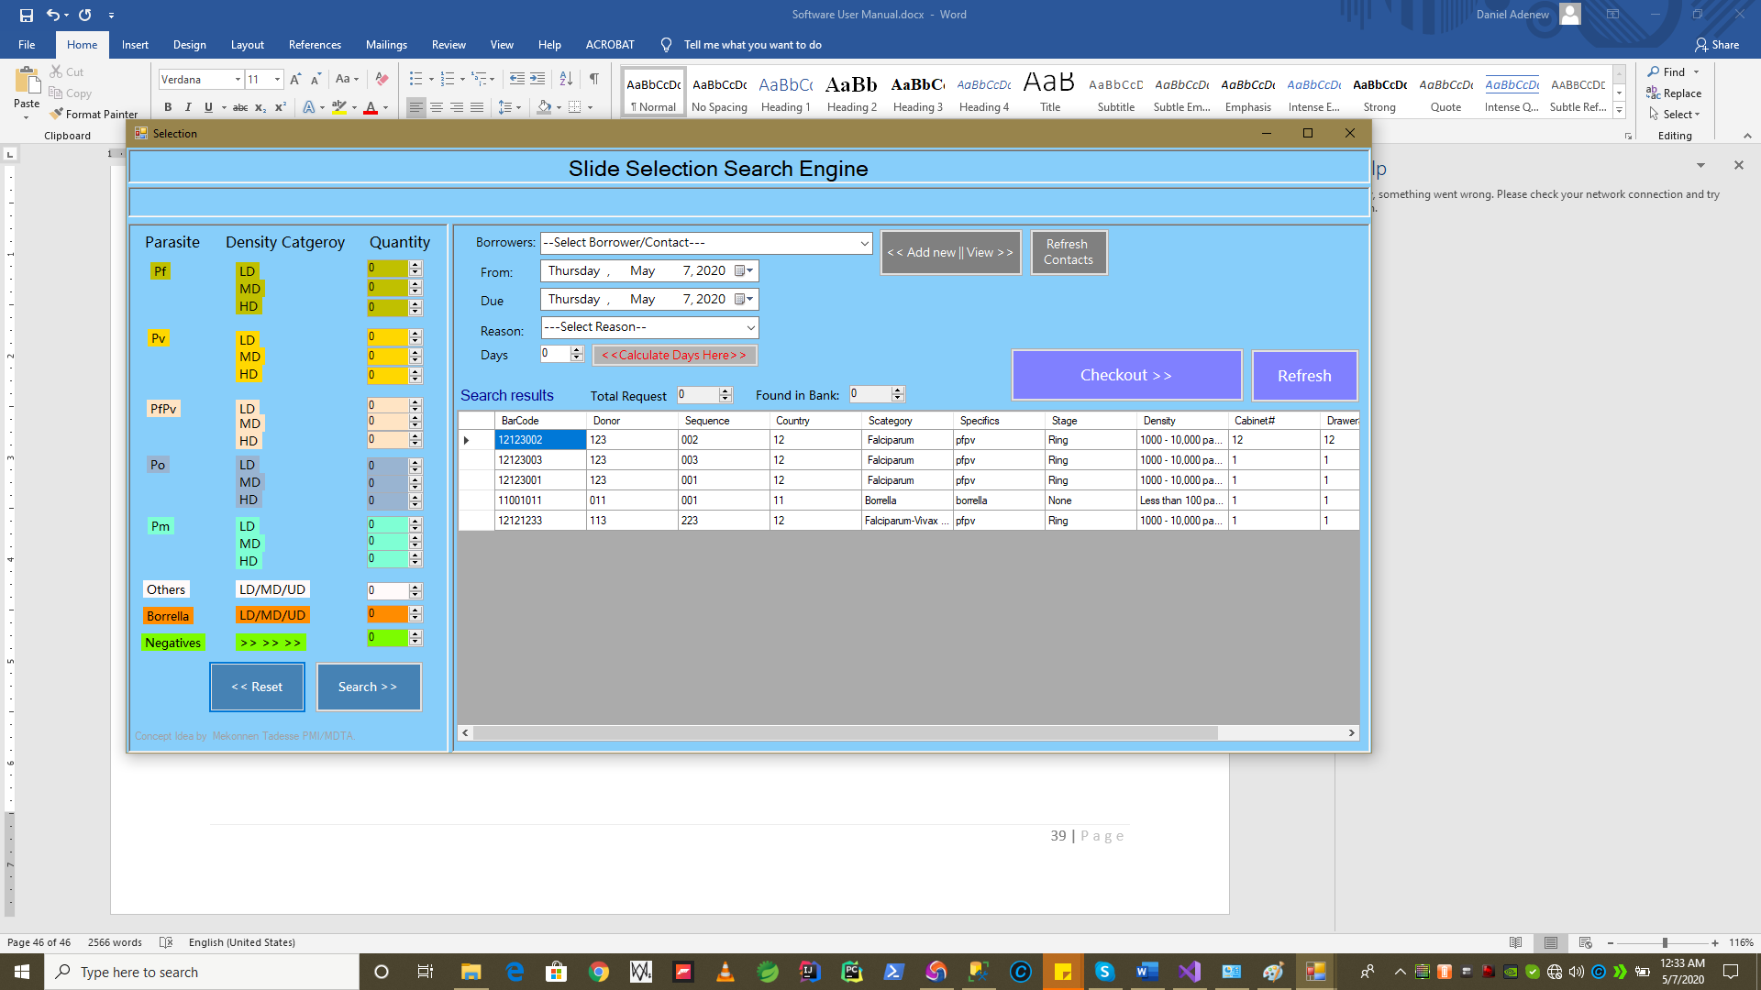

* **Checking Out Search Results –**

After doing a slide search based on the criteria examples shown above. The next operation we can perfrom on “**Slide Selection Search Engine**” form is to checkout slides for given borrower.

In the next sections we will see step by step guide how it is done.

1. First, assume we had a search e.g Pfvp HD 1
2. When search returned a result, and assume we are okay to checkout the slides in the search result
3. We select Contact/Borrower from following Drop Down list 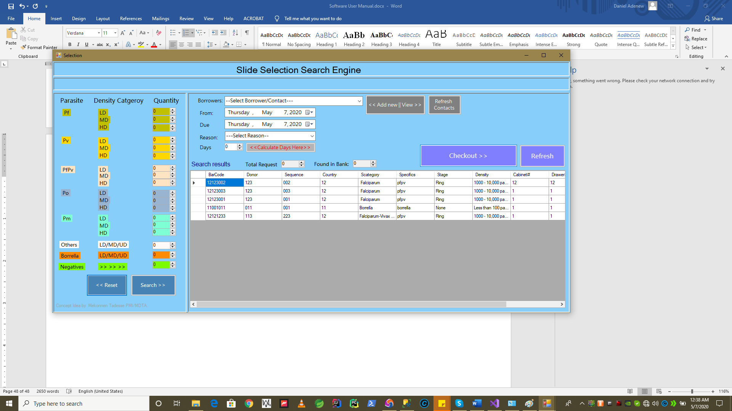

Type the name of the organization or the person to search contacts on dropdown box show below.

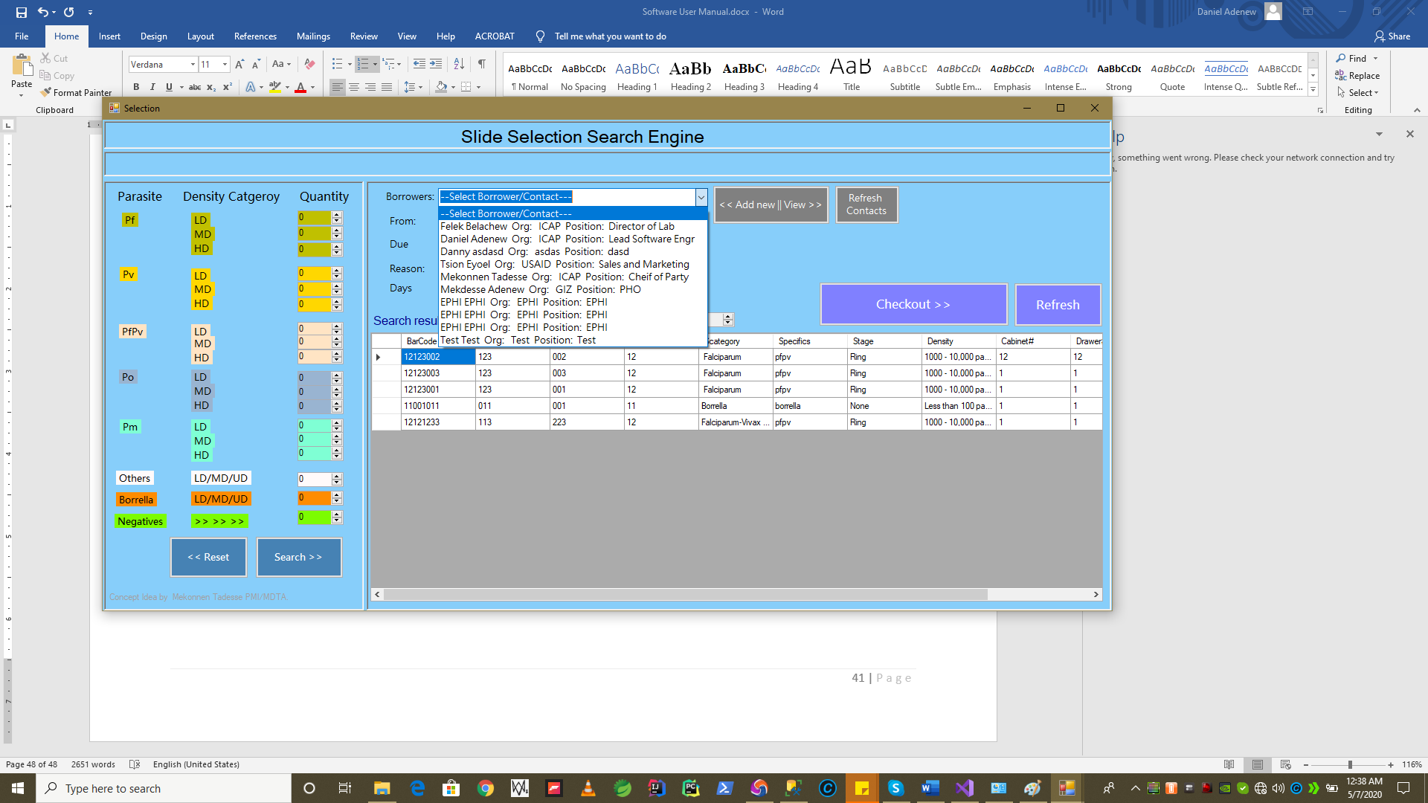

1. Select Contact
2. If you did not find the **Contact**, you can always **Add new on the fly** by pressing  **button** , and a Contact Form popups up for new registration as follows
3. Now you can add the contact details and press save. Please **refer 1.1.4** of this document for step by step **contact registration** process.

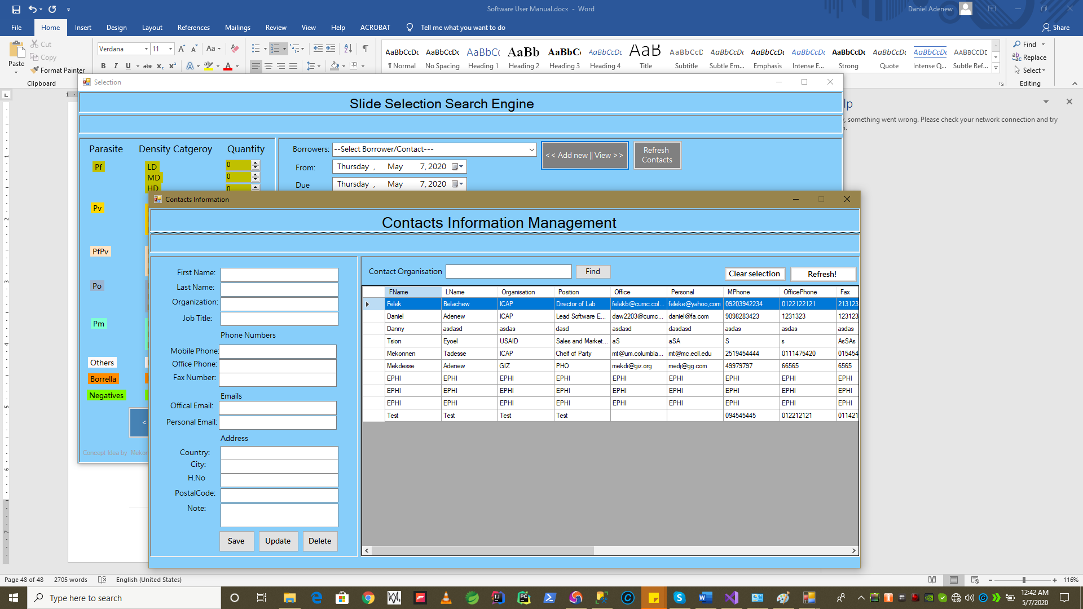

1. Now select **From** and **ToDate** using the **DateTime Picke**r to specify checkout and due dates, respectively.

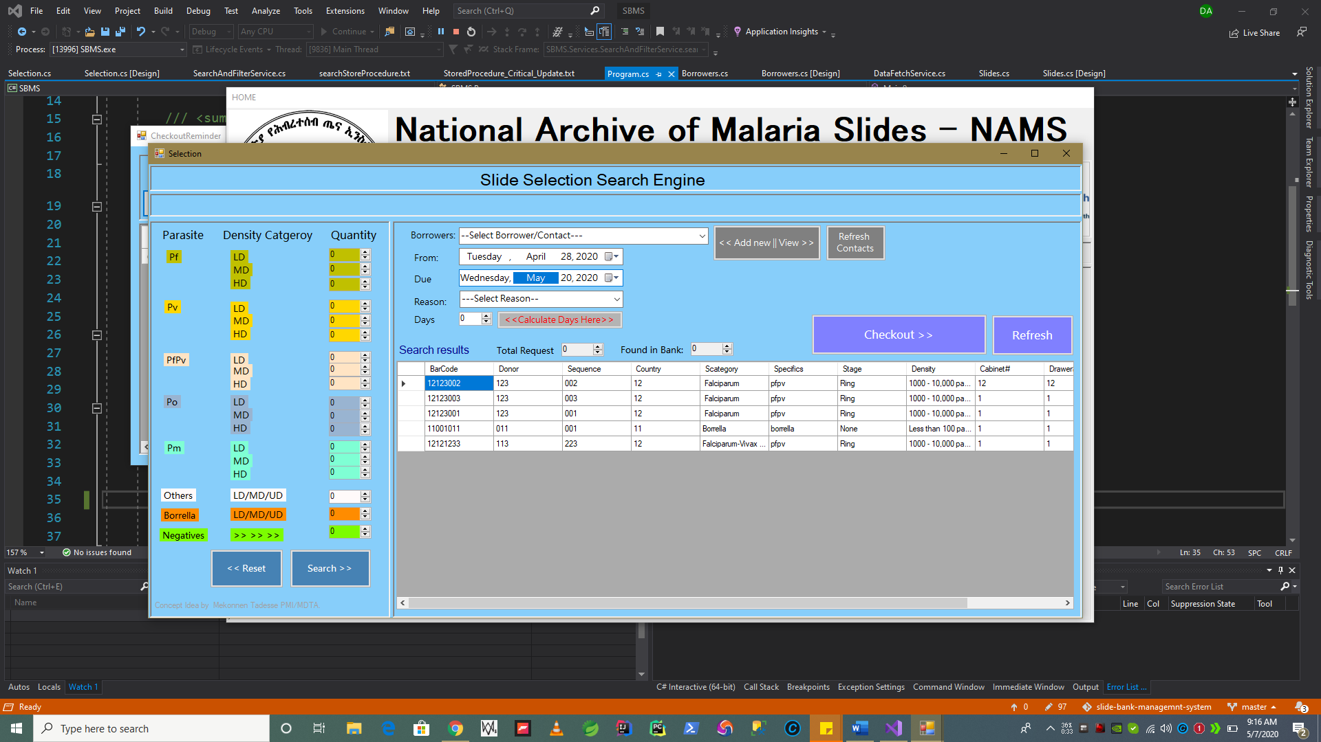

1. After entering a Valid Dates. Press “**Calculate Days**” button to compute how many days you would like to borrow.

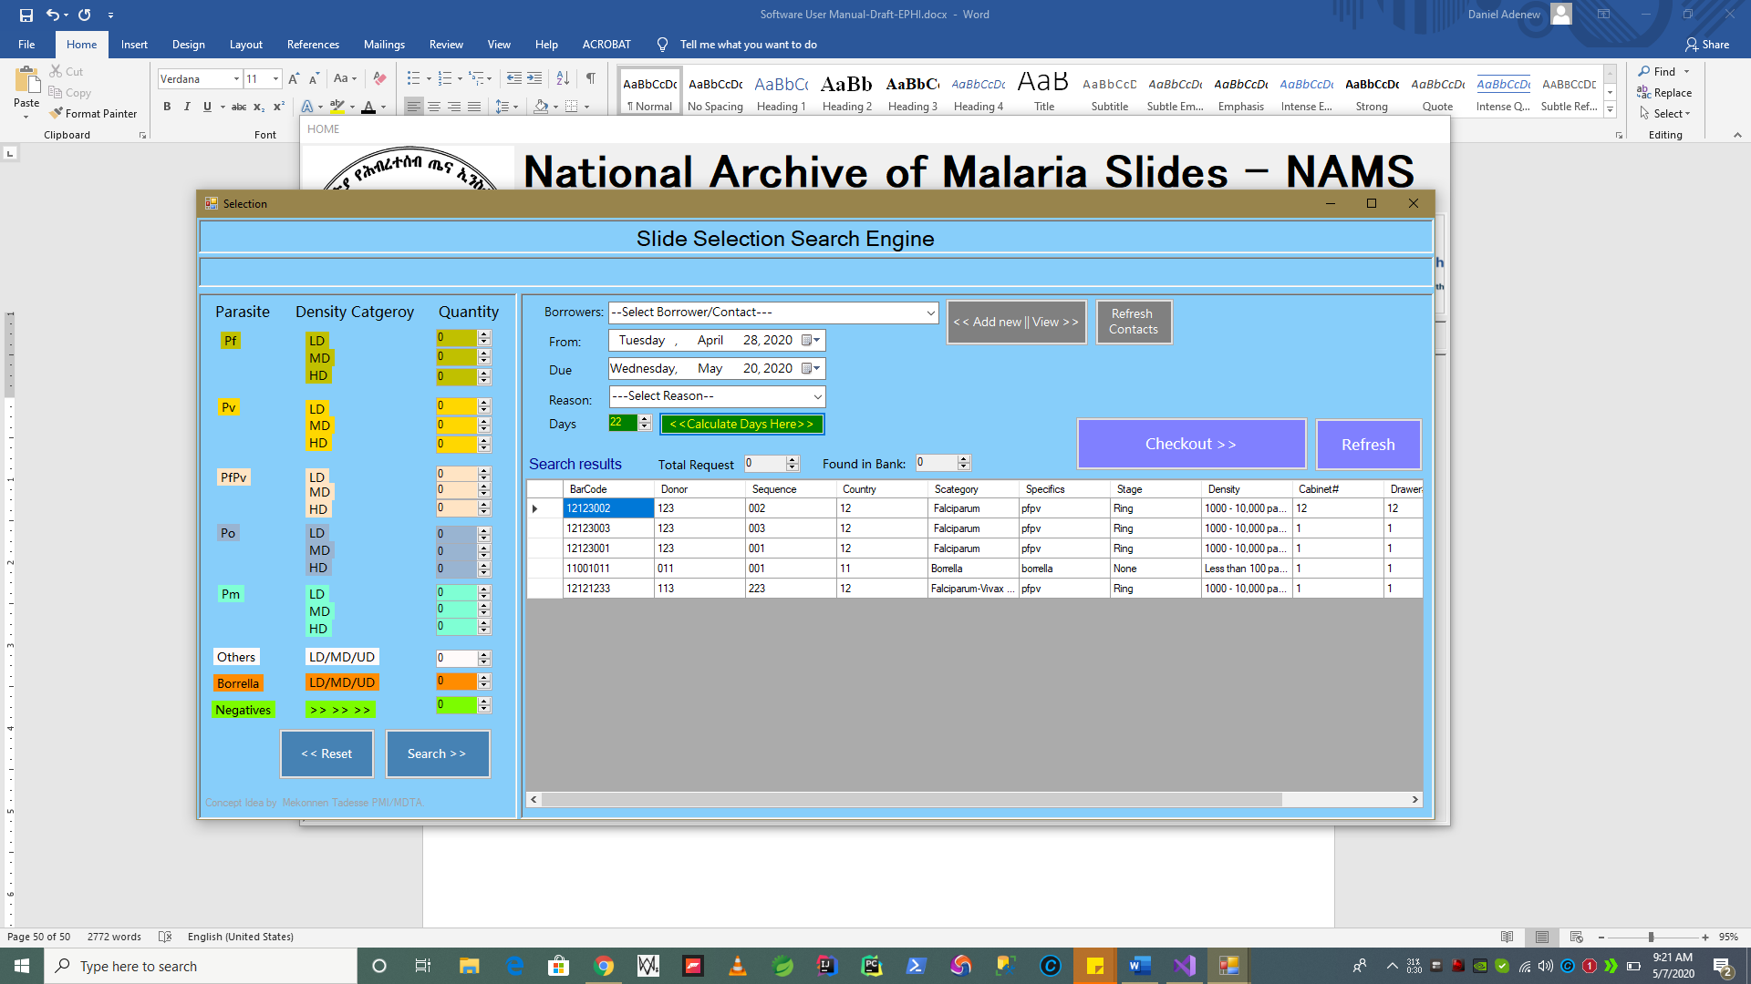

Notice that if the value is positive ,”**Calculate Days**” button will be colored in Green. If Dates are not valid , resulting **(-ve/0 zero**) days computed, **“Calculate Days Here**” button will be colored in red to show this error.

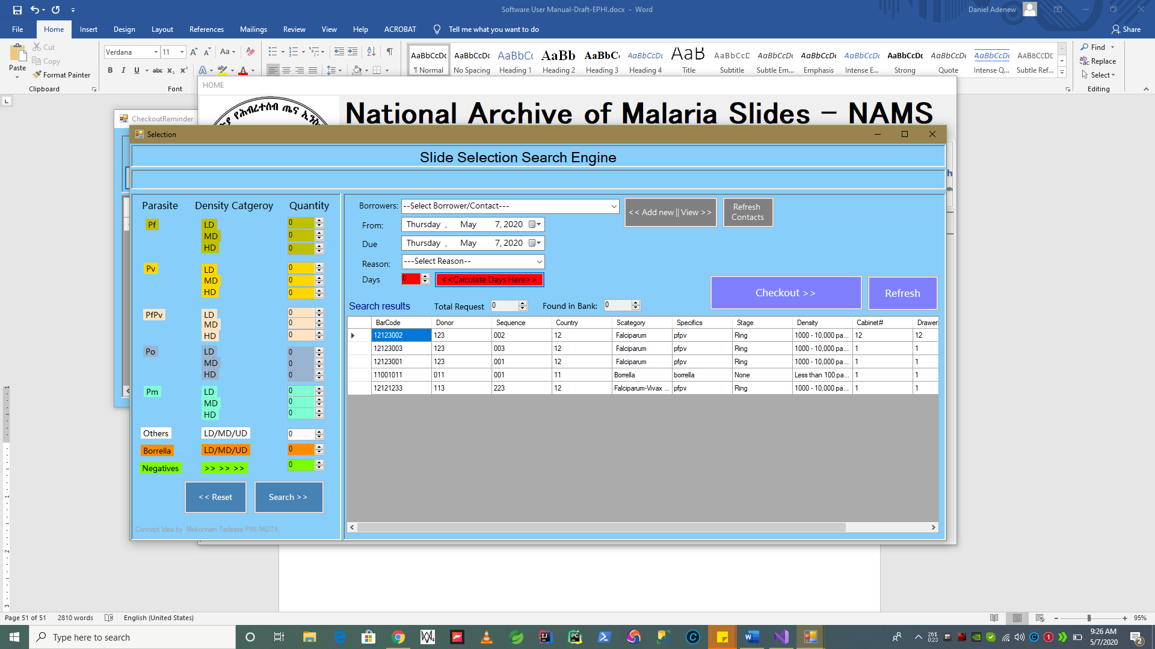

1. The next step to do once we have green light after computing “*Days*” as shown above on step 8 correctly. We might need to select the type of checkout we want to happen using the **Reason** Drop Down List options to indicate this.

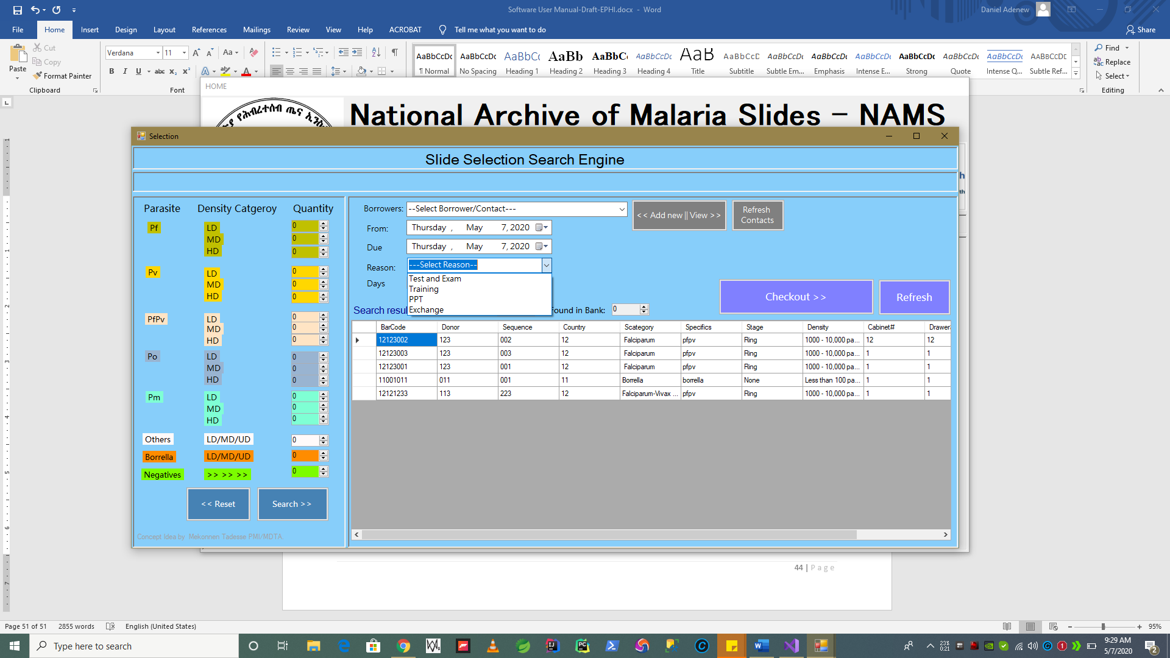

* **Reason / Checkout Types after Slide Selection Search**

**Requirement Addressed:**

Reason for Checkout Can be for the following Type as per requirements gathering.

* + 1. ***For Testing or Exam Borrower***
    2. ***Training***
    3. ***PPT***
    4. ***Exchange***

**Option 1 – 3** are almost the same. They use a borrower contacts and they are expected to return back the slides at some point of time, as per the due date.

**When Option 4(Exchange)** is selected. *~~We have special condition. See Section Below dedicated to Exchanges] -~~*

* We skip to apply From and Due Date. i.e. Slides who are checked out for (indefinite) time as Exchange will not be returned back to the slide archive in a normal Check-in/Checkout Circulations. There is a section about Exchange below if you would like to learn more about Exchanging Donor/Slides, Viewing Exchanged Slides.

For this part lets focus on use of **option 1-3.**

* **Completing Checkout Operations for Test, Exam, Training options**
  1. First as shown above on Selection search engine section of this document. After performing the search select the Reason to indicate the type of checkout.

*i.e. slides with* ***Reason*** *listed below are called* ***– None Exchange Checkouts*** *(Slide are expected to be checked in later on) where us for* ***Exchange Checkouts with Reason Exchange*** *are not.*

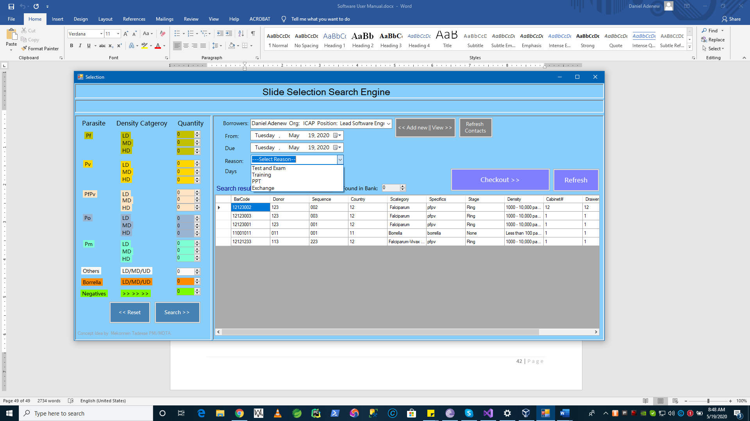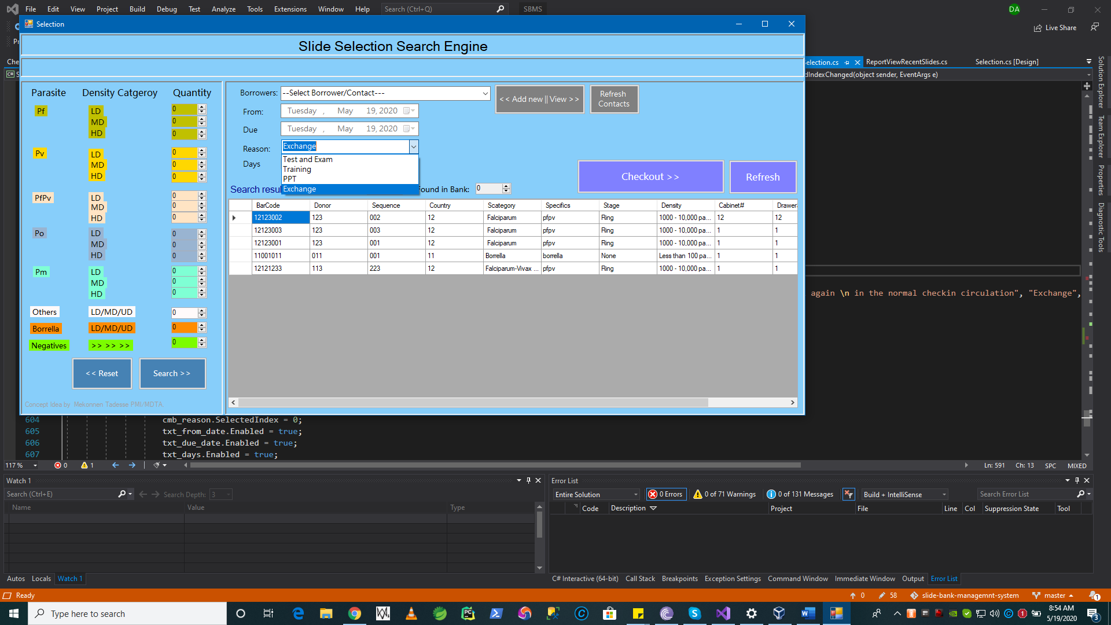

* 1. Before completing the checkout, system validates for all the inputs are correctly set.
     1. Checks if you have selected a contact/borrower
     2. From Date
     3. To Date – (***system will only accept future dates, if days computed using*** *From* ***and*** *To* ***are -ve***) that will be validation error. See below
     4. Reason
     5. Days by pressing Calculate date

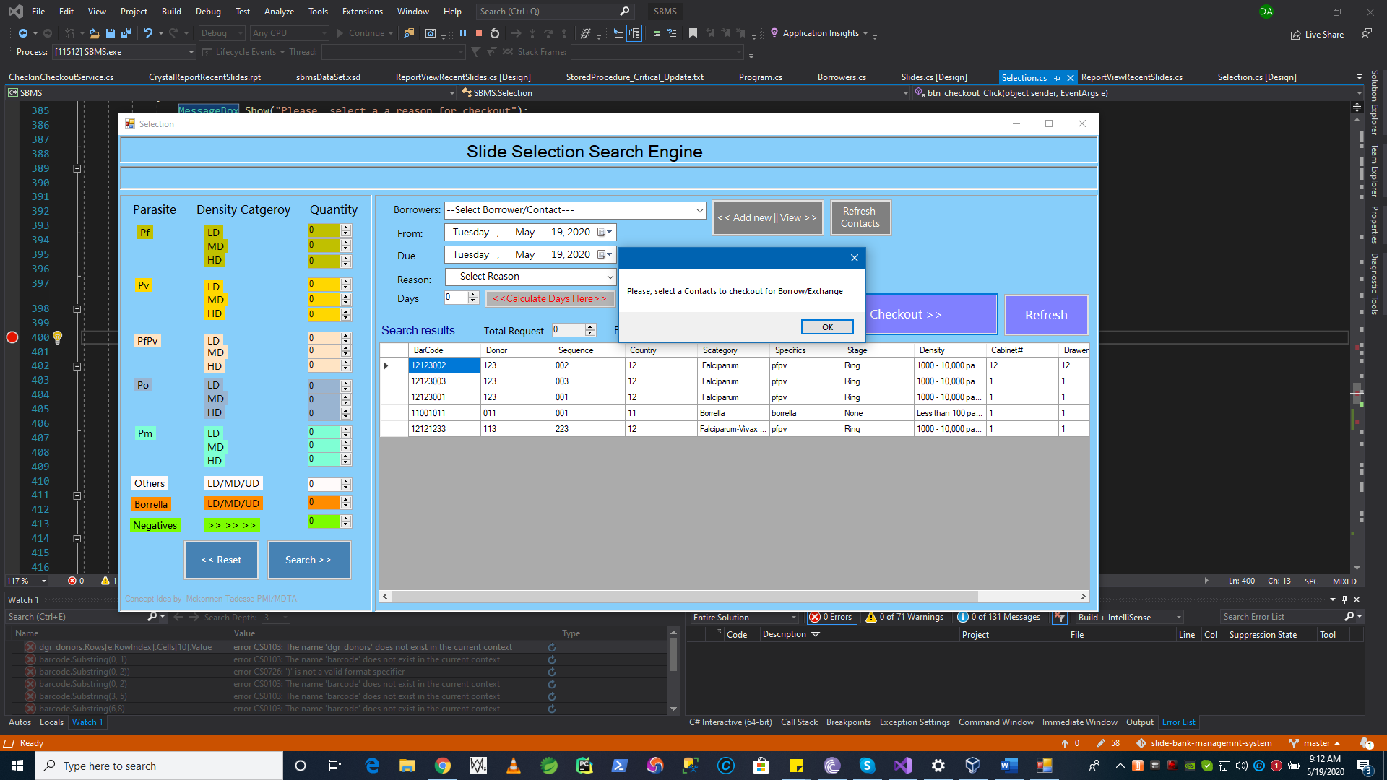

**Validating Checkout Reason:**

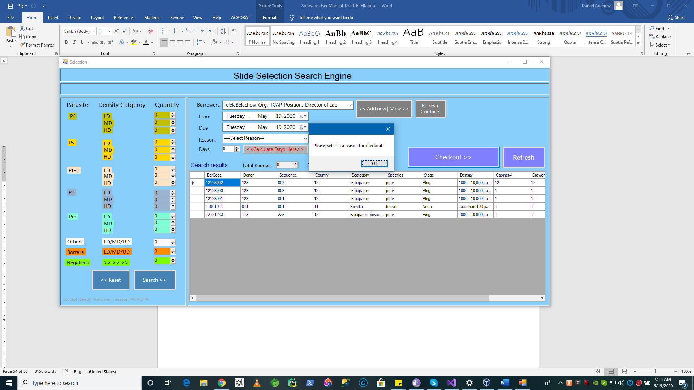

Validating ***From and To Date*** , can be calculated by pressing calculate days button. If you day calculated is equal or less than zero **(-ve)** value the button shows **error** by turning into red.

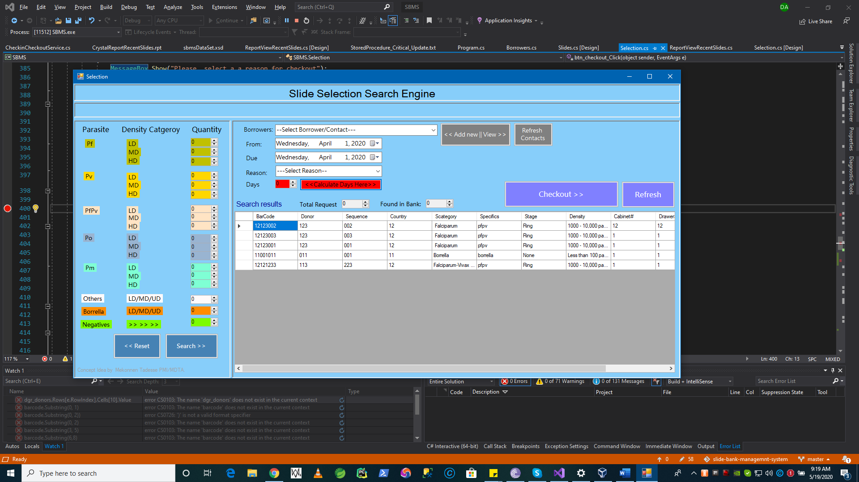

If all validations are corrected after the validation messages shown above and/or inputs are field correctly as shown below.

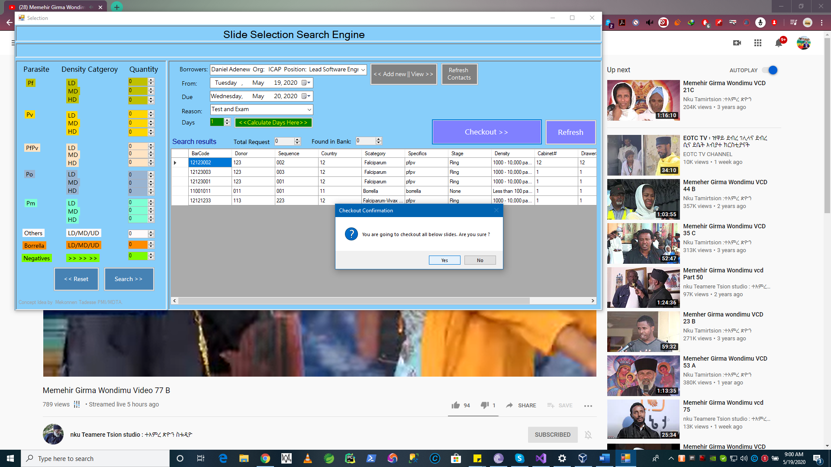

***Congrants****! if you come to this step correctly a complete checkout will happen and system report will be generated for your print out. See below.*

E.g. *checking out PfPv slide with HD and quantity 1. After a performed search we found 1 result returned and checkout out as shown in the example below.*

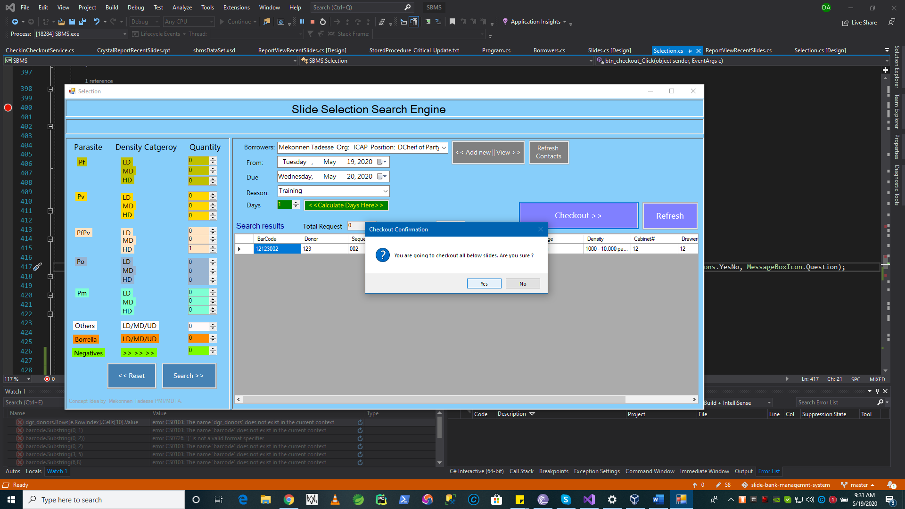

Press “**Yes**” if you would like to continue checking out.

Press “**No**” to cancel checking out.

* **System will show success for the searched and selected slides checkout as follows.**

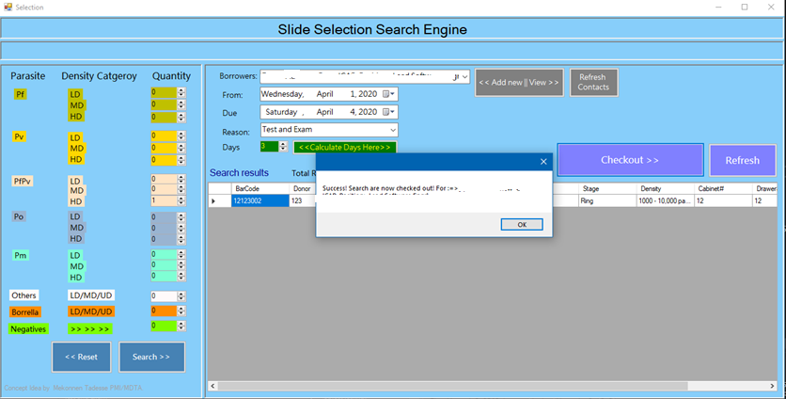

Press **Okay** to anyways and wait a little, a **printout** will be opened automatically on the screen as show below.

In below example we have showed that checking out a **single slide.**

**Print the report as you prefer or save it using the tool bar. **

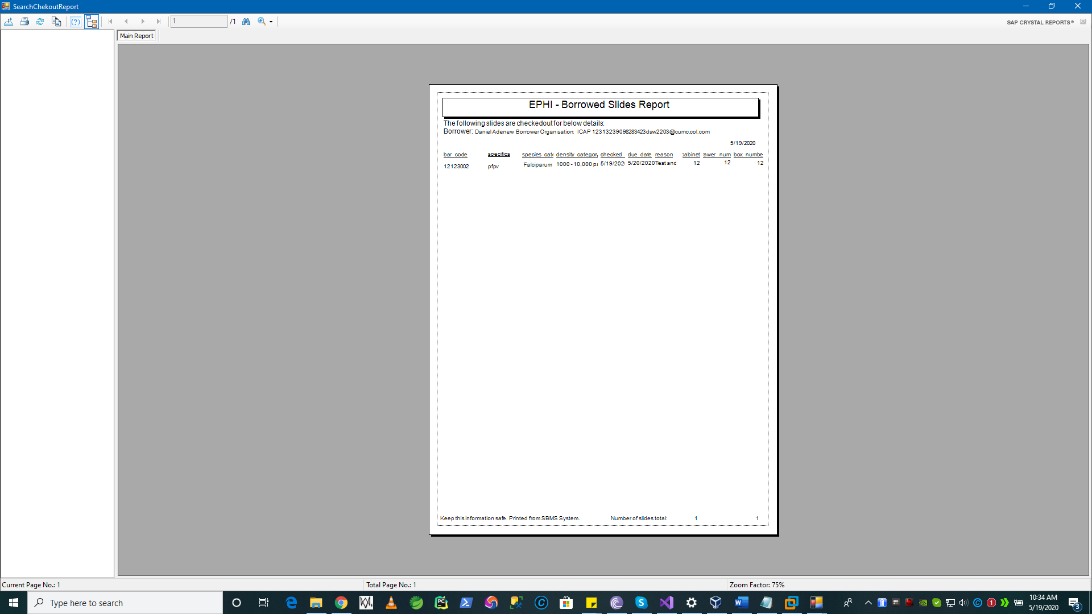

* **Let see the report in next window**



**N.B [**Non-Exchange Slide Selection and checkout process is completed].

To confirm that you checked out slide is **Correctly** checked out. Go to Main menu and press

“**Check-in Slides Button**”.

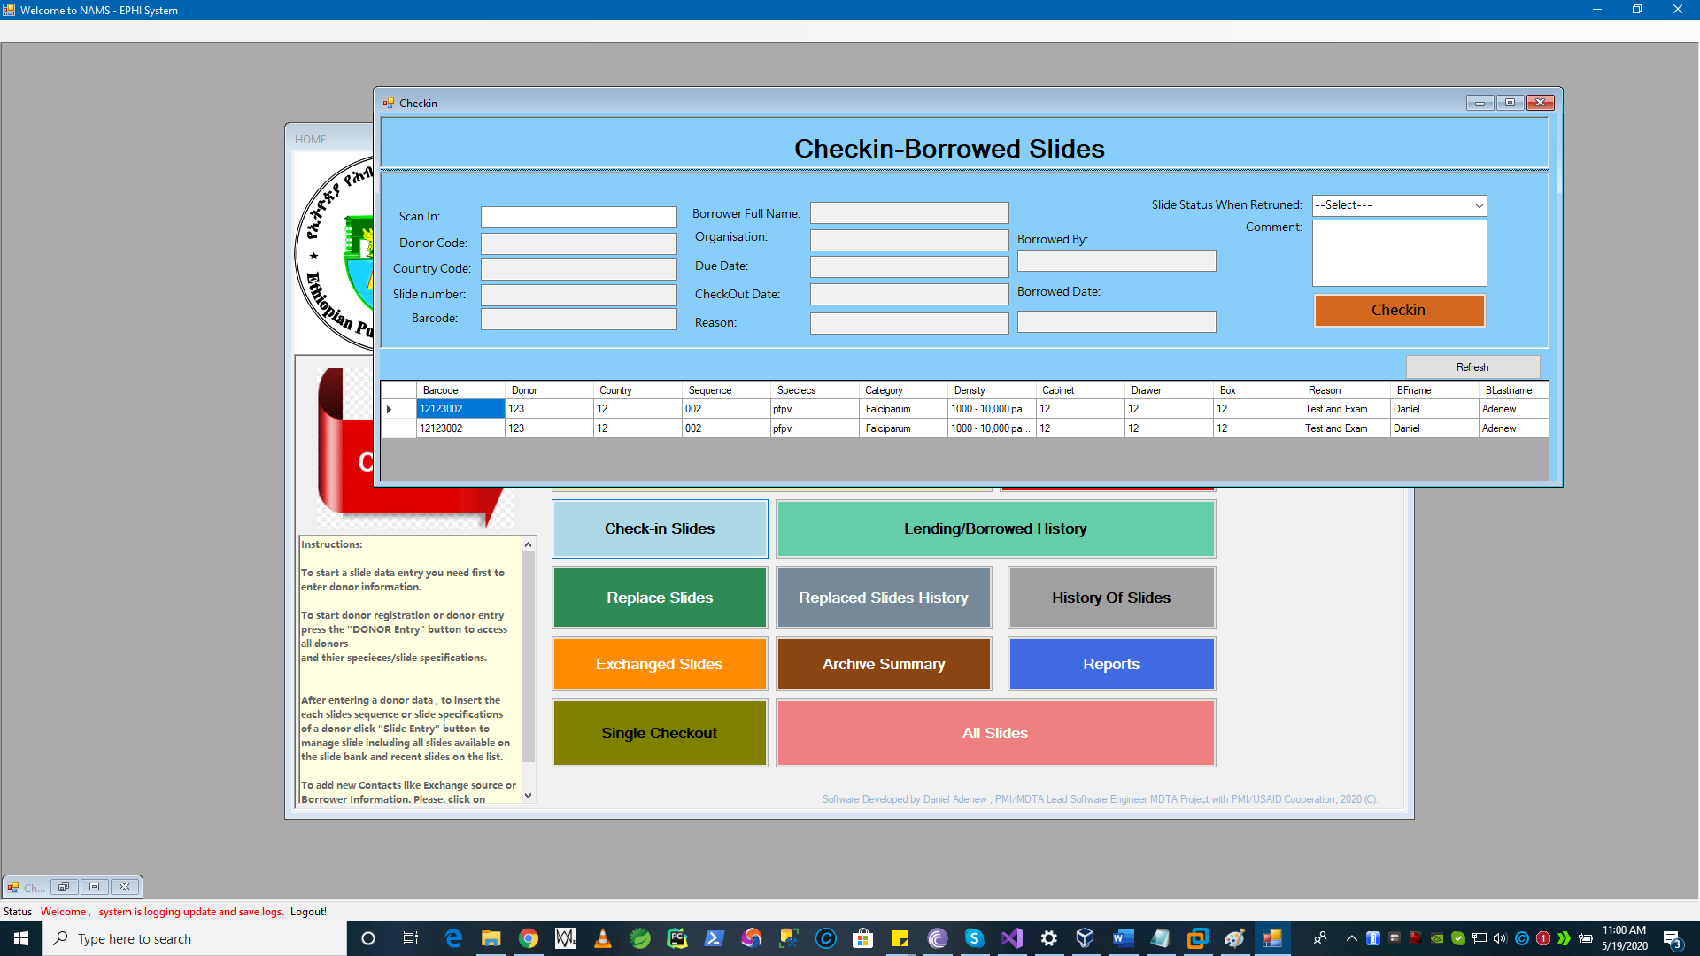

* + 1. Exchanging Slides / Checkout for Exchange

**Requirements addressed Here:**

* + The ability to check out slides to Exchange contact’s once the search performed based on above abilities, and results found based on the given criteria’s
  + Slide are checked out as exchange, printout / report of the exchange is available right after the action

To start the **Exchange operation**, we need to select the “**Selection Search Engine Form**” button from the central menu as depicted in the diagram below.

Please refer section **1.1.4** of this document “**Selection Search Engine**”.

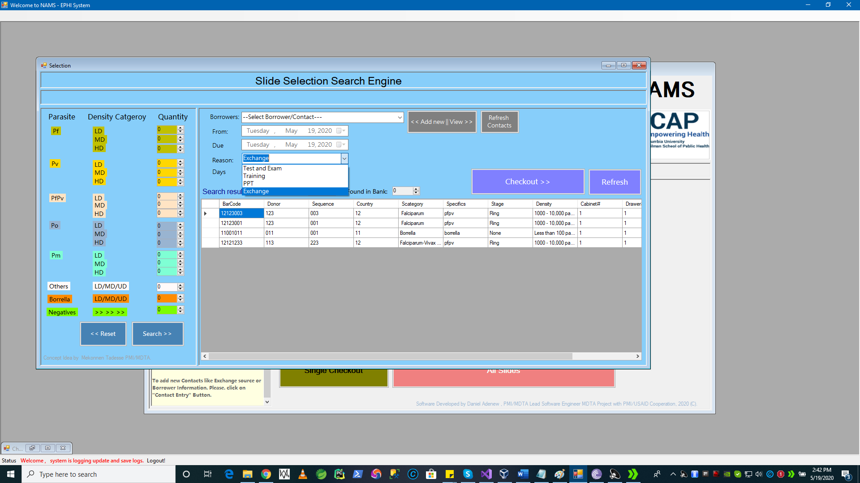

**Steps are continued on next page.**

* **Searching and Selecting Slides for checkout**

As this is similar concept with slide selection for **Training/Exam/PPT**. The one thing different here is the option for Slide Checkout **Reason** has to be Selected as **Exchange**.

1.First perform a search of any kind of slides by species types and density/quantity using the “Search”

2. Select the Exchange Contact if you have it on the system before

3. If contact is New press **“Add New Contact” Button 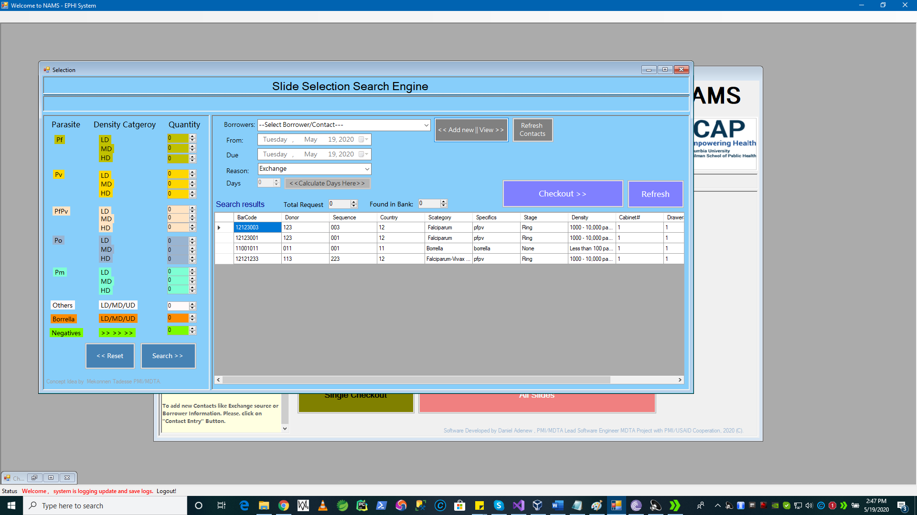 and Contact windows will appear as shown**

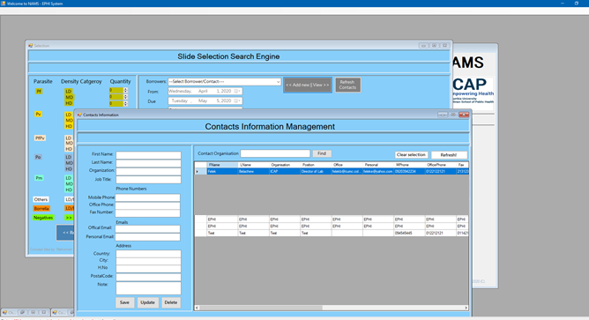

1. After adding a new contact or select existing from the list
2. Skip From and To Inputs as we don’t want them to be filled for Exchange
3. Change the Reason Drop Down Box To **Exchange.**
4. System will immediately shows you the following message: and Press “**Yes**”/”**No**” based on your choice.

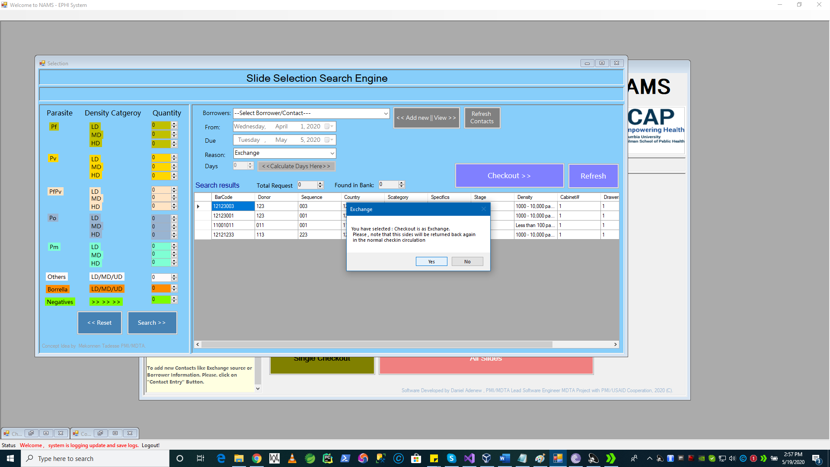

1. To do this Just go to Reason Drop Down Box and Select Exchange, that will make al the input buttons including ***Days, From and To Data*** fields disabled as they are not necessary for the exchange information capturing and skipped for validation checks



* Also the contact Drop Down List will automatically change to displaying contacts with their Country , Full Name and City as show below.

1. Select the **Exchange Contact**

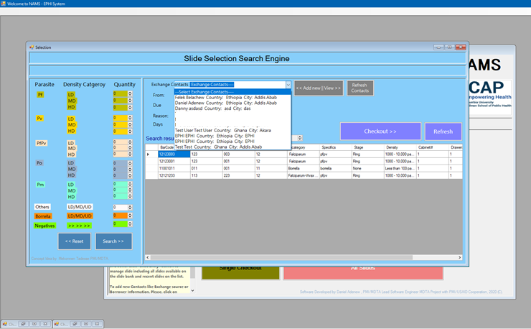

Select one contact for instance we have selected Test – Test, Country : Ghana ,City Akhara

1. Complete the Exchange Checkout

Now if you are okay with Slide Listed and Want to go checking out the list of slides as **Exchange**

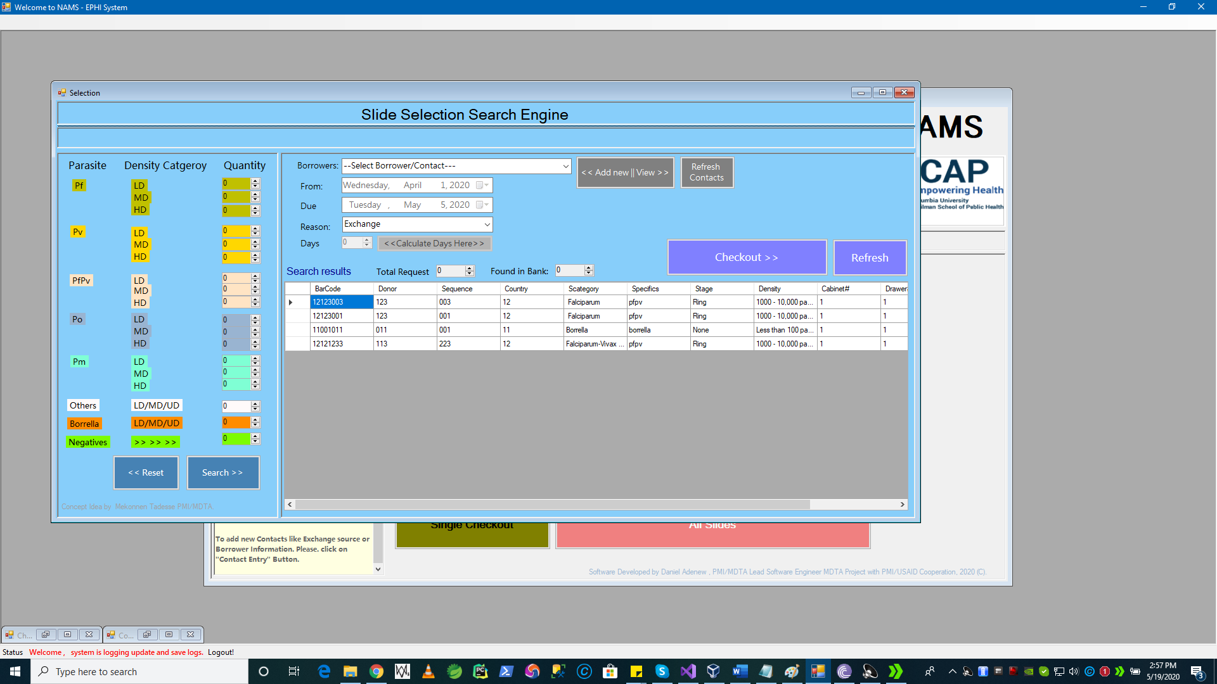**Press – “Checkout “Button**

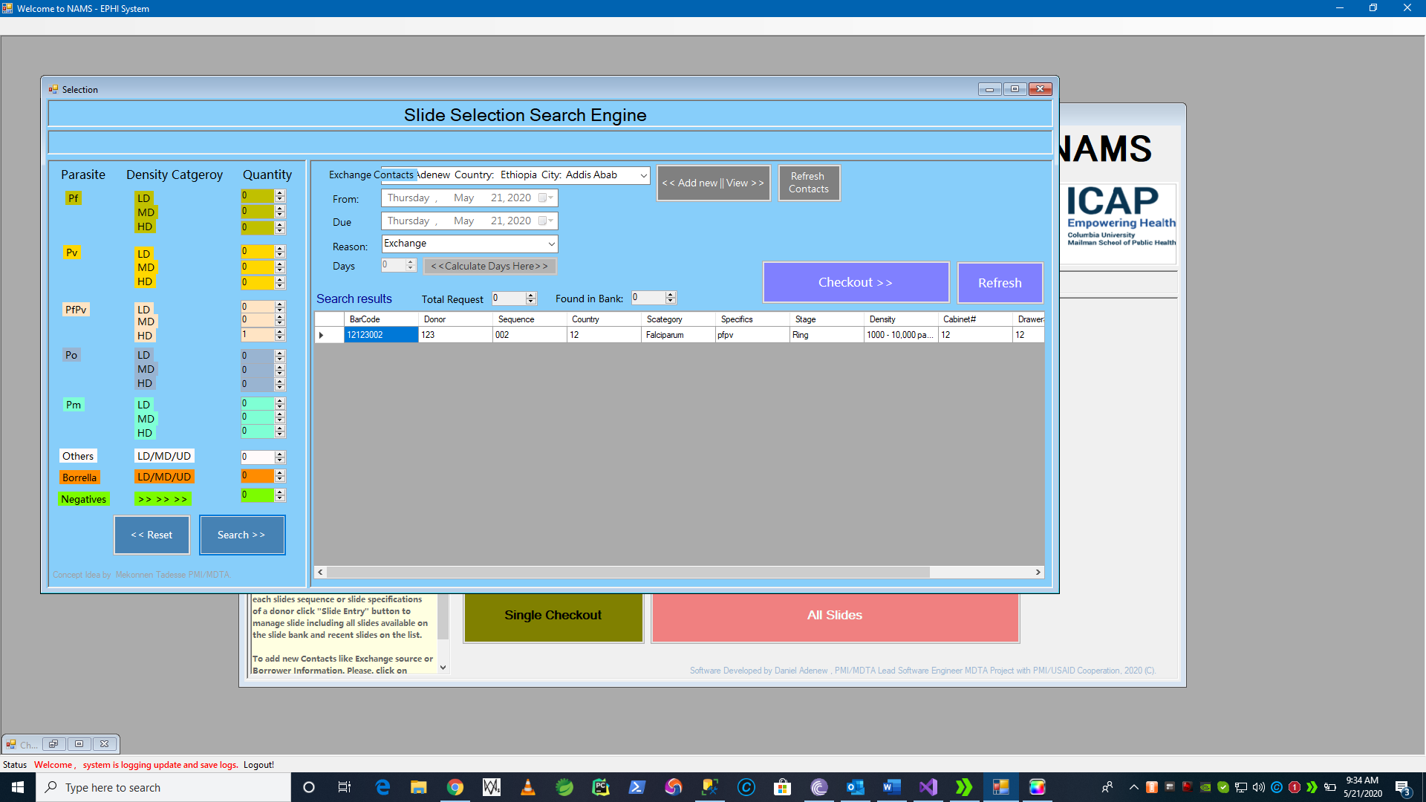

As shown in the record listing above we have searched and found 1 slide for exchange.

1. If Okay after pressing “**Checkout**” button. System will display a message if okay to proceed with checking out/exchange in this case with **Yes/No** dialog system. Pressing **“No”** will do nothing. See next for **“Yes”**

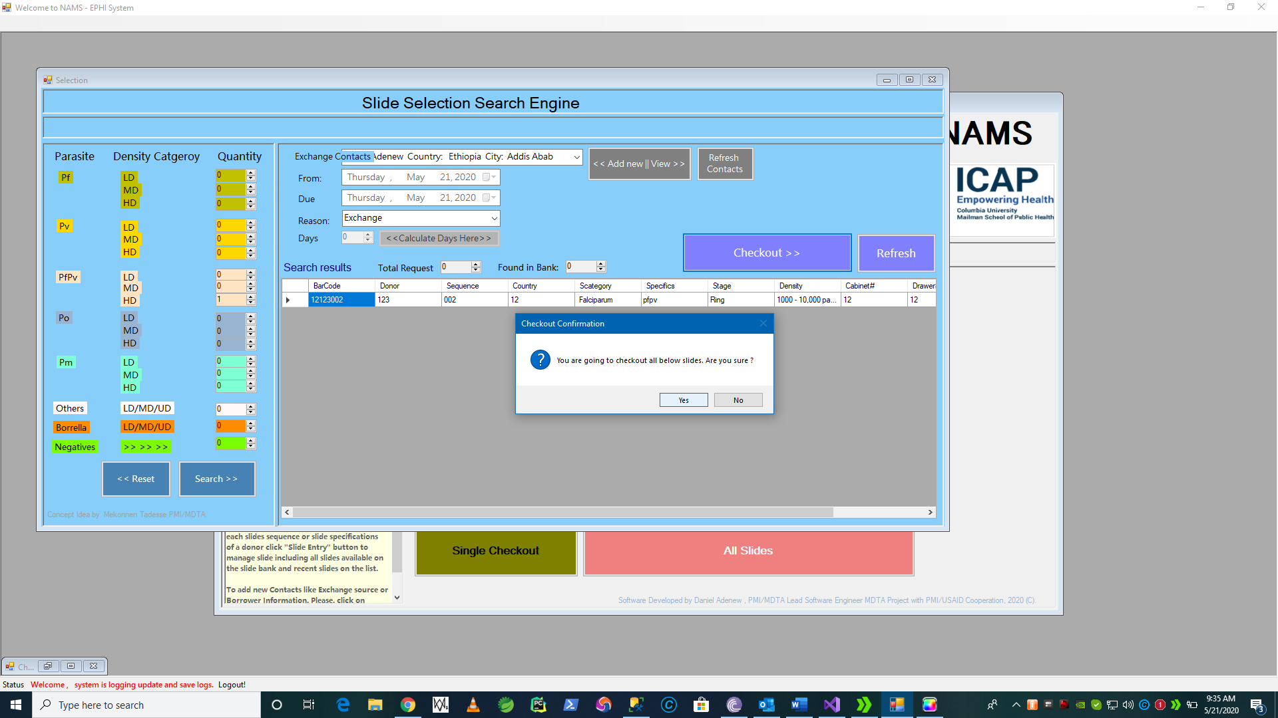



1. Final Step of the Exchange Checkout process is: When pressing **“Yes”** the system start processing the slides for checkout and exchange.

If Checking out was successful the system shows a **successful** message as shown below.

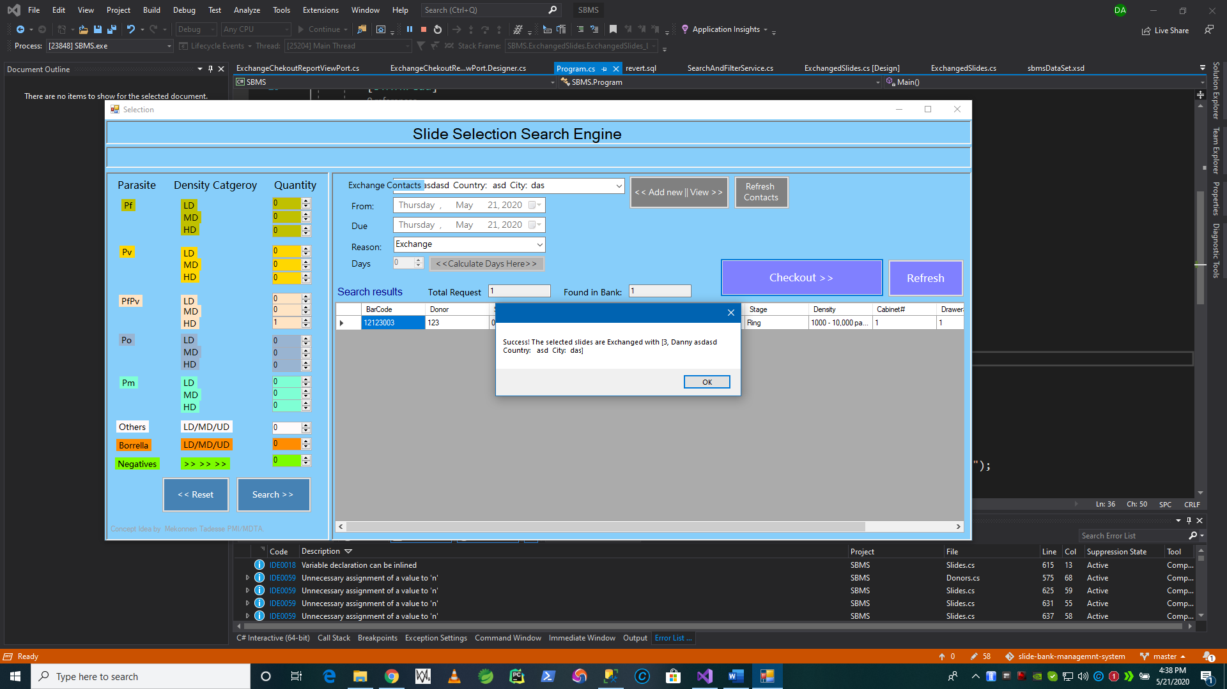

**Finalizing Requirements Addressed:**

* 1. Slides that are selected as shown in **step 9** of this section will be reported as ***Exchange*** and printout will be displayed on the screen.
  2. The slides will no longer be shown available for ***checkout/borrow/exchange*** and cannot be borrowed or replaced/searched again.

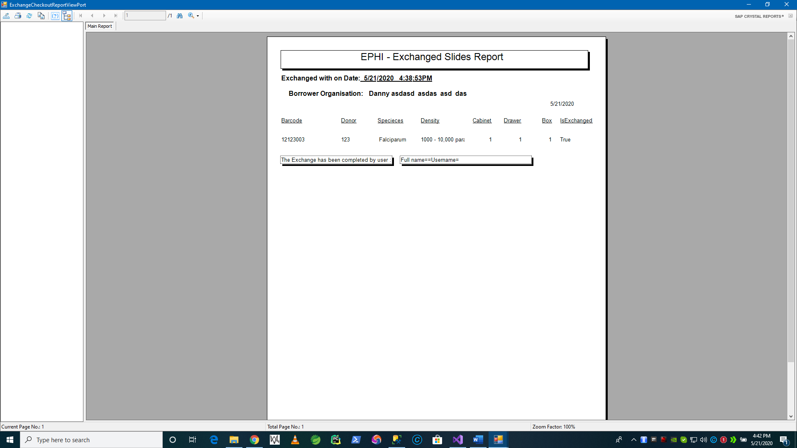

**Print out report is generated for Exchanged Slides.**

* 1. **If you open to see the slides list page** 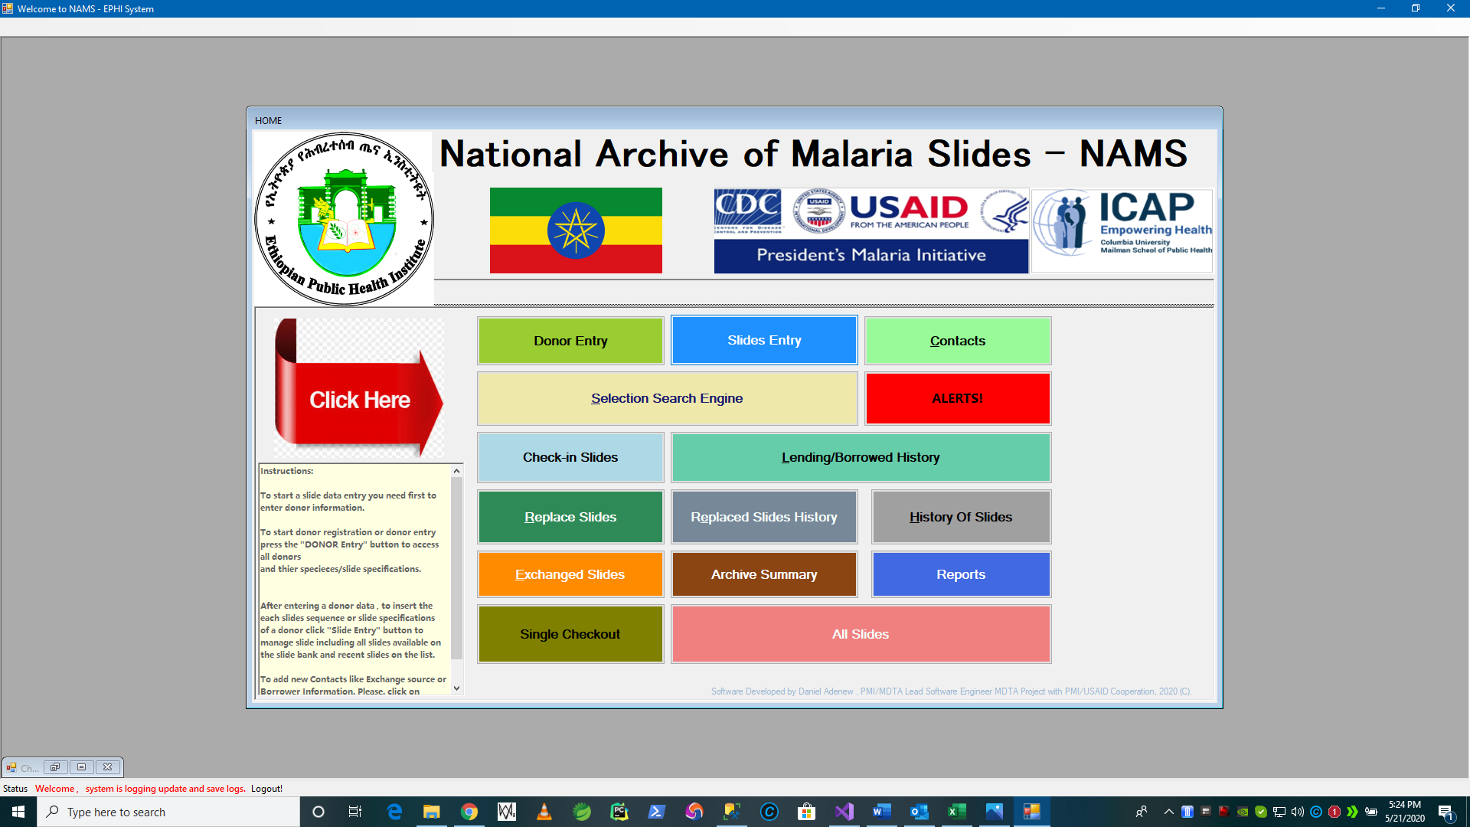

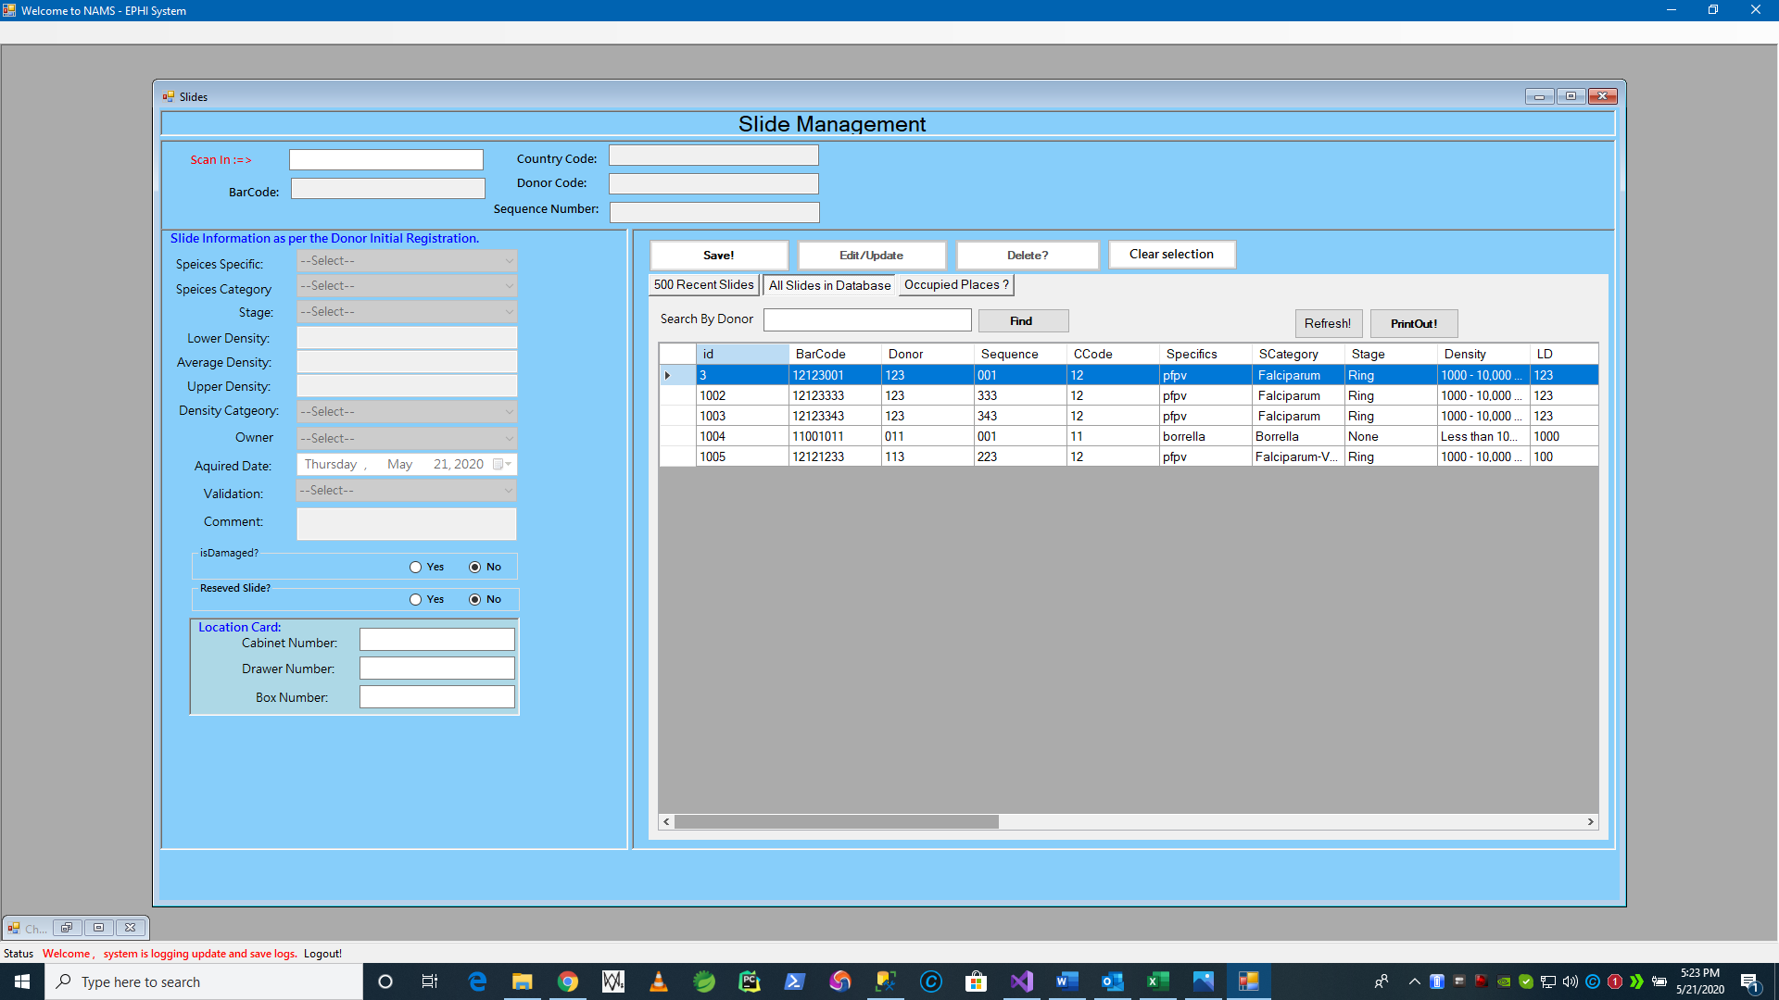

The exchanged slide will longer be seen on slides list page. Its history know. As we see below.

* + 1. Incoming and Outgoing Exchanging Slides Views

To see all **exchanges in/out** takes placed in the database. We have to launch the following form from the Main Menu:

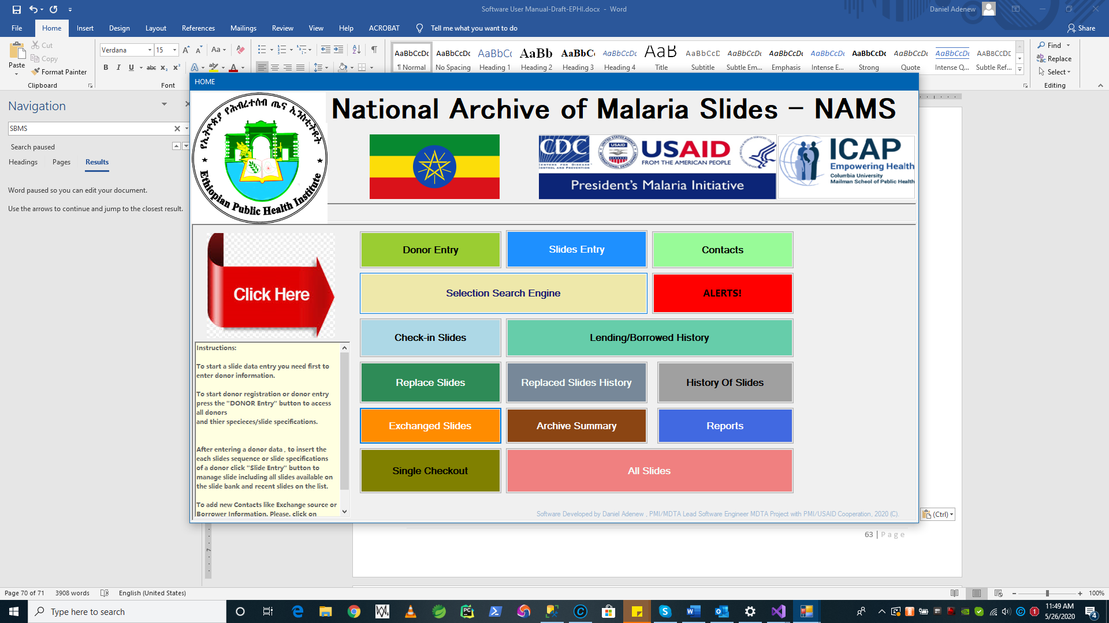

The following form will appear after you click the “**Exchange Slides**” button. See below

In following screen, the **Exchange Slide View Form** shows you the list of slides coming in on the left and list of slides going out as Exchange for other country.

* **Exchanged Slides All List of Records View**

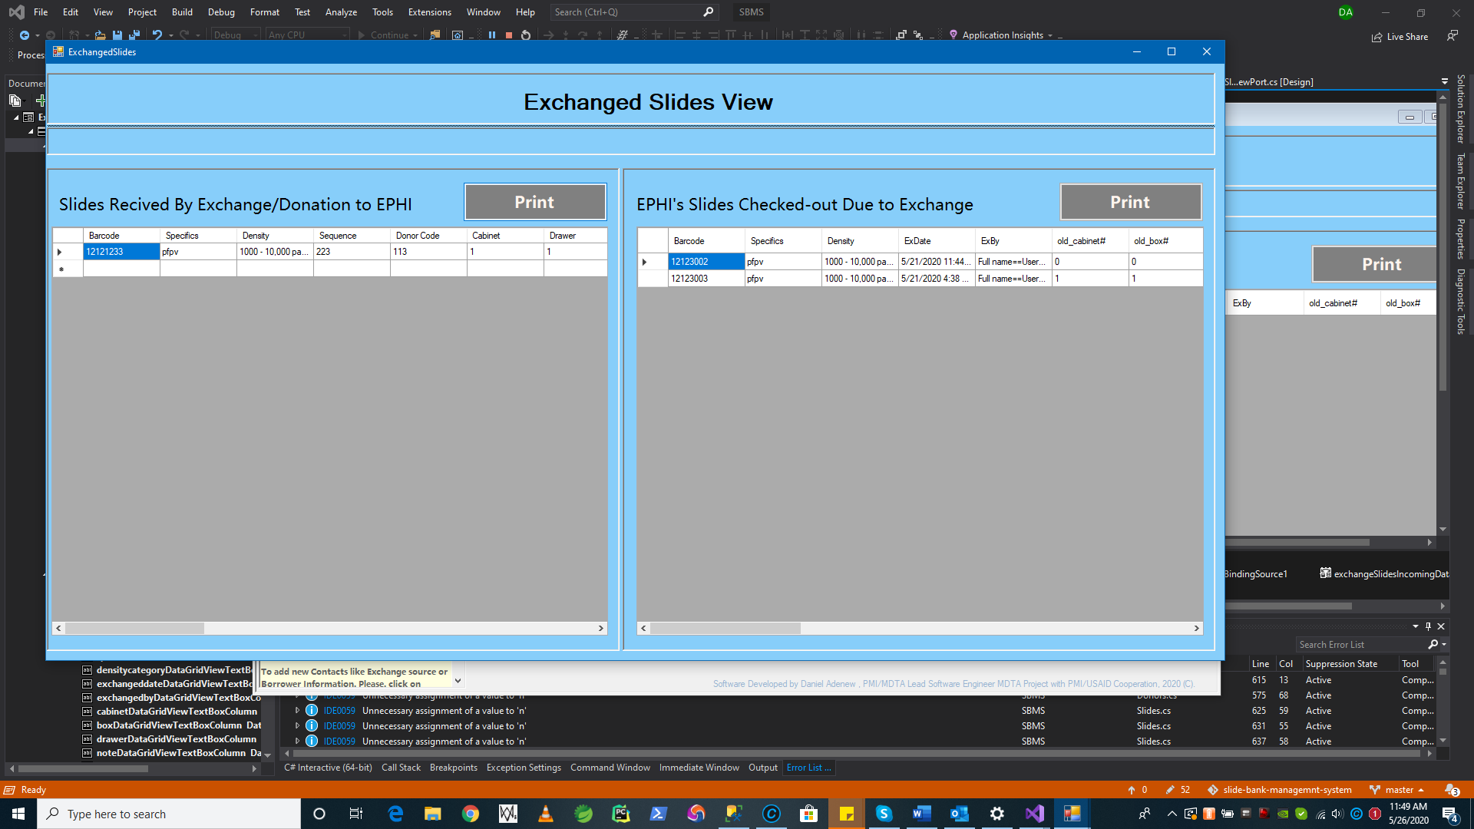

Requirements addressed:

* The ability to view all exchanged slides in one place
* Printouts using “Print” command button is available.
* Also by scrolling the data grid view horizontally shows more columns of the data elements as we will see on the next window.

Scrolling to view more columns about the list of record on the **Exchange Slide View**

* **IsExchanged-** is on when a slide is coming to slide bank by donation from other country
* IsExchangedOut - is when a slide is going out of slide bank/donated to other country by exchange

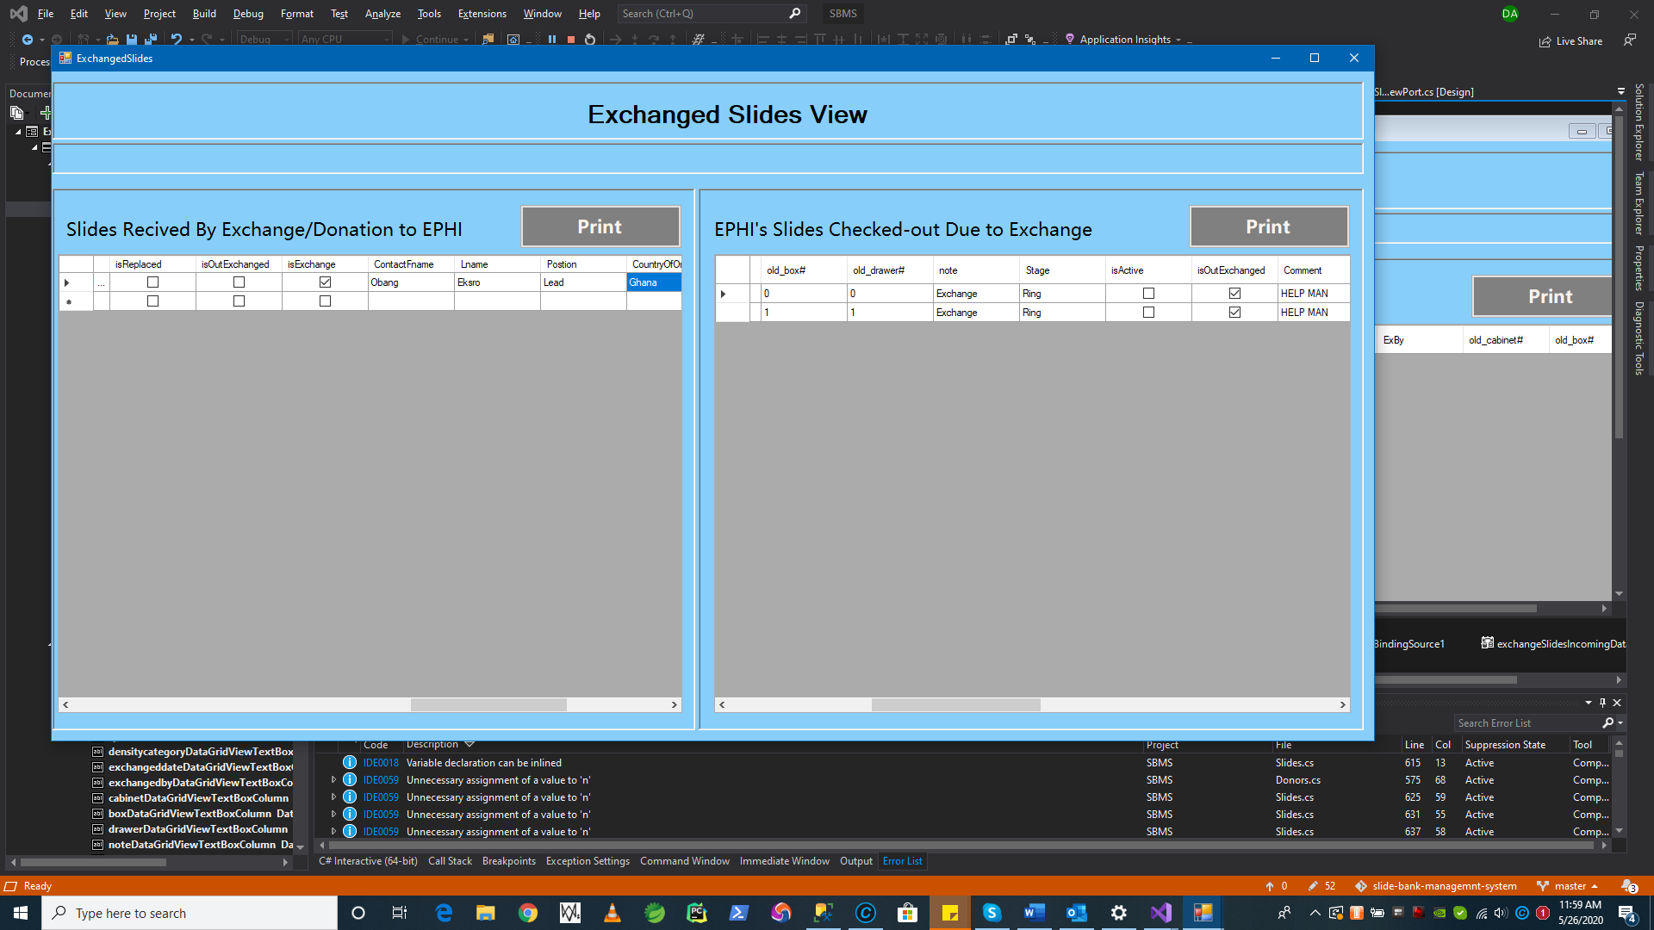

Scroll here .

Next let see the print outs we get from “**Exchanged Slides** **View**” form shown above.

* **Printing out a report all Incoming and Outgoing Slide Exchange Data**

1. Press **“Print”** here to see incoming

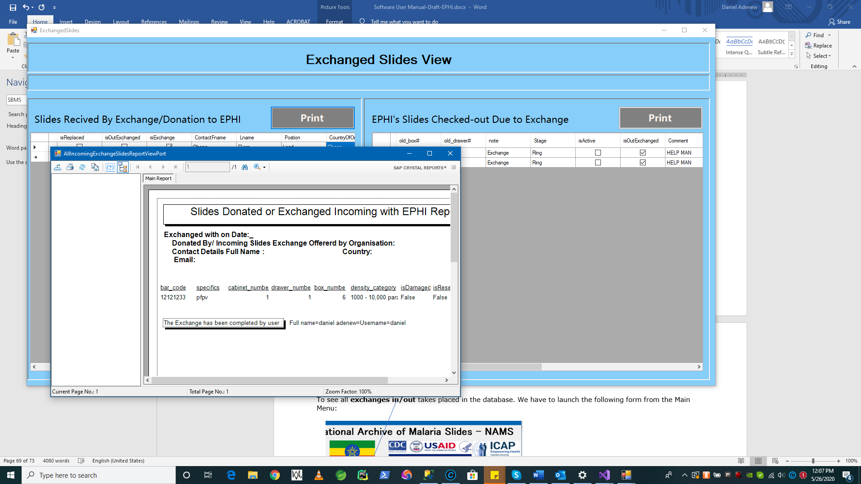

On the same window of the Exchange Slide View Print out the exchanged slides list as follows.

1. Press **“Print”** here to see Out Going Slide Exchanges ( *see slide Exchange part on Selection Search Engine on this docuemnt*).

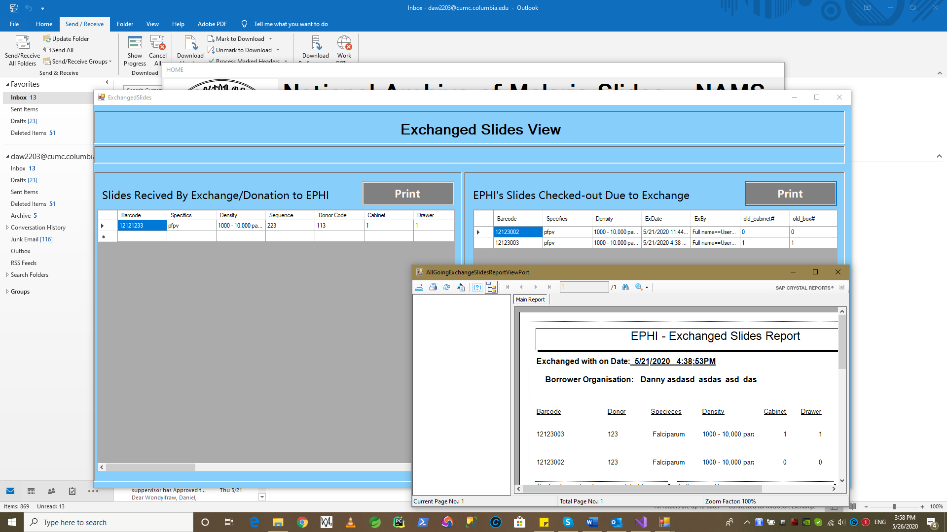

* There is one remining operation or action from the exchange slides work process. *i.e* ***seeing exchanged slides which are checkedout/out going as in slide history***. Let see the requiremnts addressed here.
* **Viewing Slide Exchanged History** 
  + To launch the **Slide History** page press 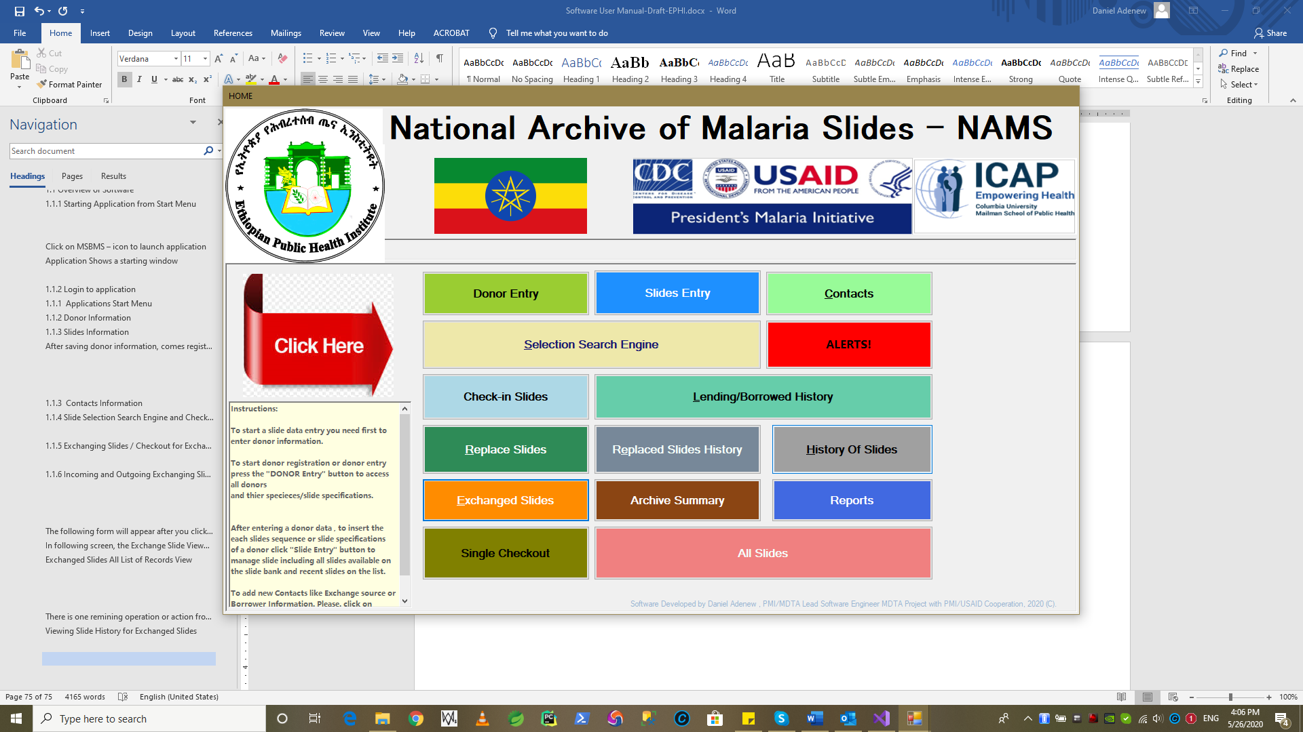 button.



**Requiremnts Address:**

* + - * + Exhanged Slides or Slides that are checkedout as Exchange should leave or unoccupidy from the cabinet. Their location data will be rested to 0,0,0 for cabinet, drawer and box identifications numbers.
        + Such that their former place is shown as history as old_cabinet , old_drawer and old_box as history in the next window.
* **Viewing Slide Exchanged History for exchanged slides**

1. **See Current Location** column below related places are set to zero identification. To denote slide doesn’t exisit.

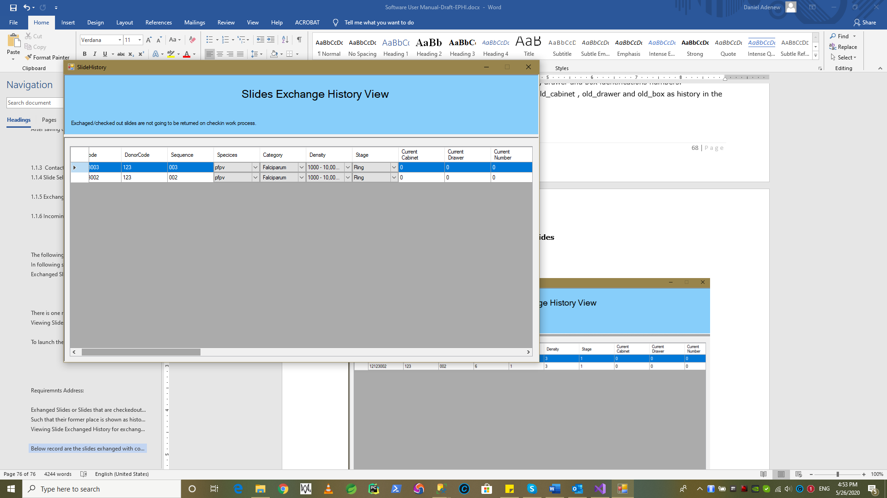

1. **See the old location for refenece.**

Seeing old location helps to recal any discprenacy when arranging slides if any. So that we can come back to this and see what was being set on locations before or not.

In the slide history page , by horizonally scrolling we can see that other data columnas for the exchanged slides.

i.e [**old_cabinet , old_drawer , old_box] column** as shown in figure below.

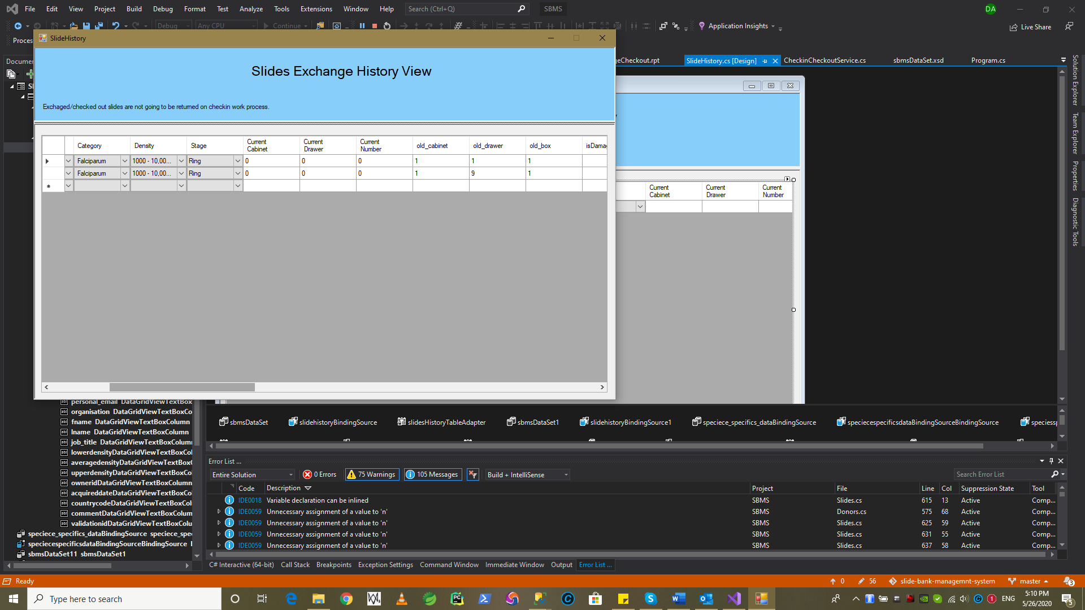

* + 1. Check-in-Reminder Pag/Popup when you Login

Requiremnts addressed Here:

* Popup alert when a user logins using
* Print due date passed borrowed slides
* List and show all due date passed slides

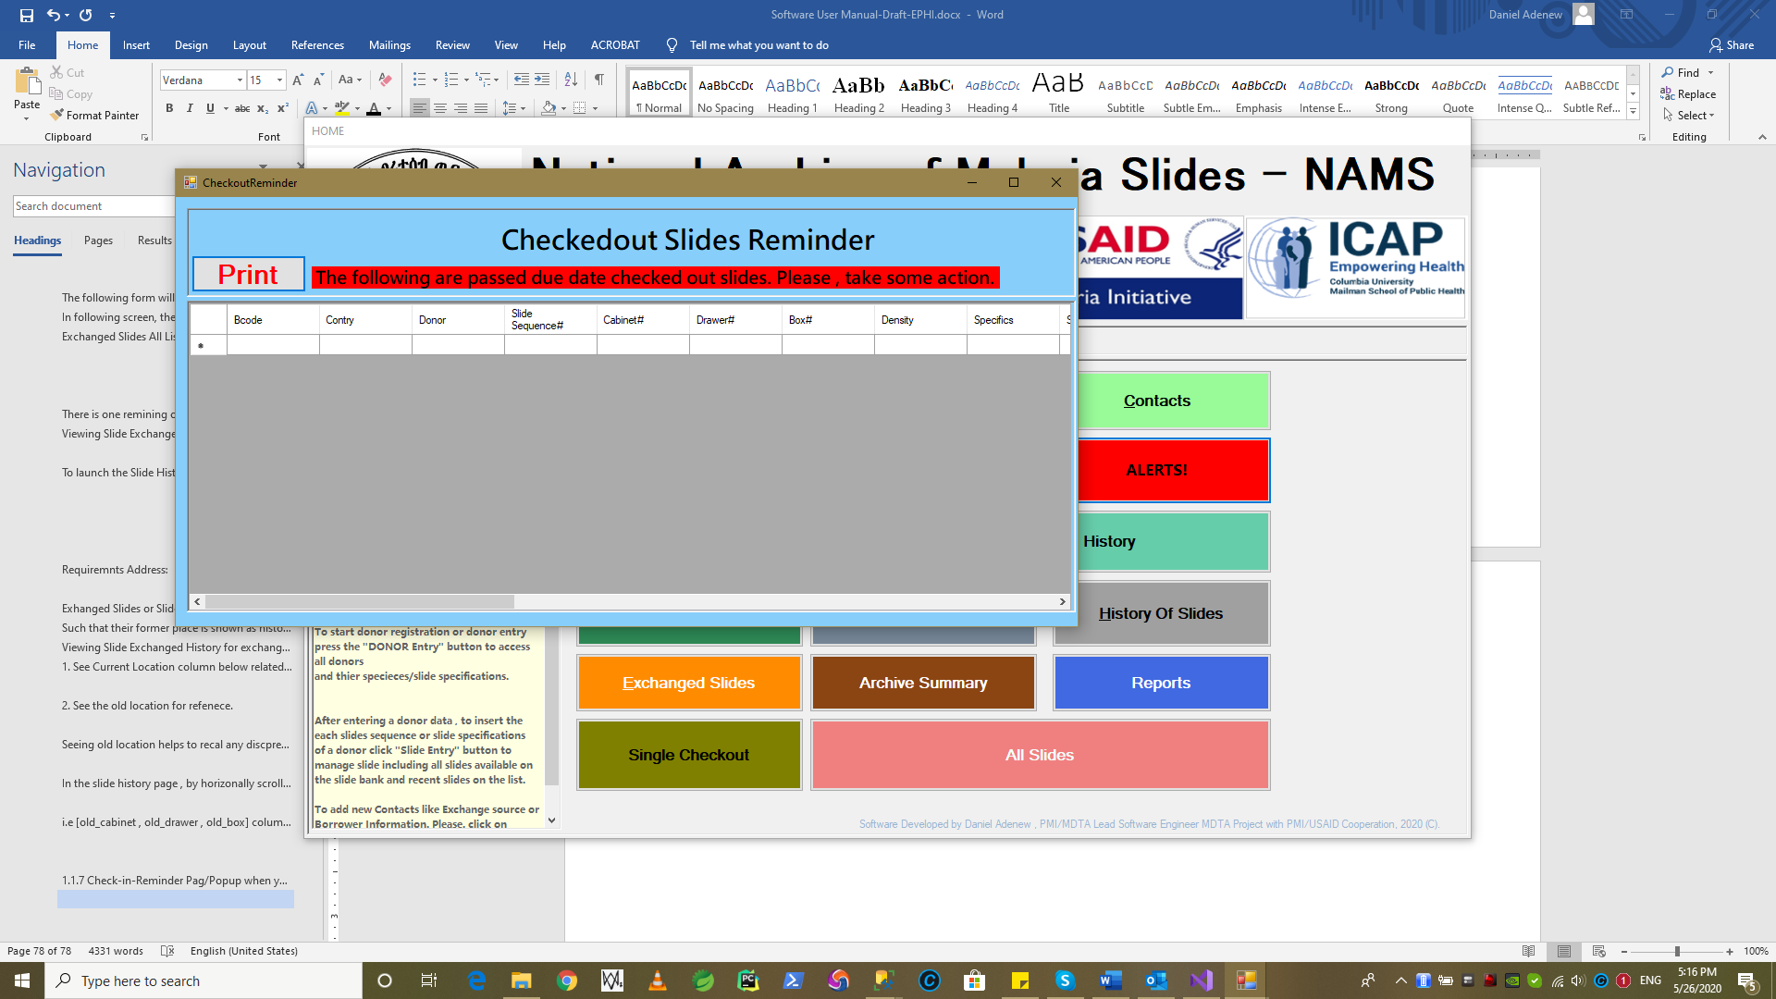

When user trie to close it. Shows **confrmation** message with **Yes/No**

If there are any slides checked out and unreturned/passed duedate.

**Except Exchange Slides it will be seen listed in “CheckedOut Slides Reminder”** formas shown above.

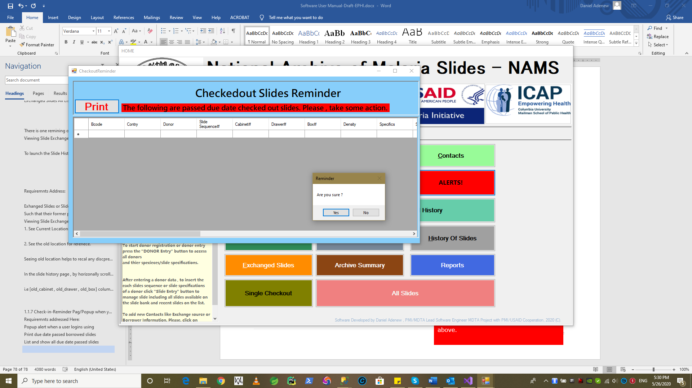

* + 1. Check-in Data Processing (Returning Borrowed Slides)

When slides are checked out as we seen **on Section 1.1.5** using a reason for checkout as

1. Training
2. PPT
3. Exam

**Requirements Addressed Here:**

* As per the requirements of EPHI , the slides are expected to return at given due date during checkout.

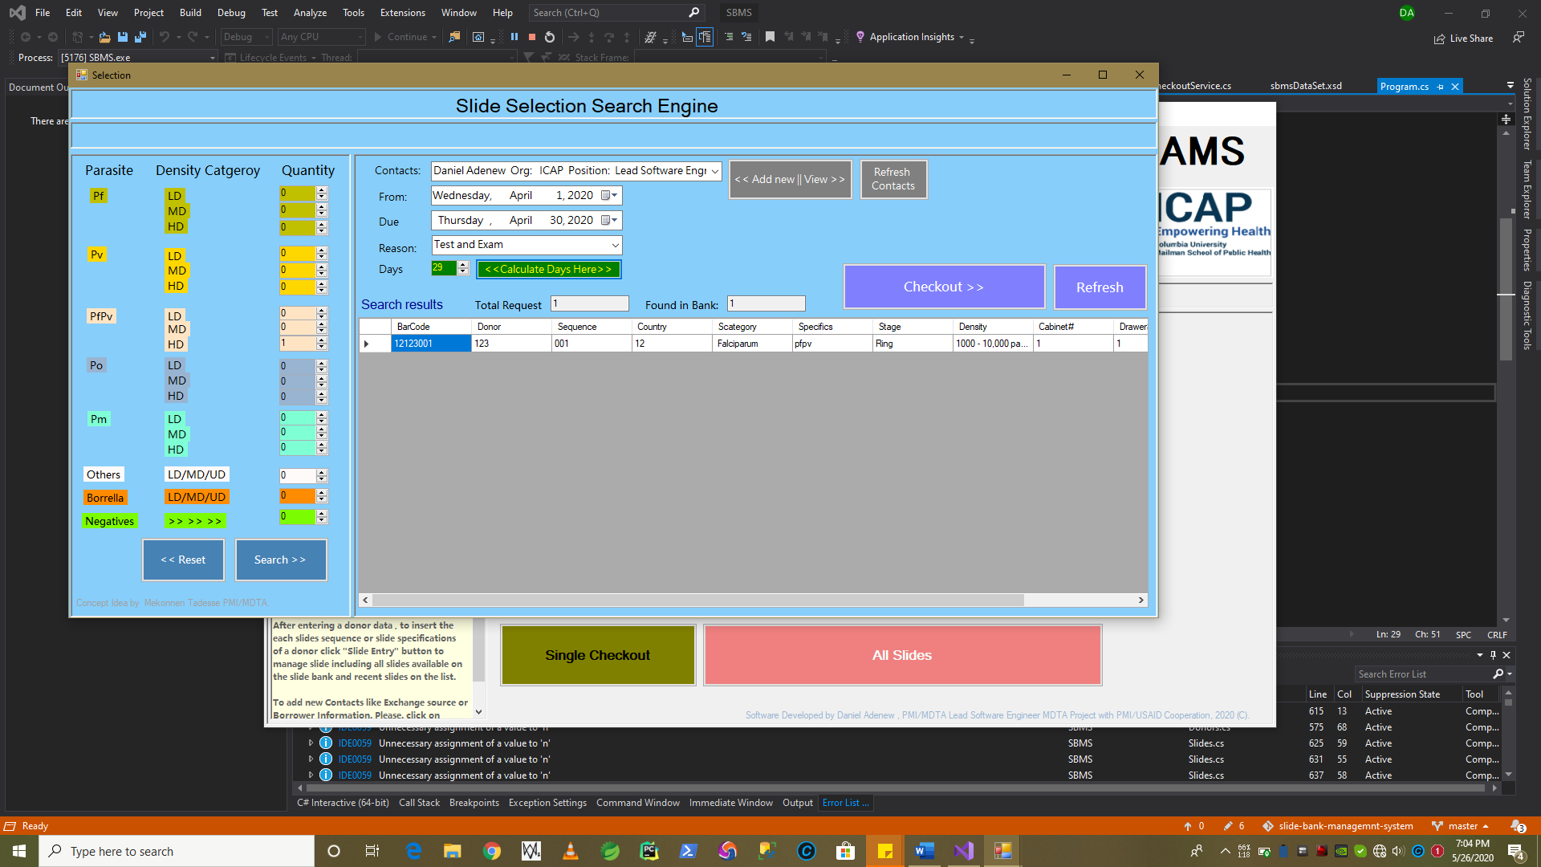

To **Checkin-in** slides must be checked out first as shown in the example.

Lets remind Checkout process so that we can reference the action of performing the usual slide **check-in-checkout** process work flow using **MSBMS** software.

* **Perform a Checkin for Borrowed Slides**

To return a slide with borrwed status. We have to launch the Checkin-Slides Button on Main Menu of the MSBMS application as shown in figure below.



1. By Default system show **all Checkedout to be returned(Borrowed) slides as list** as shown below.



* **Now , there are two method to perfrom a slide checkin operation.**

1. Just Selecting the row of the datagid view or slides from the list by clicking in one of the records you would like to check-in
2. By Manual Typing the Barcode into scan in or using directly a barcode scanner and pressing “Enter” key on your keyboard after typing all the code.

Let see them by example on below section with digrams.

1. Just Selecting the row of the datagid view or slides from the list by clicking in one of the records you would like to check-in

**Select the row** as , system will hightlight in blue and show you **selecte row message box**. Press **“Ok”** , slide will be loaded on the upper input fileds of the fome as shown in this example.

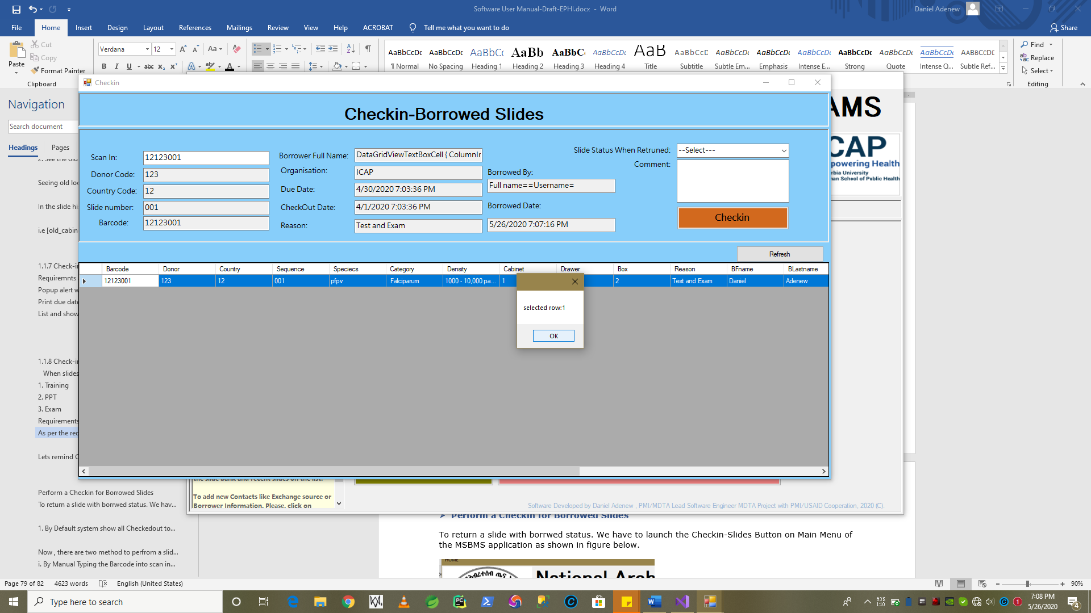

1. By Manual Typing the Barcode into scan in or using directly a barcode scanner and pressing “Enter” key on your keyboard after typing all the code.

Type the code inside the input box and press “Enter” key on your keyboard.

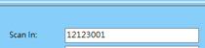Input the Barcode in the following box : system will load the slide details automatically.

1. Next stage is , if you selected the record correcltly as shown. You **can complete the check-in slide process** by using the following steps.
   * When, you scan a barcode or select a row . The upper input box will be loaded automatically with the slide information selected.
   * But , Except **“Slide Status Returned**” DropDownBoxand **“Comment”** box all are ready only (i.e **we can not modify slide’s information here**).

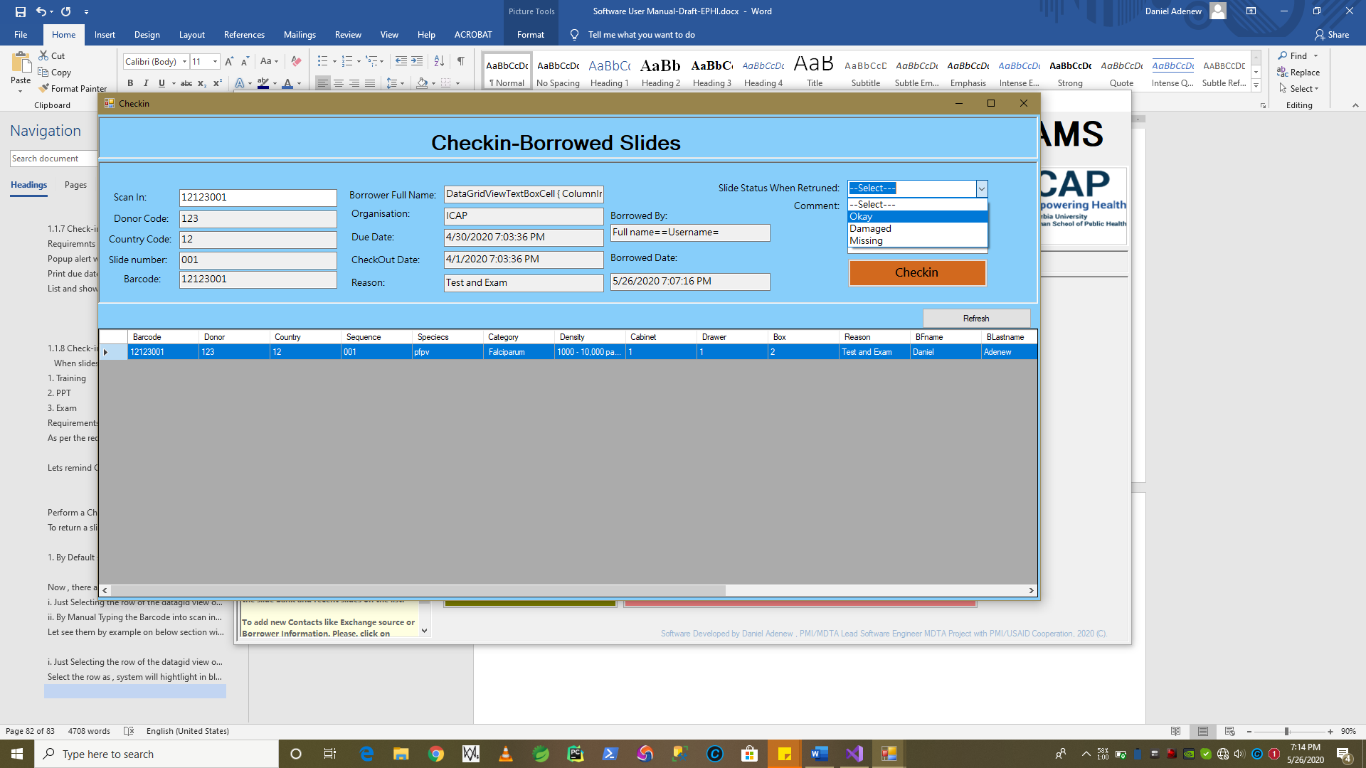

1. **Select the Slide Return Status for the slide being checked in.**

Slide Return status can be the following : 

1. **Okay**
2. **Damaged**
3. **Missing**

**Requirements Addressed Here:**

* Selecting “**Okay”** status will make the slide normaly get back to the circulation with Borrowed status turned off.

**i.e** we can search , borrow or exchange the slide if we checkin-as **“Okay”** status.

* Selecting “**Damaged/Missing”** status will make the slide normaly get back to the circulation with Borrowed status turned off but they will not be availabe for search/selection/borrow/checkouts.

**i.e We can only get Damaged Slides for replacment.** Now , lets perfrom checkin by pressing **“Checkin”** button **on Checkin-Slide Form**.

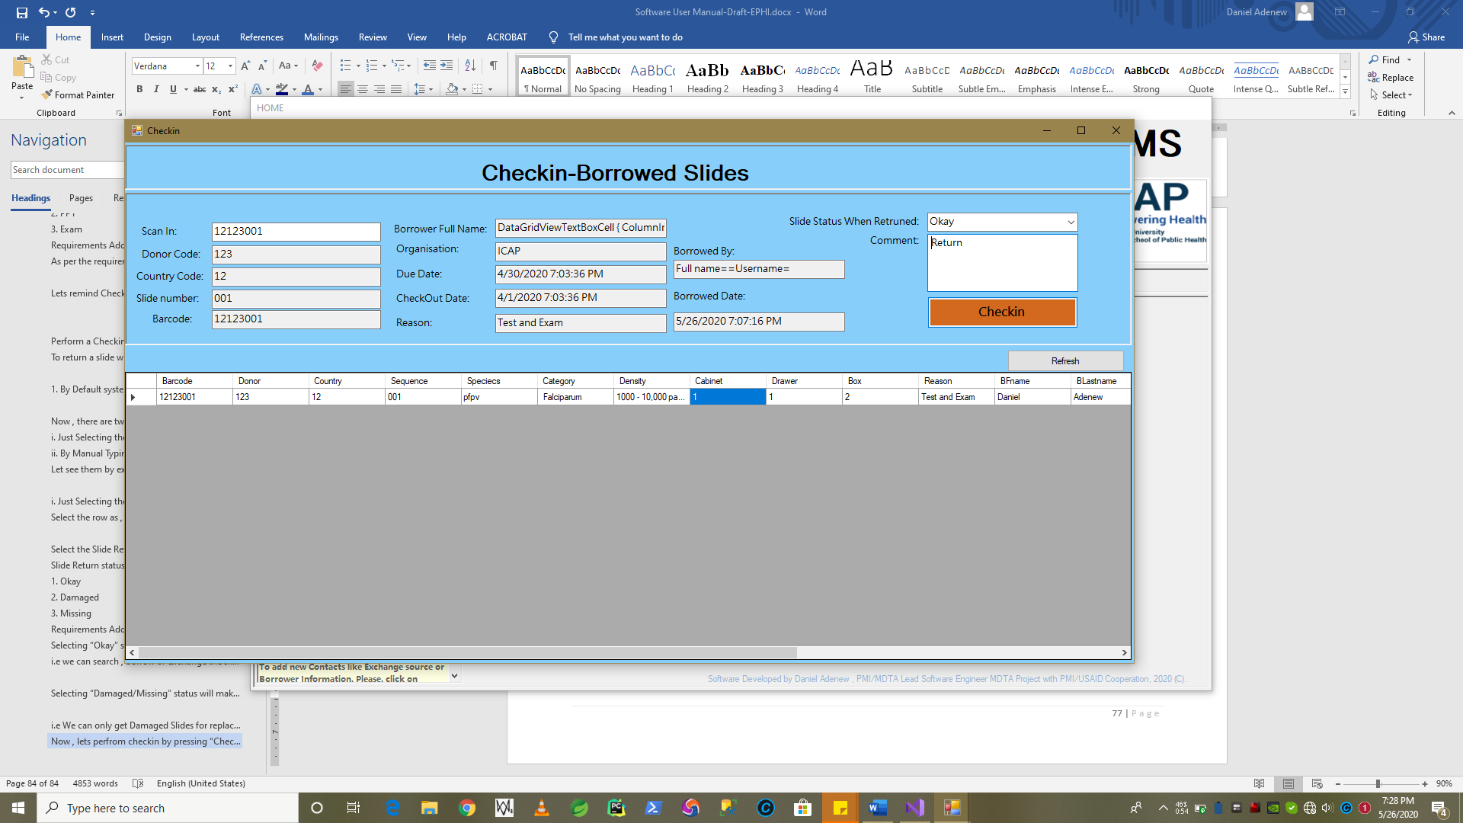

1. System shows checkin **Succesfull** **message**.

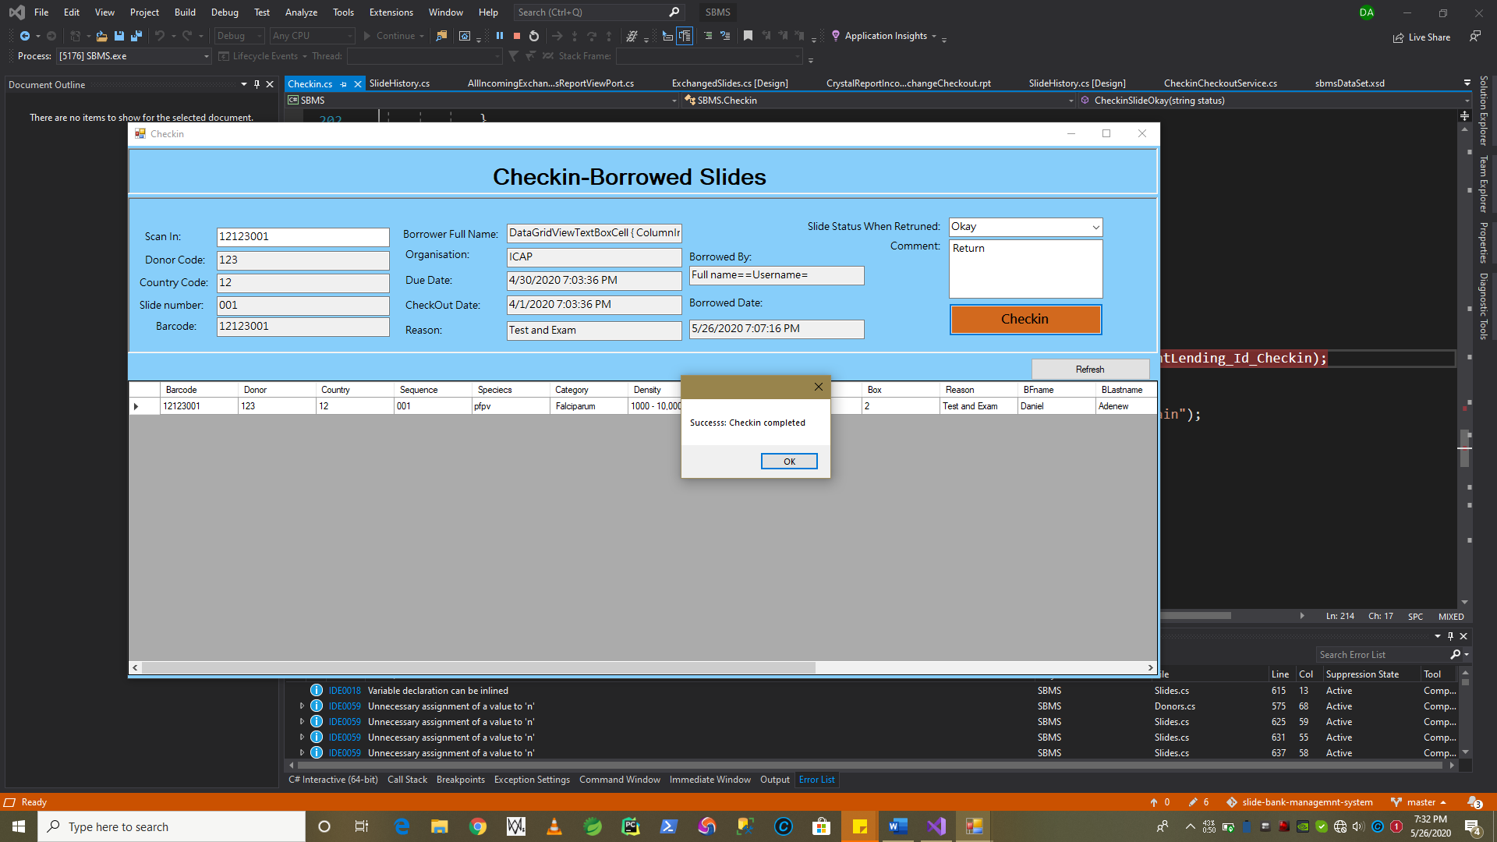

Press **“Okay”** ,System clears the checked-in slides from the list and input boxes. As shown figure below.

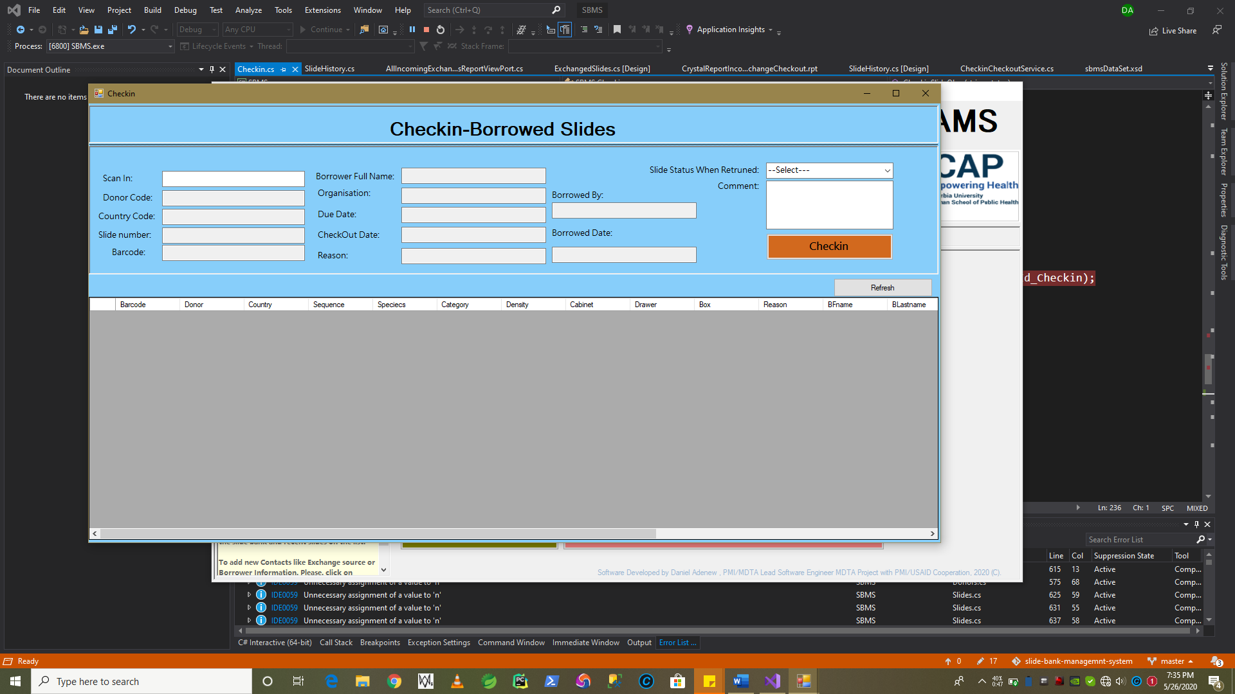

* + 1. Viewing Lending/Borrowed History

To view previously borrowed and current lending history, press 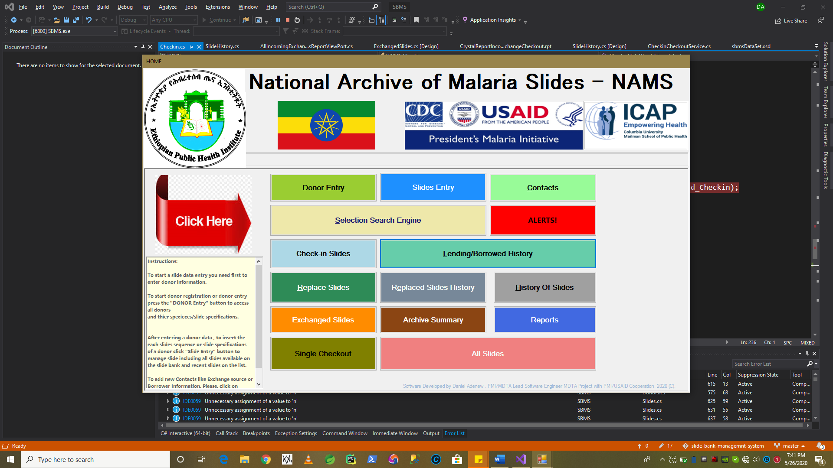



Click on All Lending History Tab Button as follows. When the Current Borrowed Slides and Lending History Launchs.

* All “**check-in”** and **“checkout”** we perfromed will be recored and keep int the system as history as follows.

